-

MALL FOOTFALL PREDICTION

CAPSTONE PROJECT

Submitted in partial fulfilment of the requirements of the Post Graduate Certification Program

in

Artificial Intelligence and Machine Learning

By

|  |  |
| --- | --- |
| **Name** | **Bits ID** |
|  | 2019AIML061 |
|  | 2019AIML089 |
|  | 2019AIML072 |
|  | 2019AIML156 |
|  | 2019AIML157 |
|  | 2019AIML193 |

Under the supervision of Mr. Satyaki Dasgupta

Project work carried out at

BIRLA INSTITUTE OF TECHNOLOGY AND SCIENCE

Pilani (Rajasthan) INDIA September, 2020

PCAM ZC321 CAPSTONE PROJECT

MALL FOOTFALL PREDICTION

Submitted in partial fulfilment of the requirements of the PGP - Artificial Intelligence and Machine Learning

By

|  |  |
| --- | --- |
| **Name** | **Bits ID** |
|  | 2019AIML061 |
|  | 2019AIML089 |
|  | 2019AIML072 |
|  | 2019AIML156 |
|  | 2019AIML157 |
|  | 2019AIML193 |

Under the supervision of Mr. Satyaki Dasgupta

Project work carried out at

BIRLA INSTITUTE OF TECHNOLOGY AND SCIENCE PILANI (RAJASTHAN)

September, 2020

**ACKNOWLEDGEMENTS**

A project like Mall footfall prediction or any such project needs in depth understanding of Data Analytics technics, mathematics behind it, various machine learning models available and the way to implement them, reasoning ability to choose a right technique for a given problem statement, ability to apply all the techniques through a language like Python.

Thank you to Dr. N.L.Bhanu Murthy for being a pillar support for the AIML program and laying the foundation required through the basic mathematics and Regression Videos

Thank you to Dr. Chetana Gavankar, for covering the core concepts of Regression, Classification and some of the Text mining topics in depth, taking time to clear all the clarifications and ensuring that every student understood the concepts to the core.

Thank you to Prof. Srikanth Gunturu for covering the classification concepts clearly through the videos, making them as elaborate and simple as possible.

Thank you to Prof. Aruna Malapati for covering the core concepts of Feature Engineering and Text Mining through Videos, making the videos extensive and easy to understand.

Thank you to Prof. Pravin Pawar, for covering feature engineering through in depth technical sessions and practical applications.

Thank you to Prof. S.P. Vimal for laying the foundations through elaborate introductory Python videos and for covering core concepts of Unsupervised Learning.

Thank you to Prof. Raja Vadhana P for clearly covering the topics related to Association rule mining through videos and sessions.

Thank you to Prof. Kamlesh Tiwari for covering with detailed videos on Deep learning and Artificial Neural networks.

Thank you to Dr. Sugata Ghosal for further covering Deep learning and Artificial Neural networks in depth with elaborate sessions and helping with multitude sources of information/study material

Thank you to TAs – for supporting at each stage with additional reference material, clarifying doubts through additional sessions and assignments

Thank you to Mr. Rahul Mohandasan for anchoring the entire cohort and being the support for all the technical and academic queries and issues.

Thank you to Mr. Satyaki Das Gupta for guiding us throughout the project in step by step manner, helping us to unearth many new dimensions in data analytics and especially in solving the problems involving timeseries.

Thank you to all fellow students who were available for various technical discussions, helping us explore and learn the machine learning concepts even better.

A big Thank you to the Organizations we work for and our family members for bearing with us and being the support in the backend for all these months allowing us to spend extended time on the learning, assignments and the final project.

**BIRLA INSTITUTE OF TECHNOLOGY AND SCIENCE, PILANI**

**CERTIFICATE**

This is to certify that the Capstone Project entitled **Mall Footfall Prediction**

# and submitted by Mr./Ms. Name1, Name2, Name3, ID No. 2019AIML060, 2019AIML070, 2019AIML090, 2019AIML104,2019AIML152, 2019AIML176

in partial fulfilment of the requirements of PCAM ZC321 Capstone Project, embodies the work done by him/her under my supervision.

Place : Kolkata Signature of the Mentor

*Satyaki Dasgupta*

Date : 12/Nov/2020 Name : Mr. Satyaki Dasgupta

**BIRLA INSTITUTE OF TECHNOLOGY AND SCIENCE, PILANI**

**CERTIFICATE**

This is to certify that the Capstone Project entitled **Mall Footfall Prediction**

and submitted by Mr. **Name1** ID No. **2019AIML065**

in partial fulfilment of the requirements of PCAM ZC321 Capstone Project, embodies the work done by him under my supervision.

Place : Kolkata Signature of the Mentor

*Satyaki Dasgupta*

Date : 12/Nov/2020 Name : Mr. Satyaki Dasgupta

**BIRLA INSTITUTE OF TECHNOLOGY AND SCIENCE, PILANI**

**CERTIFICATE**

This is to certify that the Capstone Project entitled **Mall Footfall Prediction**

and submitted by Mr. ID No. **2019AIML063**

in partial fulfilment of the requirements of PCAM ZC321 Capstone Project, embodies the work done by him under my supervision.

Place : Kolkata Signature of the Mentor

*Satyaki Dasgupta*

Date : 12/Nov/2020 Name : Mr. Satyaki Dasgupta

**BIRLA INSTITUTE OF TECHNOLOGY AND SCIENCE, PILANI**

**CERTIFICATE**

This is to certify that the Capstone Project entitled **Mall Footfall Prediction**

and submitted by Mr. ID No. **2019AIML059**

in partial fulfilment of the requirements of PCAM ZC321 Capstone Project, embodies the work done by him under my supervision.

Place : Kolkata Signature of the Mentor

*Satyaki Dasgupta*

Date : 12/Nov/2020 Name : Mr. Satyaki Dasgupta

**BIRLA INSTITUTE OF TECHNOLOGY AND SCIENCE, PILANI**

**CERTIFICATE**

This is to certify that the Capstone Project entitled **Mall Footfall Prediction**

and submitted by Mr. ID No. **2019AIML178**

in partial fulfilment of the requirements of PCAM ZC321 Capstone Project, embodies the work done by him under my supervision.

Place : Kolkata Signature of the Mentor

*Satyaki Dasgupta*

Date : 12/Nov/2020 Name : Mr. Satyaki Dasgupta

**BIRLA INSTITUTE OF TECHNOLOGY AND SCIENCE, PILANI**

**CERTIFICATE**

This is to certify that the Capstone Project entitled **Mall Footfall Prediction**

and submitted by Mr. ID No. **2019AIML134**

in partial fulfilment of the requirements of PCAM ZC321 Capstone Project, embodies the work done by him under my supervision.

Place : Kolkata Signature of the Mentor

*Satyaki Dasgupta*

Date : 12/Nov/2020 Name : Mr. Satyaki Dasgupta

**BIRLA INSTITUTE OF TECHNOLOGY AND SCIENCE, PILANI**

**CERTIFICATE**

This is to certify that the Capstone Project entitled **Mall Footfall Prediction**

and submitted by Mr. ID No. **2019AIML156**

in partial fulfilment of the requirements of PCAM ZC321 Capstone Project, embodies the work done by him under my supervision.

Place : Kolkata Signature of the Mentor

*Satyaki Dasgupta*

Date : 12/Nov/2020 Name : Mr. Satyaki Dasgupta

**BIRLA INSTITUTE OF TECHNOLOGY & SCIENCE, PILANI SECOND SEMESTER 2019-20**

**PCAM ZC321 CAPSTONE PROJECT**

|  |  |
| --- | --- |
|  |  |
| Project Title | : MALL FOOTFALL PREDICTION |
| Name of Mentor | : Mr. SATYAKI DASGUPTA |
| Name of Student | : |
| ID No. of Student | : |
| **Abstract**  Footfall — also known as People Counting, Shopper Counting or traffic is the measurement of the number of people entering a shop or shopping mall.  Why should anyone count and predict the footfall?   * Calculating footfall is a key metric or measurement for retail businesses wanting to increase sales and drive profits up. By counting footfall, retailers can identify at any time of the day, the purchasing opportunities they have in-store and crucially, by collating that with sales data, identify the ones missed out. * Knowing the hourly, daily and weekly retail footfall can give retailers that extra edge to target peak hours, convert browsers into customers and ultimately optimize store performance. * Measuring footfall lets businesses and retailers can reap multitude of benefits like valuable analytics and key performance indicators, improve the visitor experience, understand customer behaviour, optimise operations, popular store areas etc   How can we predict the footfall?   * Collect the past footfall data and other data related to the impacting factors like holidays, weather conditions each day etc * Apply Pre-Processing and feature engineering techniques   + Understanding Data, fields involved, Visualize and Impute Missing Values   + Data Merger from Various sources - In Count Data, Holidays, Weather   + Data Normalization and Scaling, Data Reshape, Data Encoding   + Outlier Analysis and PCA   + Derive Additional Data - Lags * Decompose time series into trend and seasonal component, Detrend Time series * Apply Augmented Dickey-Fuller Test to Evaluate the stationarity * Visualization the data in various plots - Kernel Density, SNS/ggplot/panda, strip, Swarm, Box, Violen, Boxen, Point, Bar, Count, Joinplot, Displot, Pairplot, rugplot, Line plot, Numerical scatterplot, Multiple relationships with facets * Check Auto Correlation * Finalise the Model metrics and Measures * Finalise the Model Tuning Techniques | |

|  |  |
| --- | --- |
| * Finalise the Model Parameters * Prepare Datasets for Models * Apply Models   + Standard Regression Models   + Standard Ensemble Models   + LSTM Models   + Additional Models     - H20     - AutoML     - FB Prophet     - GAN * Analyse Model Metrics | |
| **Key Words:** | Footfall prediction, Timeseries, Regression, Lag variables, ADF, de trend, Stationarity Check, PCA, Feature Importance, Outlier Detection, DBCSAN, LOF, Imputation, Linear Regression, Lasso Regressor, Ridge Regressor, SVM, LSTM, H2O, Ensemble, FB prophet, Auto ML, SGD,  KNN, adaBoost, bagging, Random Forest, GAN |

# List of Symbols and Abbreviations used

|  |  |
| --- | --- |
| Symbol | Meaning/Usage |
| Ez | Expectation of z |
| pz(z) | Probability of z |
| G(z) | Generator probability of z |
| L(D,G) | GAN loss function of Generator and Discriminator |
| log | Logarithm function |

*Table 1:List of Symbols*

|  |  |
| --- | --- |
| Abbreviation | Meaning/Usage |
| ADF | Augmented Dickey-Fuller |
| AIC | Akaike's Information Criteria |
| AutoML | Automatic Machine Learning |
| BIC | Bayesian Information Criteria |
| CNN | Convolutional Neural Network |
| DBSCAN | Density Based Spatial Clustering of Applications with Noise |
| DRF | Distributed Random Forest |
| GAN | Generative Adversarial Networks |
| GBM | Gradient Boosting Model |
| KNN | K Nearest Neighbour |
| LOF | Local Outlier Factor |
| LSTM | Long Short-Term Memory |
| MAPE | Mean Absolute Percentage Error |
| MAE | Mean Absolute Error |
| ME | Mean Error |
| MLP | Multi Layer Perceptron |
| MPE | Mean Percentage Error |
| MSE | Mean Squared Error |
| PCA | Principal Component Analysis |
| RMSE | Root Mean Square Error |
| SGD | Stochastic Gradient Descent |
| SVM | Support Vector Machine |
| TFT | Temporal Fusion Transformer |
| XGBoost | eXtreme Gradient Boosting |
| XRT | Extremely Randomized Trees |

*Table 2:List of Abbreviations*

# List of Tables

Table 1:List of Symbols 13

Table 2:List of Abbreviations 13

Table 3: Completion Checklist 107

**List of Figures**

Figure 1: Process flow 21

Figure 2: Classes and functions 23

Figure 3:Execution Plan week 1 to 4 26

Figure 4: Execution Plan week 6 to 8 27

Figure 5 Pre-processing and Feature Engineering flow 27

Figure 6: Code Snippet - Reading the data to the Data Frame 28

Figure 7: Original data snapshot 28

Figure 8: Code Snippet- Data Reshape 29

Figure 9:Reshaped Data snapshot 29

Figure 10: Code Snippet - Data Aggregation 29

Figure 11: Aggregated Data Snapshot 29

Figure 12: Code Snippet - Data Merge 30

Figure 13: Data Merge Snapshot 30

Figure 14: Data Merge Snapshot 30

Figure 15: Code Snippet - Normalize Data 30

Figure 16: Normalize Data set 31

Figure 17: Code Snippet - Derive New Columns 31

Figure 18: Derive New Columns Data set 31

Figure 19: Code Snippet - Lag Columns 31

Figure 20: InControl Target Column 32

Figure 21: Code Snippet - Encoding 33

Figure 22: Before Target Encoding 34

Figure 23: After Target Encoding 34

Figure 24: Code Snippet - Stationary Check 34

Figure 25: Code Snippet - Decompose Time Series 35

Figure 26: Code Snippet Seasonal Decompose 36

Figure 27: Detrended Data Set 36

Figure 28: Code Snippet DBS can 37

Figure 29: Code Snippet LOF 37

Figure 30: DBSCAN on Incount Total 38

Figure 31: Outlier Removed Data Snapshot 38

Figure 32: Code Snippet PCA 39

Figure 33: PCA Output Data Set 39

Figure 34: Contribution of Each Feature for Principal Components 40

Figure 35: PCA on full data Top 10 features 40

Figure 36: Code Snippet Missing Values 41

Figure 37: Visualization of Missing Values 41

Figure 38: Model training and evaluation flow 45

Figure 39: List of models (1) 45

Figure 40: List of Models (2) 46

Figure 41: Model tuning methods 46

Figure 42: Datasets used for modelling 46

Figure 43: Hyper parameter tuning 48

Figure 44: Recursive feature elimination 49

Figure 45: Feature importance using normal dataset 50

Figure 46: Model results (MAPE) with different model tuning techniques 50

Figure 47: Model prediction using Normal dataset 51

Figure 48: Model metrics on Normal dataset 52

Figure 49: Top 15 models (MAPE) with normal dataset 52

Figure 50: Model prediction using detrended dataset 53

Figure 51: Model metrics on detrended dataset 53

Figure 52: Model prediction with outlier removed dataset 54

Figure 53: Model Metrics using outlier removed data 54

Figure 54: Top 15 models (MAPE) with dataset with outliers removed 55

Figure 55: Feature importance with extra features 56

Figure 56: Model prediction with extra features 56

Figure 57: Feature importance on the PCA reduced dataset 57

Figure 58: Model prediction using PCA reduced dataset 57

Figure 59: Model metrics with feature removed using PCA 58

Figure 60: Feature importance with Gradient Boosting Regressor 58

Figure 61: Model prediction with weekly dataset 59

Figure 62: Model metrics for weekly dataset 59

Figure 63: LSTM encoder decoder architecture ( source : https:/[/www.a](http://www.angioi.com/time-series-)n[gioi.com/time-series-](http://www.angioi.com/time-series-) encoder-decoder-tensorflow/) 60

Figure 64: LSTM encoder decoder training 61

Figure 65: Model prediction with LSTM encoder decoder 62

Figure 66: Model prediction with CNN LSTM encoder decoder 63

Figure 67: Autoencoder architecture 63

Figure 68: Model prediction with LSTM autoencoder MLP 64

Figure 69: Model prediction with LSTM simple model 65

Figure 70: Model prediction with Ensemble average 66

Figure 71: Model prediction with stacked Ensemble LSTM 67

Figure 72: Model prediction with Ensemble of Ensembles LSTM 68

Figure 73: LSTM model metrics 69

Figure 74: Different H2O machine learning tools (source: H2O.ai) 69

Figure 75: H2O model hyper parameters 70

Figure 76: H2O model tuning 70

Figure 77: H2O model prediction 71

Figure 78: Model training with AutoML 72

Figure 79: Feature importance 72

Figure 80: Feature importance against different models 73

Figure 81: AutoML leaderboard and model scores 73

Figure 82: FB prophet dataset creation 74

Figure 83: FB Prophet model plot 74

Figure 84: FB prophet model prediction 74

Figure 85: Model score with FB prophet 75

Figure 86: GAN architecture 75

Figure 87: Training of GAN models 77

Figure 88: Model prediction with GAN model 78

Figure 89: Metrics used for different models 79

Figure 90: Best models (based on MAPE) 80

Figure 91:Code snippet for ggplot 82

Figure 92: Histogram of InCount Total 82

Figure 93: Distribution of rain 83

Figure 94: Mean temperature distribution 83

Figure 95: Distribution of wind-speed 84

Figure 96: Code snippet for ggplot 84

Figure 97: Distribution of InCount total based on other categorical attributes 86

Figure 98: Code snippet for Seaborn Swarm plots 87

Figure 99: Daily distribution of InCount total 87

Figure 100: Incount daily distribution with hist=Month 88

Figure 101: Incount total Monthly distribution(Swarm plot) 88

Figure 102: Strip plot of Incount Total 88

Figure 103: Strip plot Monthly distribution of Incount 89

Figure 104: Bar graph of Incount total 90

Figure 105: Violin plot(Incount total) 90

Figure 106: Boxen plot (Incount total) 91

Figure 107: Line graph of Incount Over years 92

Figure 108: Kde plot (Incount of gate Briggate : Daily & Monthly) 93

Figure 109 Kde Plot (distribution over HIgh temp & Low temp) 93

Figure 110: Kde plot (distribution over Rain & Holidays) 94

Figure 111: Categorical variables distribution 95

Figure 112: Pair plots 96

Figure 113: Correlation among discrete variables 97

Figure 114: Intra-day distribution 97

Figure 115: % Distribution of categorical variables (1) 98

Figure 116: % Distribution of categorical variables (2) 99

Figure 117: % Distribution of categorical variables (3) 100

Figure 118: % Distribution of categorical variables (1) 101

Figure 119: Multi-horizon forecasting with static covariates, past-observed and future known inputs 103

Figure 120: TFT architecture (source : https://arxiv.org/pdf/1912.09363.pdf) 103

Table of Contents

List of Symbols and Abbreviations used 13

List of Tables 14

List of Figures 15

1. Problem statement (what is the problem being addressed) 20
2. Objective of the project 20
3. Background of previous work done in the chosen area (Literature Review) 20
4. Machine Leaning process flow (Consolidated Approach / Solution Architecture) 21
5. Resources needed for the project, including people, hardware, software, etc. 24
6. Potential data challenges & risks in doing the project 25
7. Detailed Plan of Work 26
8. Pre-Processing steps 27
   1. Data Acquisition 28
   2. Reshape footfall data by location name 28
   3. Aggregation of Data 29
   4. Merge of Weather and Holidays data to footfall data 30
   5. Normalize the data 30
   6. Derive new columns 31
   7. Conversion of Categorical columns to numerical columns 33
   8. Stationarity check 34
   9. Decomposition of data 35
   10. Outlier detection 37
   11. PCA analysis for dimensionality reduction 39
   12. Missing value detection and imputation 41
   13. Visualization for Summarization 42
9. Machine Learning Modelling & Techniques Applied 45
   1. Standard Regression models 47
      1. Models with normal dataset 51
      2. Models with detrended data 53
      3. Models with outlier removed data 54
      4. Models with extra features 55
      5. Models with PCA reduced features 56
      6. Models with weekly data 58
   2. LSTM models 60
      1. LSTM encoder decoder 60
      2. CNN LSTM encoder decoder 62
      3. LSTM auto encoder 63
      4. LSTM simple model 65
      5. Ensemble LSTM Average model 66
      6. Stacked and Integrated Ensemble LSTM model 67
      7. Ensemble of Ensembles LSTM 68
   3. H2O models 69
   4. AutoML models 71
   5. FB Prophet models 74
   6. GAN (Generative Adversarial Network) model 75
10. Code & Screenshots (Full screenshot without cropping the system date-time) 78
11. Interpretation 78
    1. Justification of Measures / Metrics used 78
    2. Project output in terms of above measures/metrics 80
    3. Visualization Plots 81
12. Future Work & Extension or Scope of improvements 103
13. Conclusions / Recommendations 104
14. Directions for future work 104
15. Bibliography / References 105
16. Appendices 106
17. List of Publications/Conference Presentations, if any. 106
18. Duly Completed Checklist 107

# Problem statement (what is the problem being addressed)

Footfall is the measurement of the number of people entering a shop or shopping mall. Job at hand is to predict

* + Daily footfall
  + Weekly footfall
  + Peak time of the day

# Objective of the project

The primary objective of this project is to predict the possible in flow at any given future point in time, making use of the data available – 1) The in count at each hour at various locations (Also referred to as Gates) of the mall. 2) The supplementary data like weather and holiday data.

The objective is also to thoroughly understand the data in hand and derive business insights that would help predict the required information in an efficient manner.

1. **Background of previous work done in the chosen area (Literature Review)** Mall Management: An analysis of customer footfall patterns in Shopping Malls in India: <http://www.ijsrp.org/research-paper-0315/ijsrp-p3937.pdf>

Factors affecting performance of a Shopping Mall **:**

<http://www.iosrjournals.org/iosr-jbm/papers/Vol19-issue12/Version-3/A1912030114.pdf>

Demand Forecasting Using Artificial Neural Network Based on Quantitative and Qualitative Data: https://ieeexplore.ieee.org/document/9245614

# Machine Leaning process flow (Consolidated Approach / Solution Architecture)

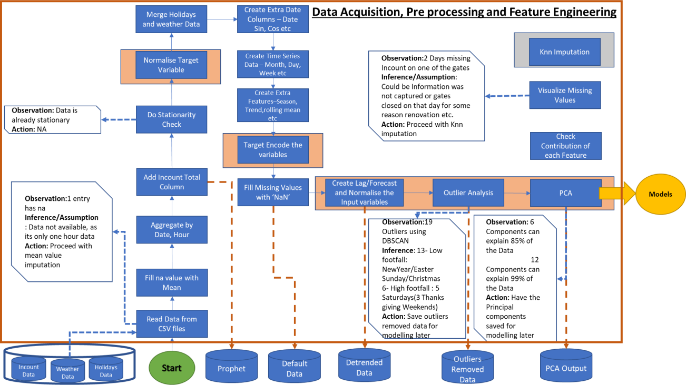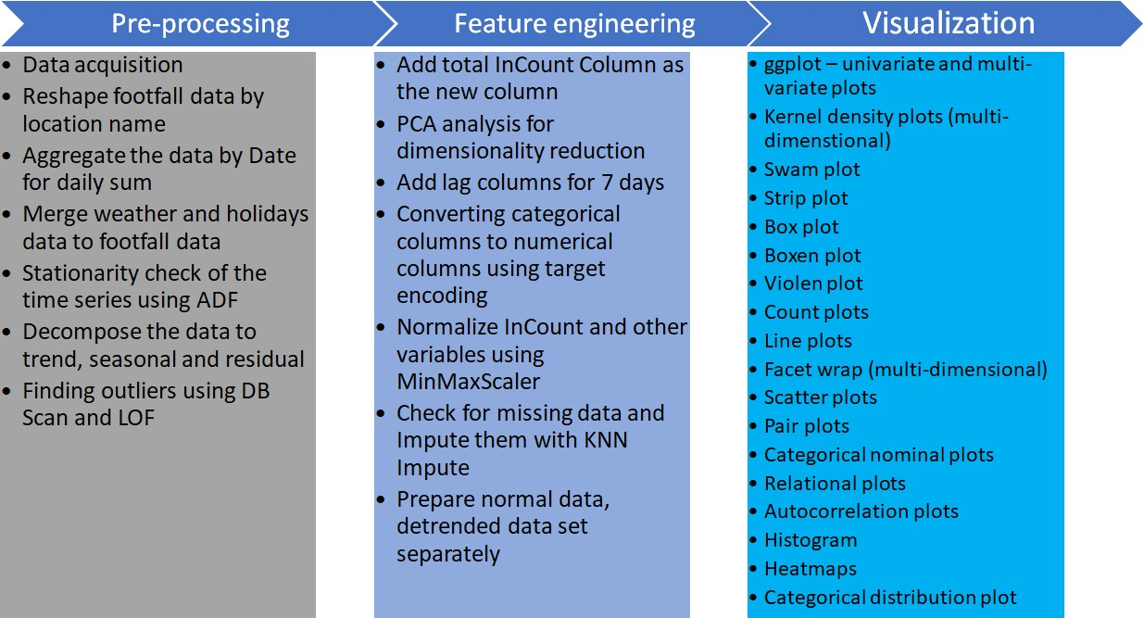

*Figure 1: Process flow*

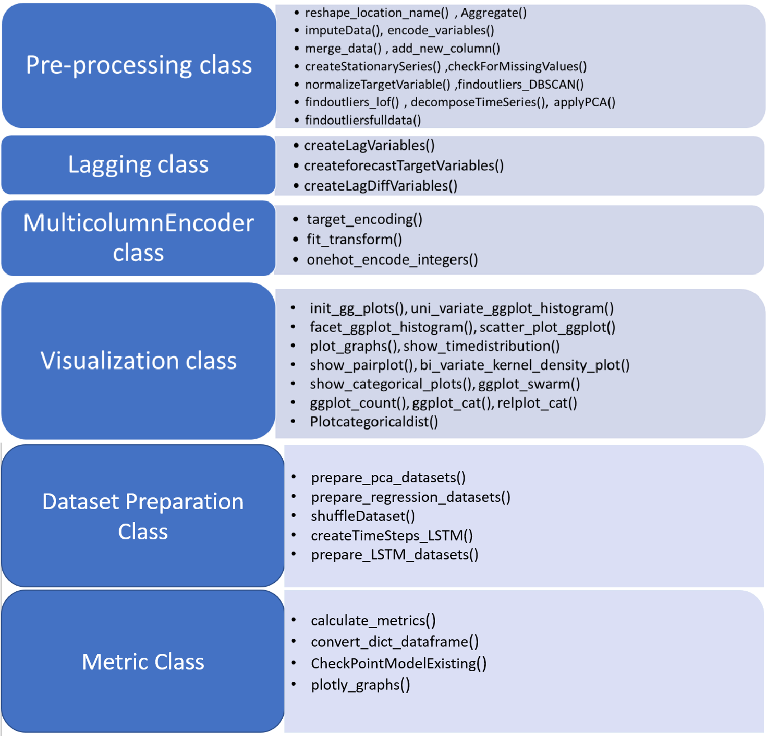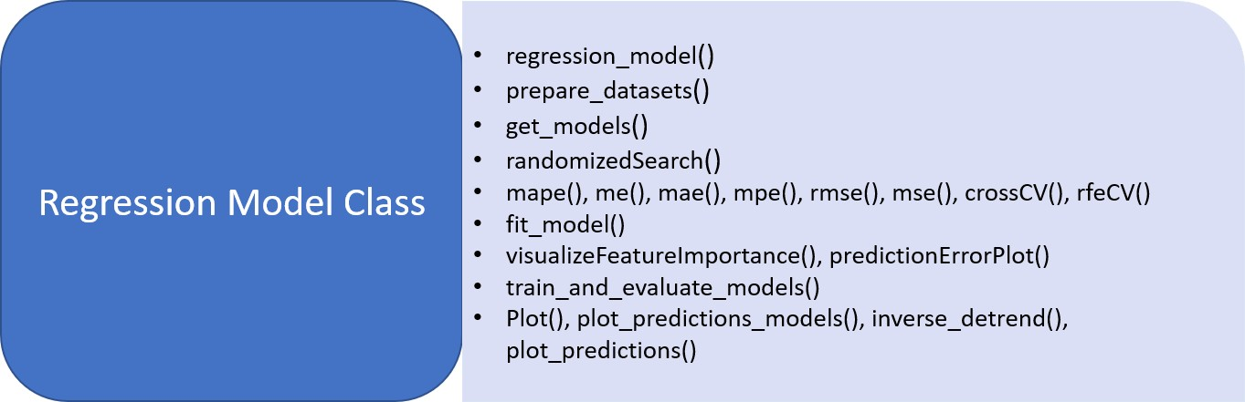

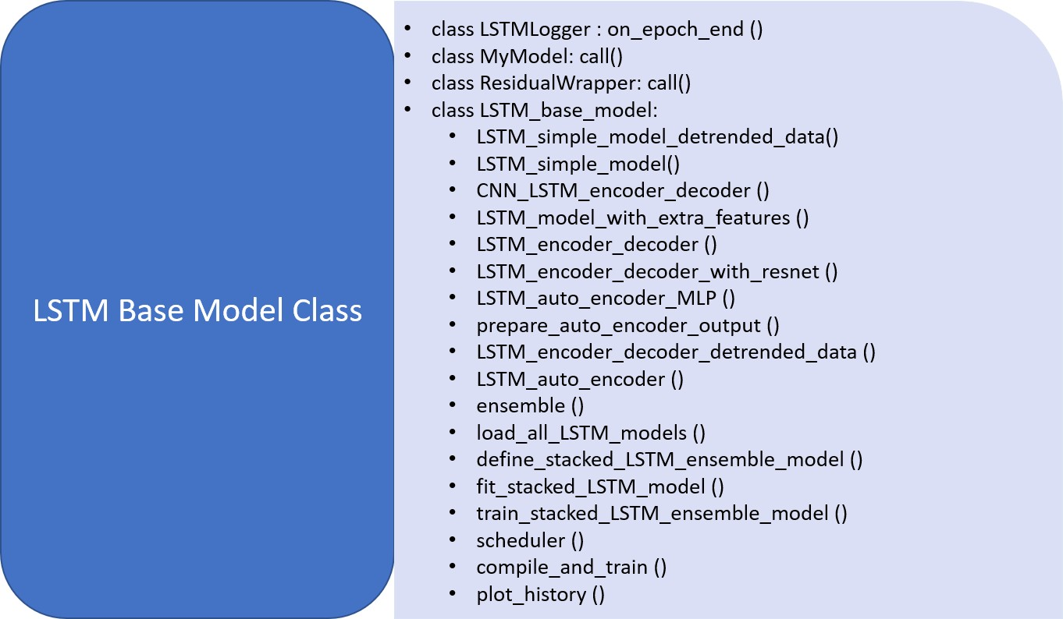

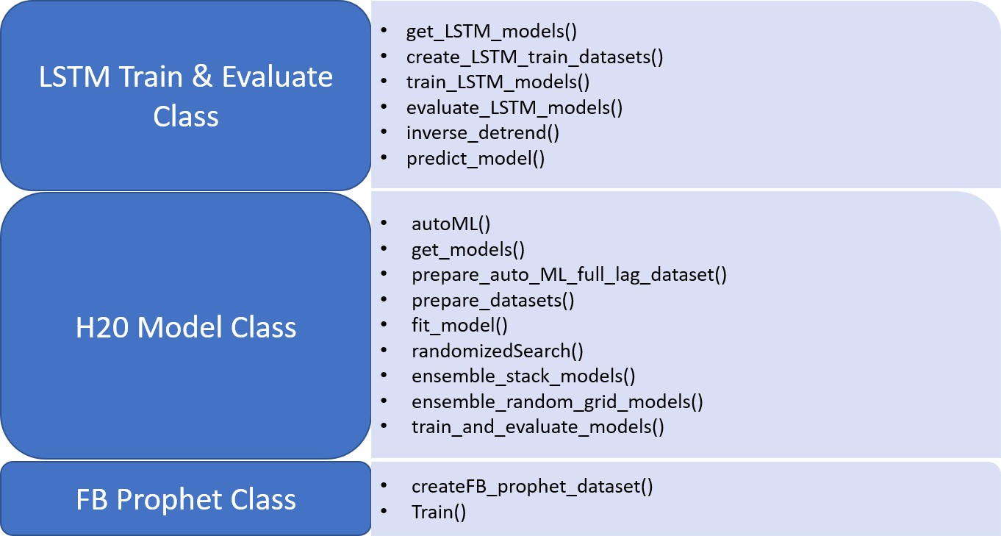

*Figure 2: Classes and functions*

# Resources needed for the project, including people, hardware, software, etc.

The resources needed for the project can be classified in to four broad categories – Information, Technology, Process and People

* + Information
    - The past data that can be used as an input for various machine learning models, after thorough pre-processing, inference and visualization of the underlying information
    - Business knowledge of what all could impact the in count of people into the Mall at various times and the degree of impact.
    - Knowledge of various tools and machine learning techniques that can be applied to be able to understand the data available better, zero down on the right machine learning models that can be applied and how to tune them to be able to predict the required parameters with the at most accuracy
  + Technology
    - Data storage at a common location accessible to all the team members
    - Python run time environments – Google Colab /Jupyter/Spyder
  + Process
    - Business Understanding
    - Project Planning and Execution
    - Resource management
      * Version Management of the code
      * Work distribution and collaboration
    - Data Collection
    - Data Pre-processing
      * Data Merger from various sources
      * Data Normalization
      * Outlier Analysis
      * Missing Values Imputation
    - Data Inference
      * Uni Variate Analysis
      * Multi Variate Analysis
      * Trend Analysis
      * Data Correlation Analysis
  + People
    - A guide to direct the team in right direction so that learnt knowledge can be applied in an efficient
    - 5-6 People with good understanding of Machine learning concepts and Python hands-on experience – preferably with Object Oriented Programming experience

# Potential data challenges & risks in doing the project

* 1. Data Challenges

Possible missing critical data or Noise Ex: An Unplanned Special Event in the Mall or a Local holiday (Un Common) not captured there by resulting in outliers/noisy data

* 1. Risks

Un availability of Data related to other Malls nearby or any other area, any major local event, promotions etc that could impact the footfall

# Detailed Plan of Work

|  |  |  |  |  |  |  |  |  |  |  |  |  |  |  |  |  |  |  |  |  |
| --- | --- | --- | --- | --- | --- | --- | --- | --- | --- | --- | --- | --- | --- | --- | --- | --- | --- | --- | --- | --- |
|  | **Week 1 and 2** | | | | | | | | **Week 3 and 4** | | | | | | | | | | | |
| **Pre Processing and Feature Engineering** |  |  |  |  |  |  |  |  |  |  |  |  |  |  |  |  |  |  |  |  |
| Understanding Data and the fields involved |  |  |  |  |  |  |  |  |  |  |  |  |  |  |  |  |  |  |  |  |
| Data Merger from Various sources - In Count Data, Holidays, Weather |  |  |  |  |  |  |  |  |  |  |  |  |  |  |  |  |  |  |  |  |
| Visualize and Impute Missing Values |  |  |  |  |  |  |  |  |  |  |  |  |  |  |  |  |  |  |  |  |
| Data Normalization and Scaling |  |  |  |  |  |  |  |  |  |  |  |  |  |  |  |  |  |  |  |  |
| Data Reshape |  |  |  |  |  |  |  |  |  |  |  |  |  |  |  |  |  |  |  |  |
| Data Encoding |  |  |  |  |  |  |  |  |  |  |  |  |  |  |  |  |  |  |  |  |
| Outlier Analysis |  |  |  |  |  |  |  |  |  |  |  |  |  |  |  |  |  |  |  |  |
| Derive Additional Data - Lags |  |  |  |  |  |  |  |  |  |  |  |  |  |  |  |  |  |  |  |  |
| **Project Documentaion** |  |  |  |  |  |  |  | |  | | | | | | | | | | | |
| **Time Series** |  |  |  |  |  |  |  |  |  |  |  |  |  |  |  |  |  |  |  |  |
| Decompose time series into trend and seasonal component |  |  |  |  |  |  |  |  |  |  |  | |  |  |  |  |  |  |  |  |
| Detrend Time series |  |  |  |  |  |  |  |  |  |  |  | | |  |  |  |  |  |  |  |
| Evaluated stationarity of the time series |  |  |  |  |  |  |  |  |  |  |  |  | | |  |  |  |  |  |  |
| Plot Time Series and Kernel Density |  |  |  |  |  |  |  |  |  |  |  |  |  | | |  |  |  |  |  |
| Augmented Dickey-Fuller Test |  |  |  |  |  |  |  |  |  |  |  |  |  |  | |  |  |  |  |  |
| **Visualization** |  |  |  |  |  |  |  |  |  |  |  |  |  |  |  |  |  |  |  |  |
| SNS/ggplot/panda |  |  |  |  |  |  |  |  |  |  |  |  |  |  |  |  |  |  |  |  |
| Categorical scatter plot with hue |  |  |  |  |  |  |  |  |  |  |  |  |  |  |  |  |  |  |  |  |
| *strip* |  |  |  |  |  |  |  |  |  |  |  |  |  |  |  |  |  |  |  |  |
| *Swarm* |  |  |  |  |  |  |  |  |  |  |  |  |  |  |  |  |  |  |  |
| Categorical distribution plots |  |  |  |  |  |  |  |  |  |  |  |  |  |  |  |  |  |  |  |  |
| *Box* |  |  |  |  |  |  |  |  |  |  |  |  |  |  |  |  |  |  |  |  |
| *violen* |  |  |  |  |  |  |  |  |  |  |  |  |  |  |  |  |  |  |  |
| *Boxen* |  |  |  |  |  |  |  |  |  |  |  |  |  |  |  |  |  |  |  |
| Categorical estimate plots |  |  |  |  |  |  |  |  |  |  |  |  |  |  |  |  |  |  |  |  |
| *Point* |  |  |  |  |  |  |  |  |  |  |  |  |  |  |  |  |  |  |  |  |
| *Bar* |  |  |  |  |  |  |  |  |  |  |  |  |  |  |  |  |  |  |  |
| *Count* |  |  |  |  |  |  |  |  |  |  |  |  |  |  |  |  |  |  |  |
| Joinplot |  |  |  |  |  |  |  |  |  |  |  |  |  |  |  |  |  |  |  |  |
| Displot |  |  |  |  |  |  |  |  |  |  |  |  |  |  |  |  |  |  |  |
| Pairplot |  |  |  |  |  |  |  |  |  |  |  |  |  |  |  |  |  |  |  |
| rugplot |  |  |  |  |  |  |  |  |  |  |  |  |  |  |  |  |  |  |  |  |
| Line plot |  |  |  |  |  |  |  |  |  |  |  |  |  |  |  |  |  |  |  |
| Numerical scatterplot |  |  |  |  |  |  |  |  |  |  |  |  |  |  |  |  |  |  |  |
| Multiple relationships with facets |  |  |  |  |  |  |  |  |  |  |  |  |  |  |  |  |  |  |  |
| **Descriptive Statistics** |  |  |  |  |  |  |  |  |  |  |  |  |  |  |  |  |  |  |  |  |
| Footfall by Year Month |  |  |  |  |  |  |  |  |  |  |  |  |  |  |  |  |  |  |  |  |
| Footfall by Day and Month |  |  |  |  |  |  |  |  |  |  |  |  |  |  |  |  |  |  |  |
| Footfall by MeanTemp |  |  |  |  |  |  |  |  |  |  |  |  |  |  |  |  |  |  |  |
| Footfall by WindSpeed |  |  |  |  |  |  |  |  |  |  |  |  |  |  |  |  |  |  |  |
| Footfall range in weekday |  |  |  |  |  |  |  |  |  |  |  |  |  |  |  |  |  |  |  |
| Footfall range by Month |  |  |  |  |  |  |  |  |  |  |  |  |  |  |  |  |  |  |  |
| **Correlation** |  |  |  |  |  |  |  |  |  |  |  |  |  |  |  |  |  |  |  |  |
| **PCA** |  |  |  |  |  |  |  |  |  |  |  |  |  |  |  |  |  |  |  |  |

*Figure 3:Execution Plan week 1 to 4*

|  |  |  |  |  |  |  |  |  |  |  |  |
| --- | --- | --- | --- | --- | --- | --- | --- | --- | --- | --- | --- |
| **Prepare for Modelling** | **Week 5** | | | | **Week 6** | | | **Week 7 and 8** | | | |
| Finalise the Metrics and Measures |  |  |  |  |  |  |  |  |  |  |  |
| Finalise the Model Tuning Techniques |  |  |  |  |  |  |  |  |  |  |  |
| Finalise the Model Parameters |  |  |  |  |  |  |  |  |  |  |  |
| Prepare Datasets for Models |  |  |  |  |  |  |  |  |  |  |  |
| **Apply Models** |  |  |  |  |  |  |  |  |  |  |  |
| Standard Regression Models |  |  |  |  |  | | |  |  |  |  |
| Standard Ensemble Models |  |  |  |  |  | | |  |  |  |  |
| LSTM Models |  |  |  |  |  | | |  |  |  |  |
| **Additional Models** |  |  |  |  |  |  |  |  |  |  |  |
| H20 |  |  |  |  |  |  |  |  | |  |  |
| AutoML |  |  |  |  |  |  |  |  | |  |  |
| FB Prophet |  |  |  |  |  |  |  |  |  |  | |
| GAN |  |  |  |  |  |  |  |  |  |  | |
| **Analyse Model Metrics** |  |  |  |  |  |  |  |  |  |  |  |
| **Project Documentaion** |  |  |  |  |  | | |  | | | |

*Figure 4: Execution Plan week 6 to 8*

# Pre-Processing steps

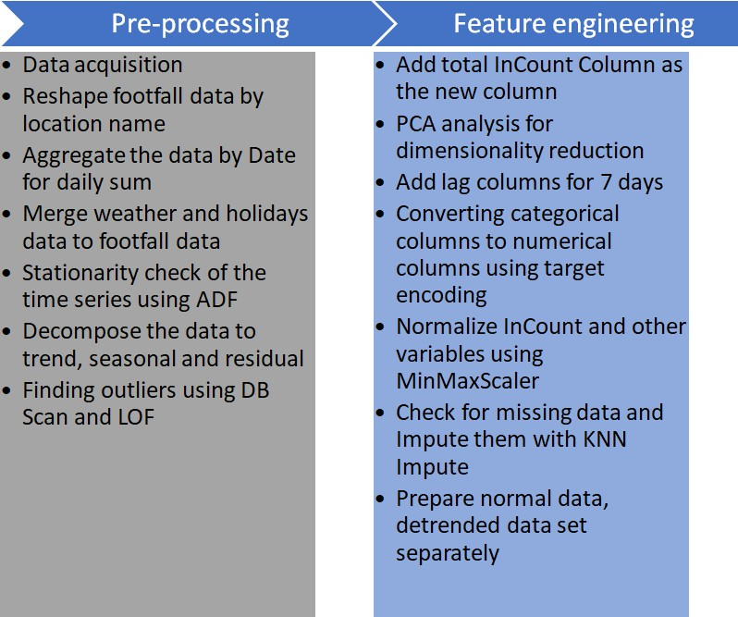

*Figure 5 Pre-processing and Feature Engineering flow*

# Data Acquisition

Data Acquisition will be useful to train correctly your training model. While acquiring the data be sure to have enough features.

The given csv file datasets are read into multiple Panda dataframes. These dataframes are kept in the common git repository and data is read from git repository rather than downloading them in local environment.

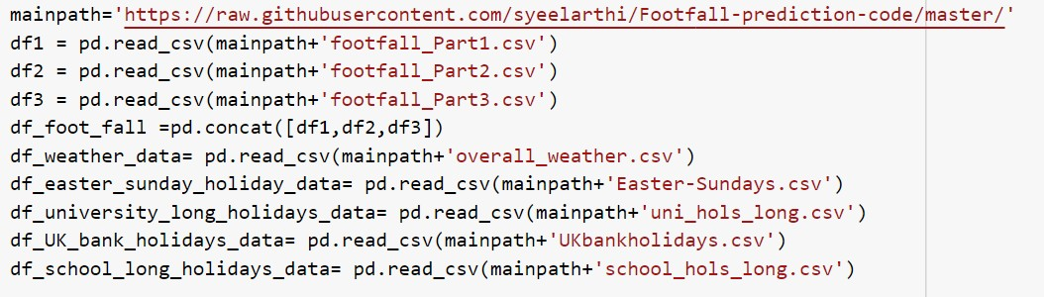

*Figure 6: Code Snippet - Reading the data to the Data Frame*

# Reshape footfall data by location name

Data set given has the hourly data for each gate, as shown below.

# Original foot fall data:

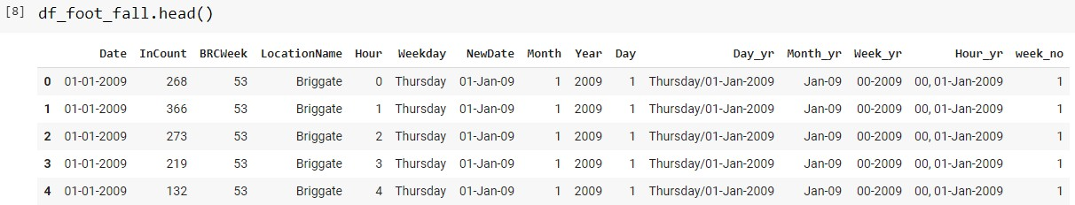

*Figure 7: Original data snapshot*

Reshape of data is done based on gate and multiple columns are created for each gate using the below code snippet.

# Data after Reshape:

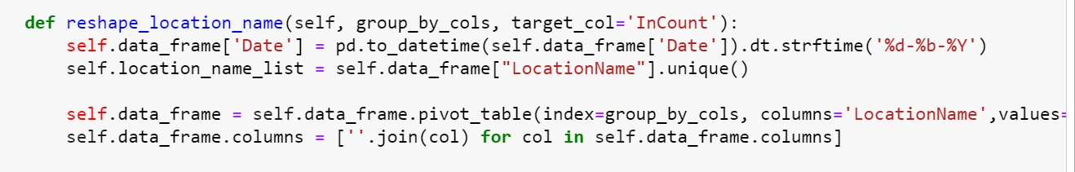

*Figure 8: Code Snippet- Data Reshape*

Below is the data set after reshaping.

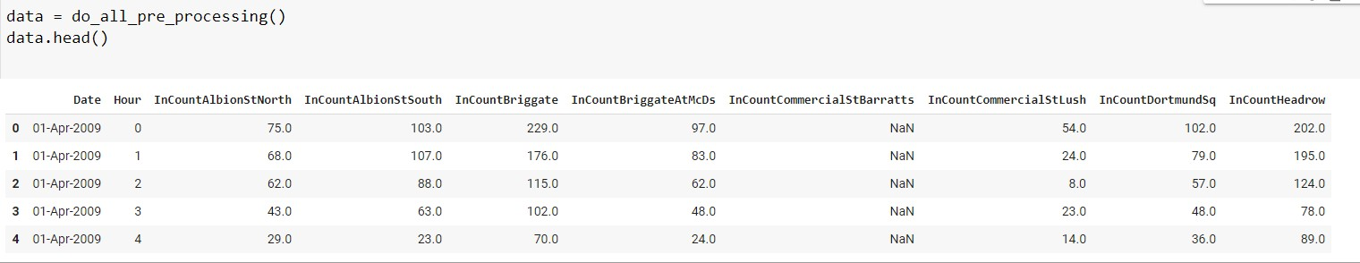

*Figure 9:Reshaped Data snapshot*

# Aggregation of Data

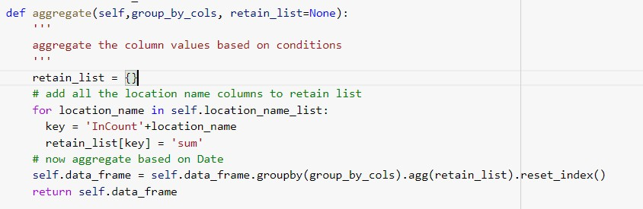Footfall data is aggregated based on Date and Hour for each gate to create a daily data. Daily data after aggregation looks like below.

*Figure 10: Code Snippet - Data Aggregation*

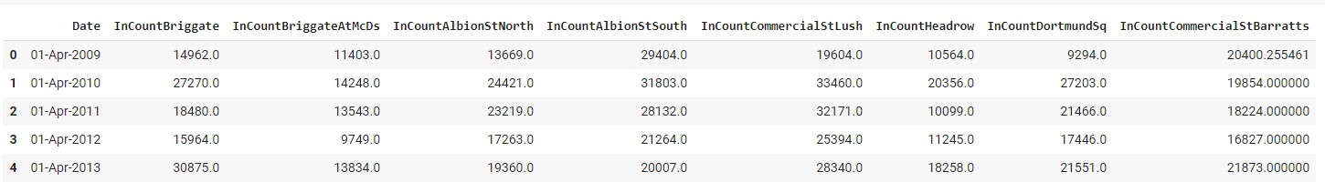

*Figure 11: Aggregated Data Snapshot*

# Merge of Weather and Holidays data to footfall data

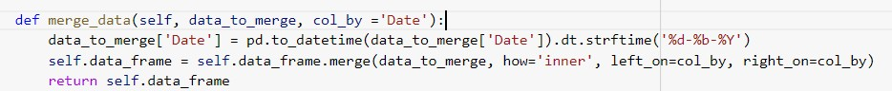Weather and holiday data are merged with the above aggregated data based on date and created a full data set as below.

*Figure 12: Code Snippet - Data Merge*

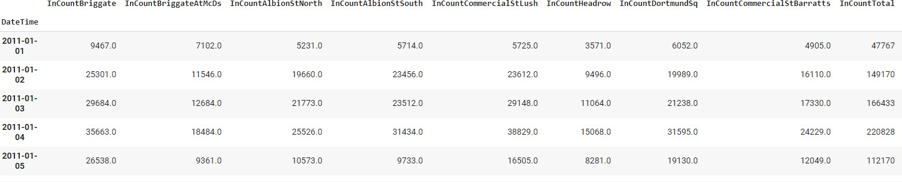

*Figure 13: Data Merge Snapshot*

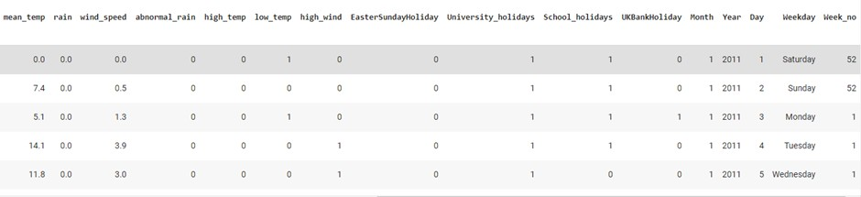

*Figure 14: Data Merge Snapshot*

# Normalize the data

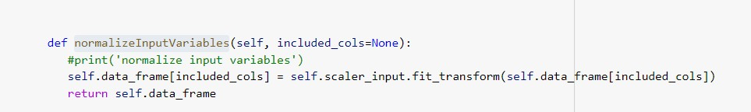Normalization refers to rescaling real valued numeric attributes into range of 0 and 1. Here MinMaxScaler() is used for normalization of data set attributes.

*Figure 15: Code Snippet - Normalize Data*

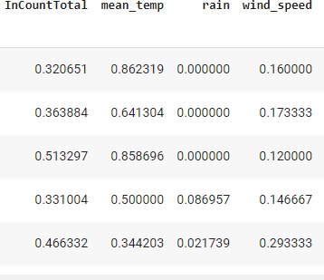

*Figure 16: Normalize Data set*

# Derive new columns

The following new columns are created:

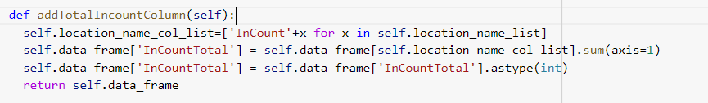InControl is derived as the sum of InCount of all locations.

*Figure 17: Code Snippet - Derive New Columns*

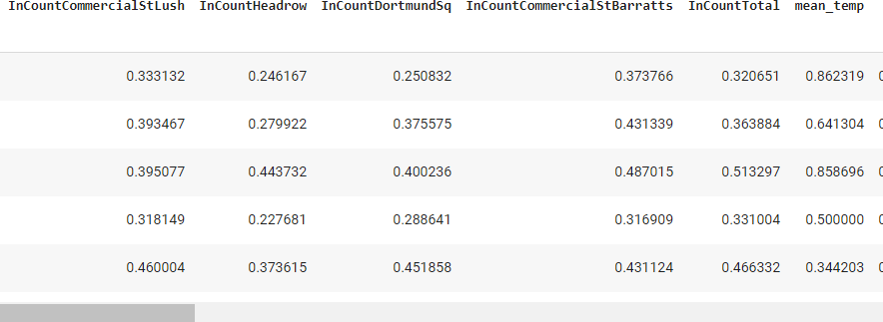

*Figure 18: Derive New Columns Data set*

Lag columns: 7 lag columns are created to use for supervised learning – previous 7 days of InCount is used as the Incount of these lag columns.

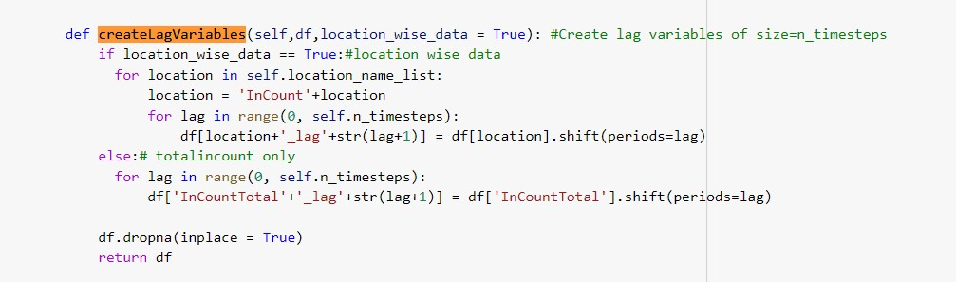

*Figure 19: Code Snippet - Lag Columns*

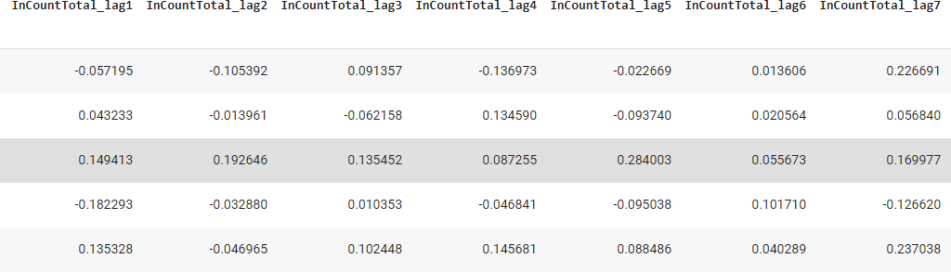

*Figure 20: InControl Target Column*

Target column: The target column is shifted by 1 day.

# Conversion of Categorical columns to numerical columns

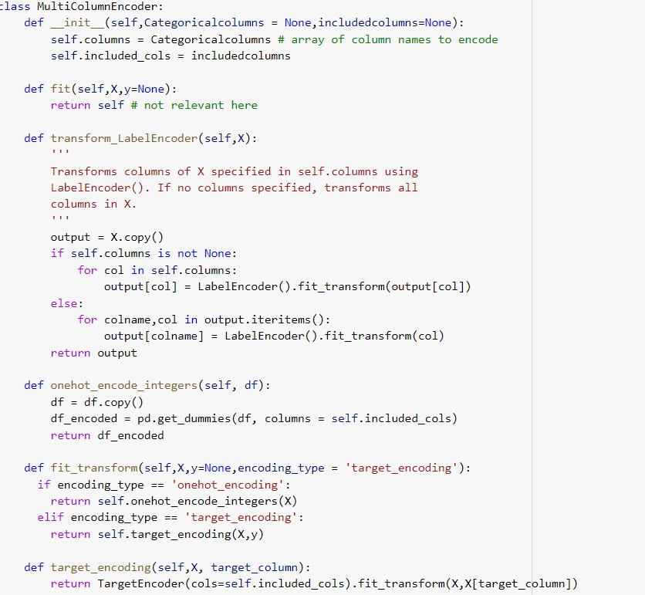Target Encoding is used to convert multi-class categorical values to numerical values. Target encoding encodes the categorical values based on their distribution against the target variable.

*Figure 21: Code Snippet - Encoding*

# Before Target Encoding:

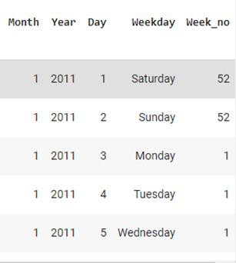

**After Target Encoding:**

*Figure 22: Before Target Encoding*

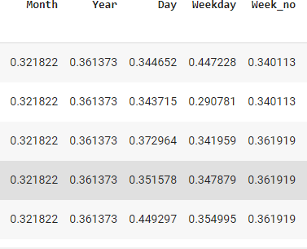

*Figure 23: After Target Encoding*

# Stationarity check

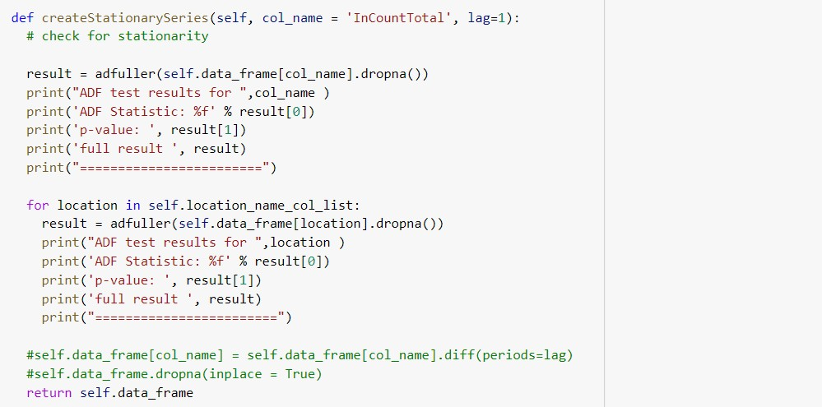ADF (Augmented Dicky-Fuller) test is used to determine if the given the dataset is stationary.

*Figure 24: Code Snippet - Stationary Check*

ADF test results for InCountTotal ADF Statistic: -7.638551

p-value: 1.9231439534300742e-11

full result (-7.638551478845224, 1.9231439534300742e-11, 28, 2869, {'1%': -

3.4326313386090552, '5%': -2.8625479402718623, '10%': -2.5673065559730883},

70040.73650505886)

# Inference: Since p-value is << 0.05, we can Cleary deduce that the given series is stationary.

* 1. **Decomposition of data**

Decomposition of data to seasonality, trend, and residue using seasonal decompose from stats models. Both Additive decompose and multiplicative decompose are applied.

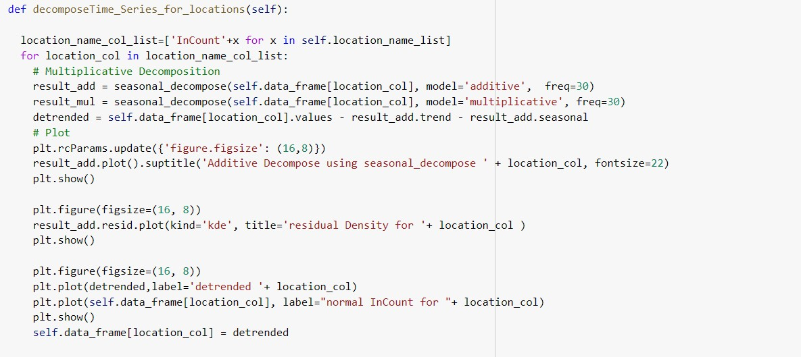

*Figure 25: Code Snippet - Decompose Time Series*

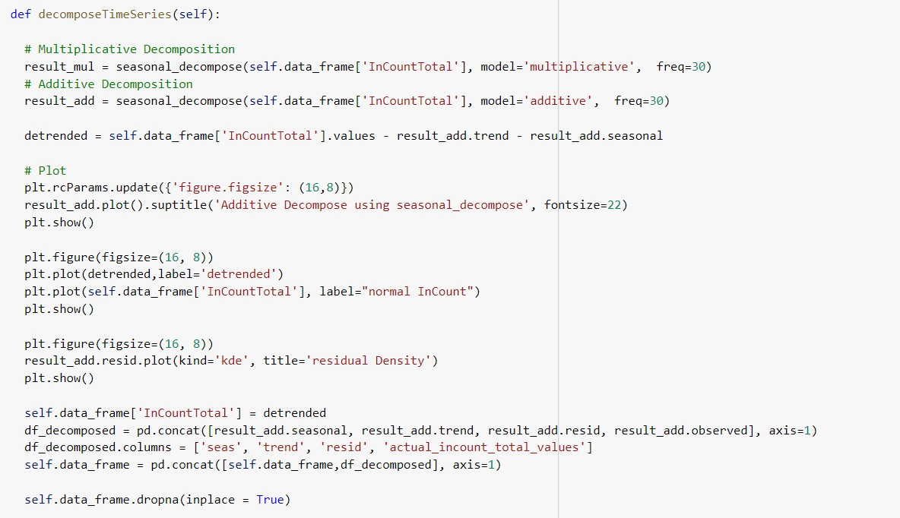

*Figure 26: Code Snippet Seasonal Decompose*

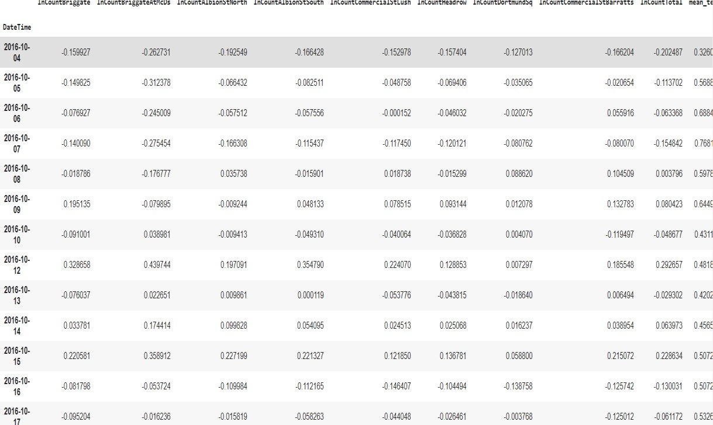

*Figure 27: Detrended Data Set*

# Outlier detection

Outlier Analysis is done using two techniques DB Scan and LOF.

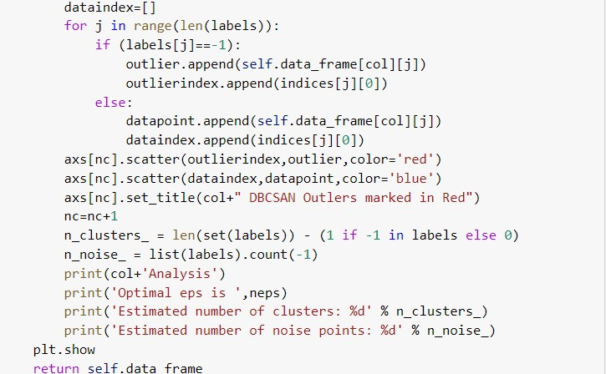

*Figure 28: Code Snippet DBS can*

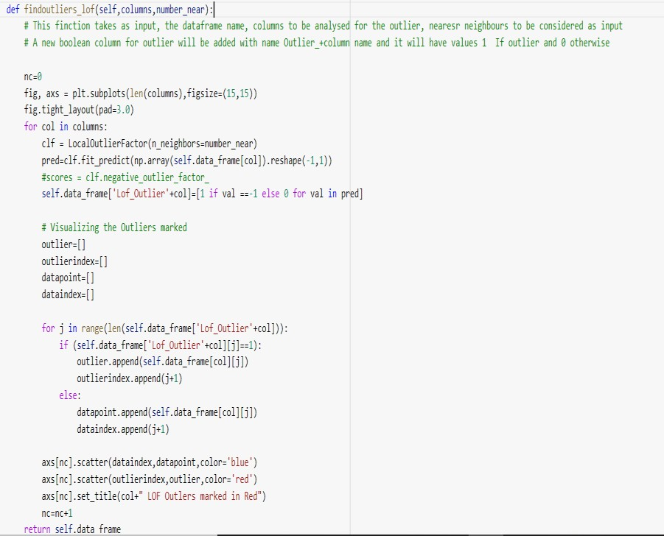

*Figure 29: Code Snippet LOF*

LOF was able to identify more outliers compared to DBSCAN, as the outliers are searched based on Local density. Since this seems more relevant to domains like medicine etc, LOF is not considered for further Analysis.

DBSCAN on InCountTotal was able to identify 19-line items as Outliers. On detailed analysis of these dates,

* + Out of the 19 outliers, 13 are either Christmas Day, New Year or Easter Sunday, with very low total InCountTotal.
  + Out of remaining 6, 5 are Saturdays and 3 of them are immediate weekend after the Thanksgiving Day
  + For the years where the immediate weekend after the Thanksgiving is not identified as Outlier, the InCountTotal is still significantly high and are close to be marked as Outliers



*Figure 30: DBSCAN on Incount Total*

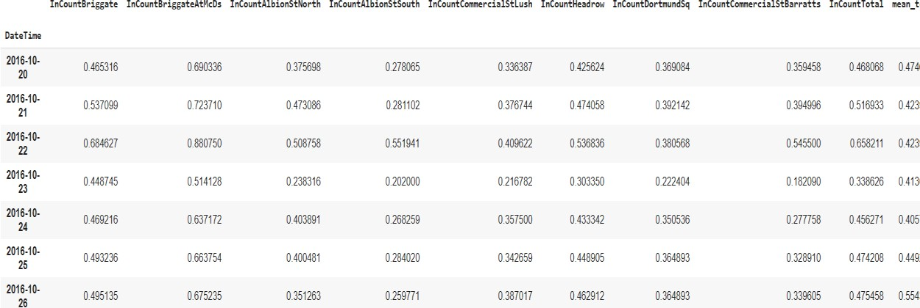

*Figure 31: Outlier Removed Data Snapshot*

# PCA analysis for dimensionality reduction

Principal component Analysis of all the features is done. For various percentage of variance retained. A separate Data set with principal components retaining 90% of the variance is retained. 11 principal components were able to retain 90% of variance

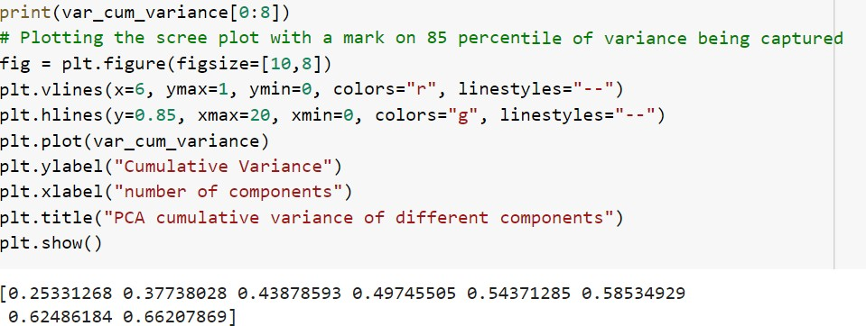

*Figure 32: Code Snippet PCA*

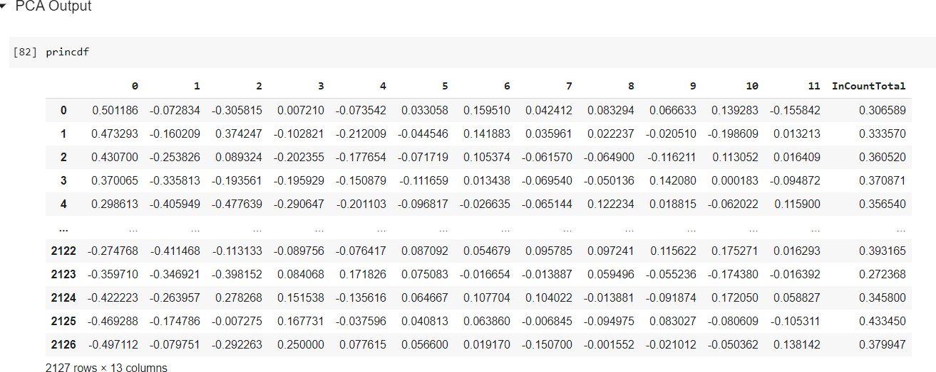

*Figure 33: PCA Output Data Set*

A detailed Analysis of contribution of each feature to the Principal components were done.

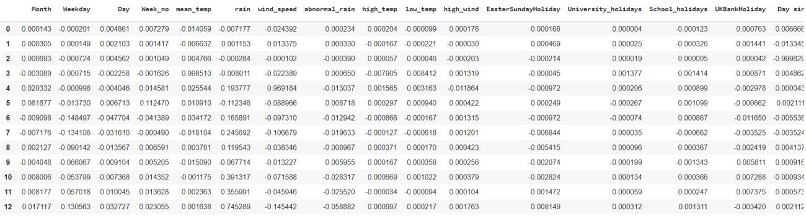

*Figure 34: Contribution of Each Feature for Principal Components*

On taking the absolute value of these numbers and sorting in increasing order for each Principal component, the feature importance (Top 10 features shown) obtained is as below.

|  |  |  |  |  |  |  |  |  |  |  |  |  |  |
| --- | --- | --- | --- | --- | --- | --- | --- | --- | --- | --- | --- | --- | --- |
| **Component** | **0** | **1** | **2** | **3** | **4** | **5** | **6** | **7** | **8** | **9** | **10** | **11** | **12** |
| **InCountTotal_lag7** | 0.985591 | 0.161999 | 0.00433 | 0.014502 | 0.019622 | 0.039503 | 0.009263 | 0.00193 | 0.000226 | 0.001273 | 0.000653 | 0.000912 | 0.002364 |
| **InCountTotal_lag6** | 0.160914 | 0.986276 | 0.014242 | 0.003854 | 0.013477 | 0.026341 | 0.01508 | 0.001363 | 0.002531 | 0.000247 | 0.001979 | 0.00152 | 0.000829 |
| **InCountTotal_lag5** | 0.024392 | 0.013375 | 0.000102 | 0.022389 | 0.969184 | 0.088966 | 0.09731 | 0.106679 | 0.038346 | 0.013227 | 0.071588 | 0.045946 | 0.145442 |
| **Month** | 0.017557 | 0.000763 | 0.003096 | 0.018843 | 0.026625 | 0.337377 | 0.423583 | 0.101102 | 0.265805 | 0.455901 | 0.553784 | 0.131204 | 0.248726 |
| **Weekday** | 0.016903 | 0.003636 | 0.003004 | 0.00667 | 0.068061 | 0.373096 | 0.194885 | 0.414601 | 0.433353 | 0.003915 | 0.507303 | 0.306458 | 0.286841 |
| **Day** | 0.01658 | 0.004022 | 0.005261 | 0.007251 | 0.055826 | 0.27174 | 0.582932 | 0.490645 | 0.264797 | 0.220202 | 0.094571 | 0.148701 | 0.332502 |
| **Week_no** | 0.015575 | 0.006697 | 0.003204 | 0.007817 | 0.044162 | 0.394432 | 0.065754 | 0.423183 | 0.255128 | 0.577168 | 0.051063 | 0.363825 | 0.318493 |
| **mean_temp** | 0.014153 | 0.010143 | 0.003292 | 0.005108 | 0.070435 | 0.375083 | 0.254902 | 0.090114 | 0.627361 | 0.287779 | 0.165579 | 0.457038 | 0.209102 |
| **InCountTotal_lag4** | 0.014059 | 0.006632 | 0.004766 | 0.99851 | 0.025544 | 0.01091 | 0.034172 | 0.018104 | 0.003781 | 0.01509 | 0.001175 | 0.002363 | 0.001638 |
| **rain** | 0.013086 | 0.008832 | 0.001685 | 0.007989 | 0.045212 | 0.322717 | 0.046819 | 0.007306 | 0.03516 | 0.007327 | 0.031206 | 0.004686 | 0.005326 |

*Figure 35: PCA on full data Top 10 features*

From the PCA analysis, it is seen that InCountTotal_lag7 has the highest co-efficient value for principal component 0 (which is the most important principal component). Therefore, we can deduce that InCountTotal_lag7 is the most important feature from variance perspective. In addition, since the dataset is not linear, dataset after PCA may not work well for modelling. This will be verified during the model analysis.

# Missing value detection and imputation

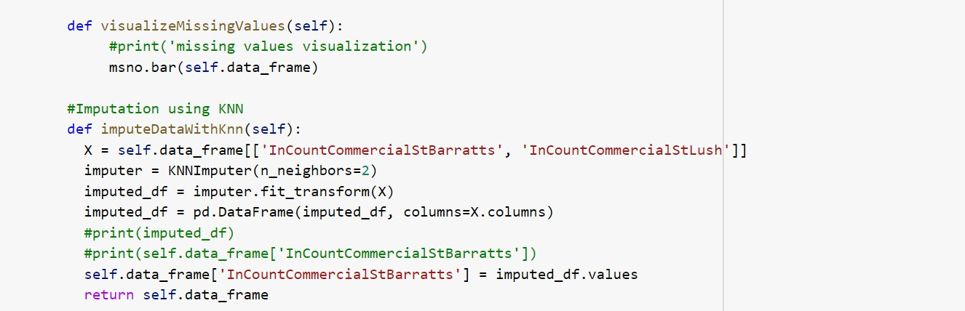Based on the missing no library it is visualized that there are only 2 missing values for the gate CommercialStBarratts. As this gate has some correlation with CommercialStLush we have imputed the values using the KNNImputer.

*Figure 36: Code Snippet Missing Values*

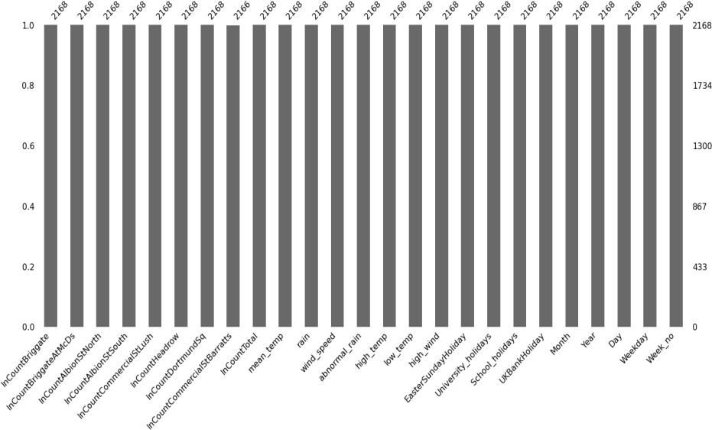

*Figure 37: Visualization of Missing Values*

The incount entries are missing for CommercialStBarrats for the dates 13th Aug and 30th Nov 2014. This could be for two reasons. 1) The data may not have been captured due to some technical glitch/typo or a mistake. 2) The data could be correct and the gates could be closed for some reason like renovation etc. There is no significant increase in incount for other gates during these dates. Hence it is assumed to be a possible mistake/Typo and mean imputation is done. This is also purely for learning purpose as the number of missing values are insignificant and the incountTotal is the actual target variable.

# Visualization for Summarization

The visualization of trend in the data, seasonality, residue, comparison of actual and detrended data, visualization of the Outliers using DB SCAN and LOF, visualization of PCA are done using various plots.

|  |  |
| --- | --- |
|  | **Technique:** decomposition using seasonal_decompose **Stage Used**: After Normalising the data, applied on  InCountTotal.  **Purpose**: To understand the trend and seasonality in the dataset  **Data**: InCount data **Inference**: 1) there is no clear trend visible 2) seasonality is visible **Action Taken**: created a separate dataset after detrending. |
| C:\Users\ed\AppData\Local\Microsoft\Windows\INetCache\Content.MSO\F3212757.tmp | **Technique:** detrending using seasonal_decompose **Stage Used**: after decomposition of the data.  **Purpose**: To remove trend and seasonality **Data**: InCount data **Inference**: after detrending, the data becomes zero mean centred.  **Action Taken**: created a separate dataset for detrending. |

|  |  |
| --- | --- |
|  | **Technique:** DBSCAN **Stage Used**: After Normalising the data, applied on the entire dataset.  **Purpose**: To understand outliers in the data **Data**: all the data variables  **Inference**: only 2 points are outliers. They also don’t seem to real far outlies  **Action Taken**: Retain those points in the dataset |
|  | **Technique:** LOF  **Stage Used**: After Normalising the data, applied on the entire dataset.  **Purpose**: To understand outliers in the data **Data**: all the data variables  **Inference**: many points are shown as outliers, but all are based on local reachability density. In our specific business context, the LOF doesn’t seem applicable  **Action Taken**: Retain those points in the dataset |

|  |  |
| --- | --- |
| C:\Users\ed\AppData\Local\Microsoft\Windows\INetCache\Content.MSO\E009693.tmp | **Technique:** PCA  **Stage Used**: PCA was done towards the end of pre-processing step.  **Purpose**: To understand how many principal components give maximum variance **Data**: all the data variables  **Inference**: 85% variance can be preserved with 6 principal components and 90% can be preserved with 11 principal components **Action Taken**: Since we don’t have too many number of variables, we don’t intend to use PCA to reduce the dimensions |

# Machine Learning Modelling & Techniques Applied

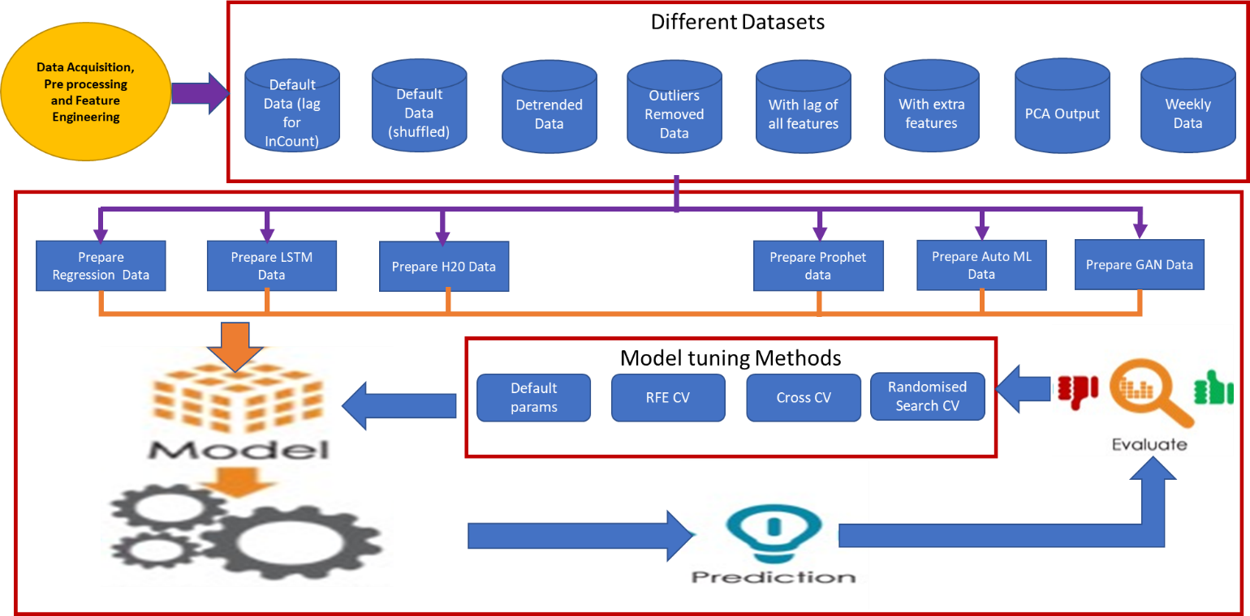Model training flow is depicted in the below diagram.

*Figure 38: Model training and evaluation flow*

Different types of regression models were created including standard regression models, ensemble models, LSTM models, H2O models, AutoML models and FB prophet model. We also experimented with GAN model to check how discriminator and generator models can fool each other to make accurate predictions. The models are listed below.

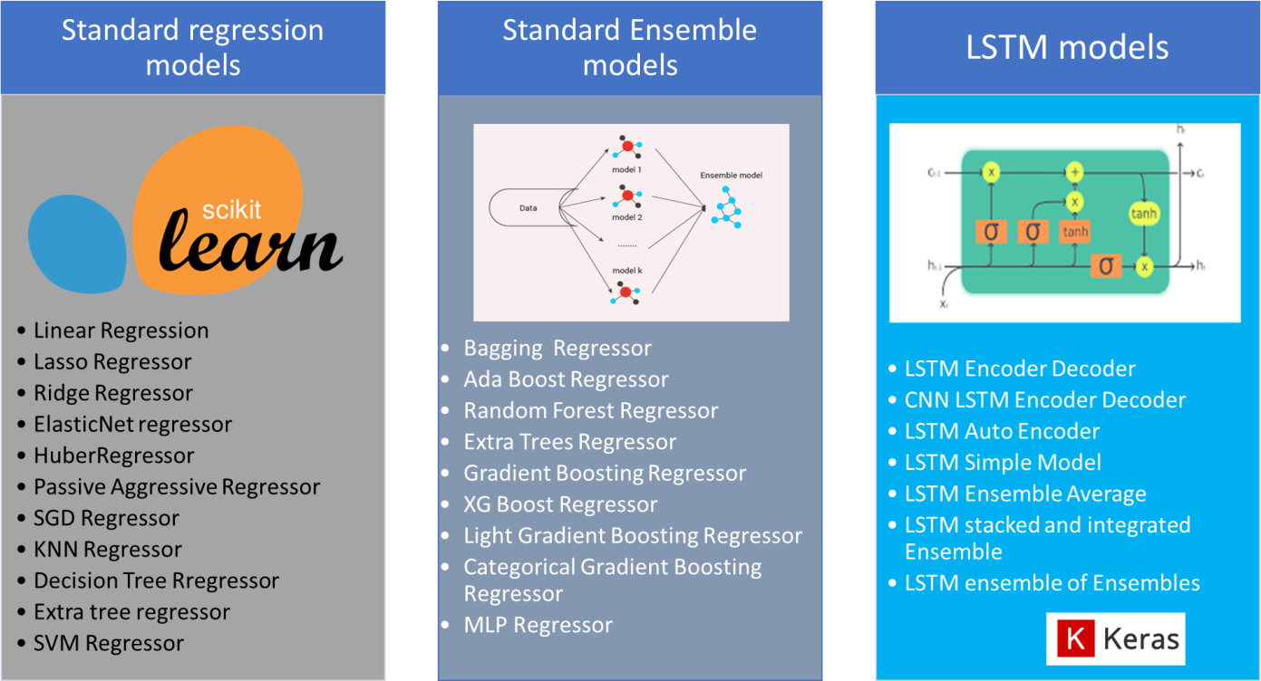

*Figure 39: List of models (1)*

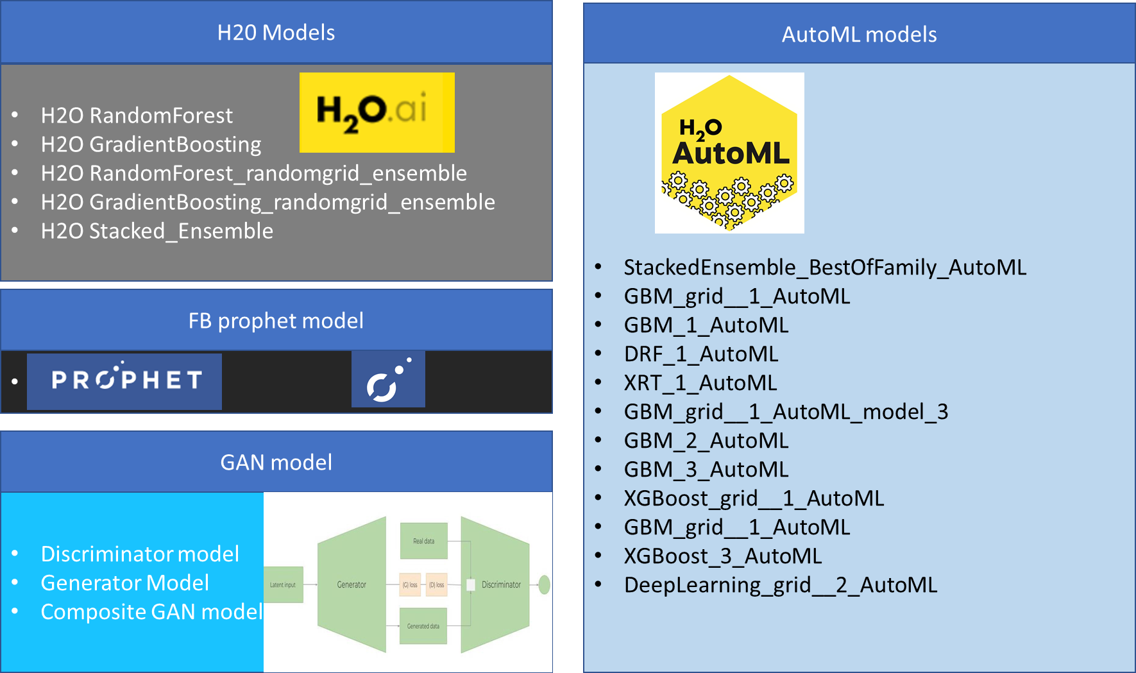

*Figure 40: List of Models (2)*

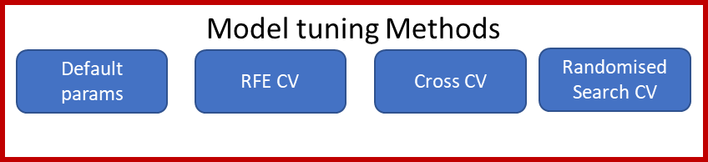For each of these models, different techniques were used to conduct the model tuning.

*Figure 41: Model tuning methods*

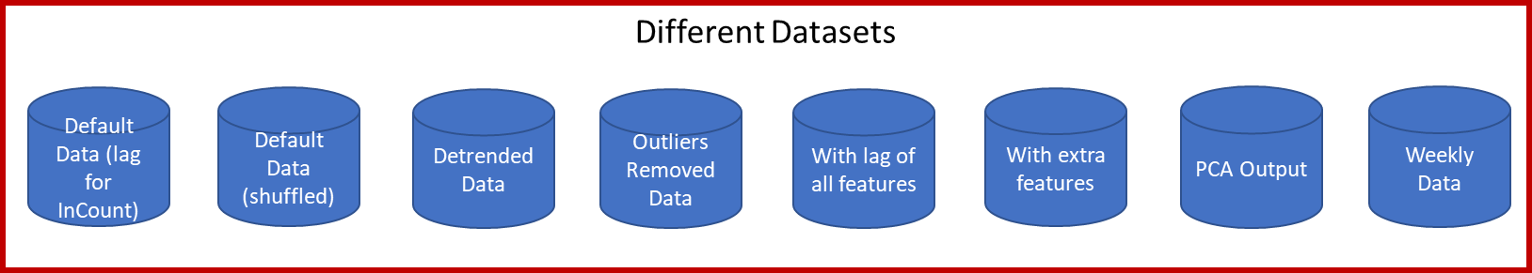Different types of datasets were created to check performance of various models.

*Figure 42: Datasets used for modelling*

During the process of model creation, 656 models were created and trained.



# Standard Regression models

The below linear, non-linear and ensembles models were created during the modelling phase.

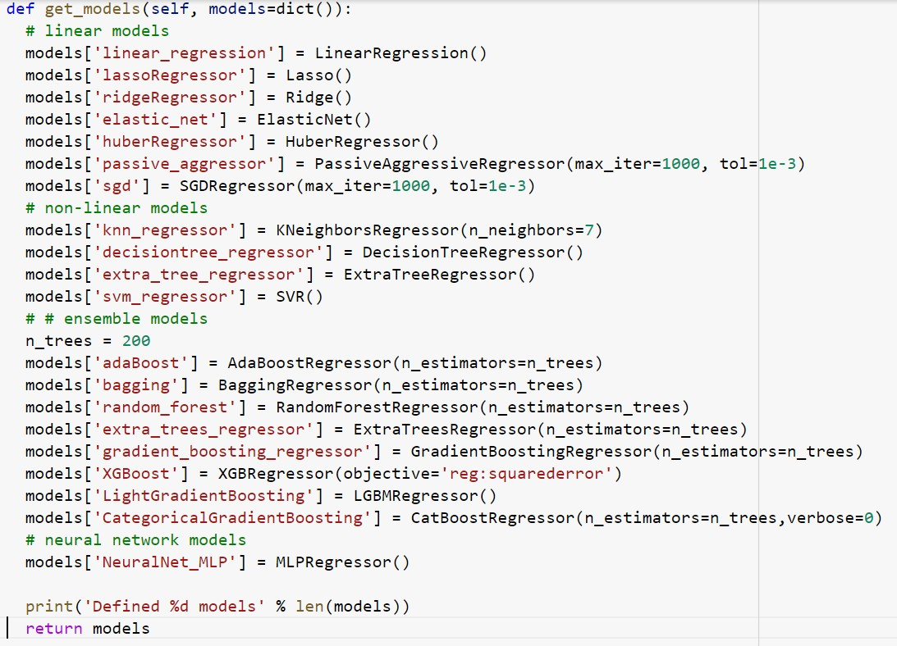

All the models were trained using the below techniques:

* + Using default parameters for the models
  + Hyperparameter tuning with RandomizedSearchCV

All the 20 models were trained with different combinations of hyperparameters Example of hyperparameters:

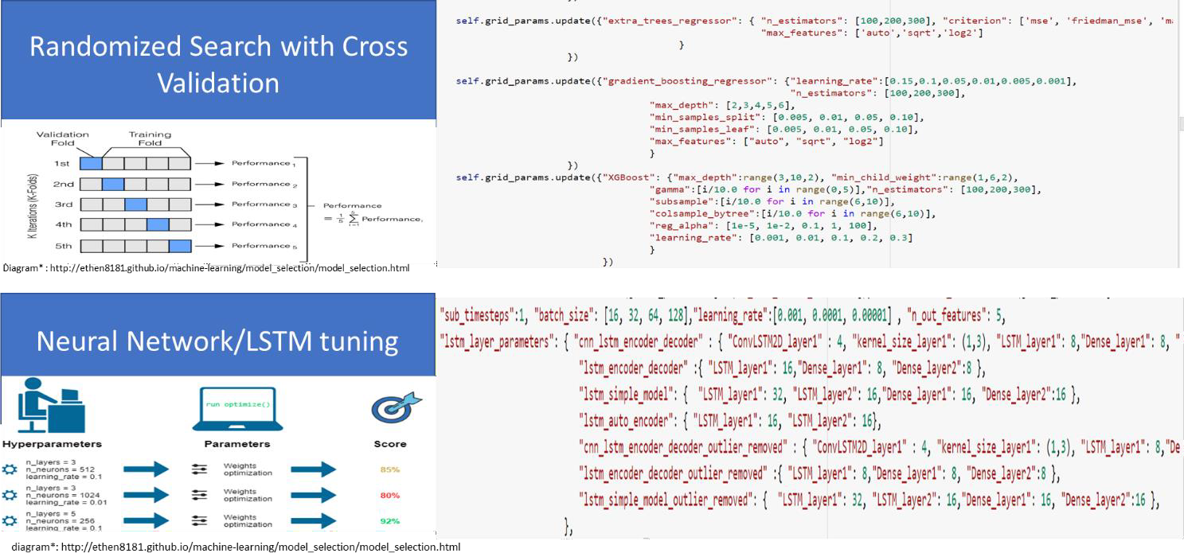

*Figure 43: Hyper parameter tuning*

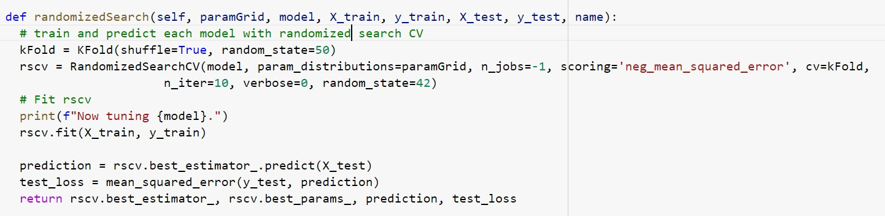

# Cross Validation technique

Cross validation and cross_val_predict were applied on all models to get the most generalized models.

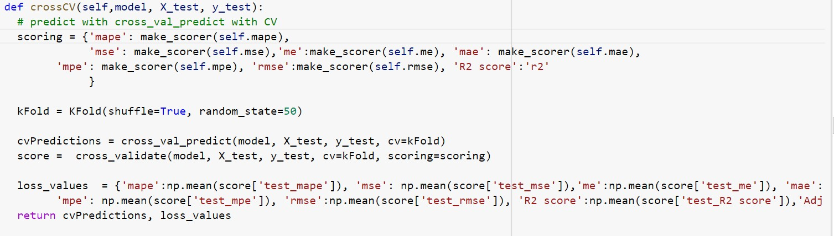

# RFE (Recursive Feature Elimination) CV technique

RFE CV technique was used to eliminate the not important features and find the most optimal set of features

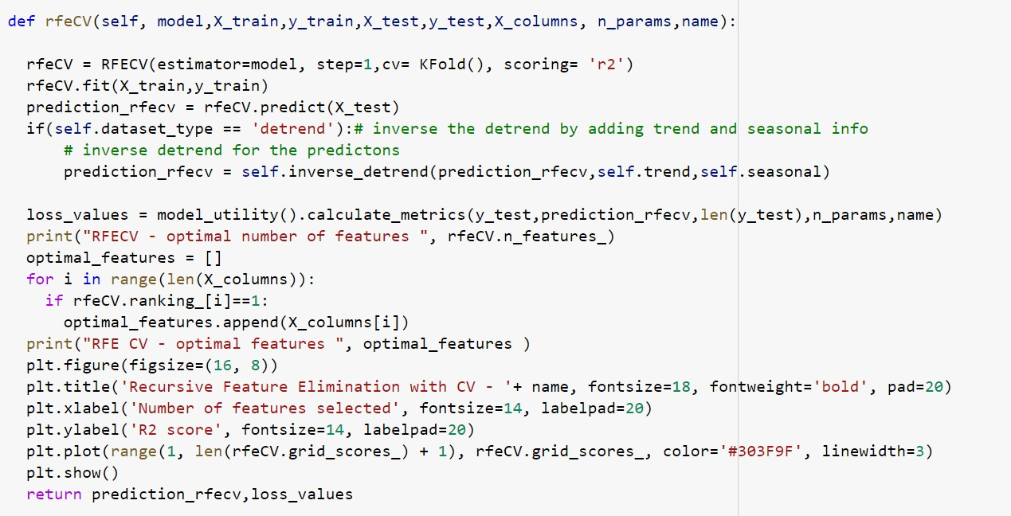

# Example of feature elimination for extra trees regressor:

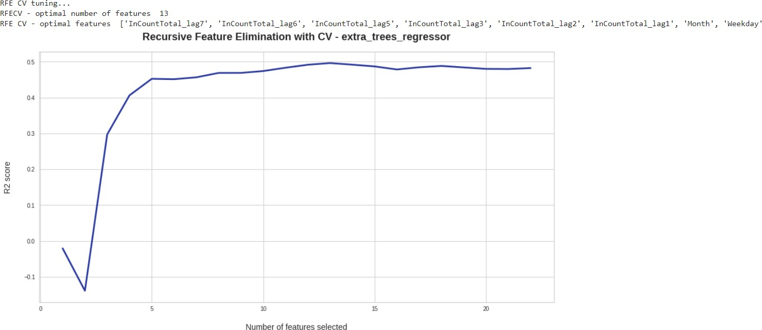

*Figure 44: Recursive feature elimination*

# Feature Importance:

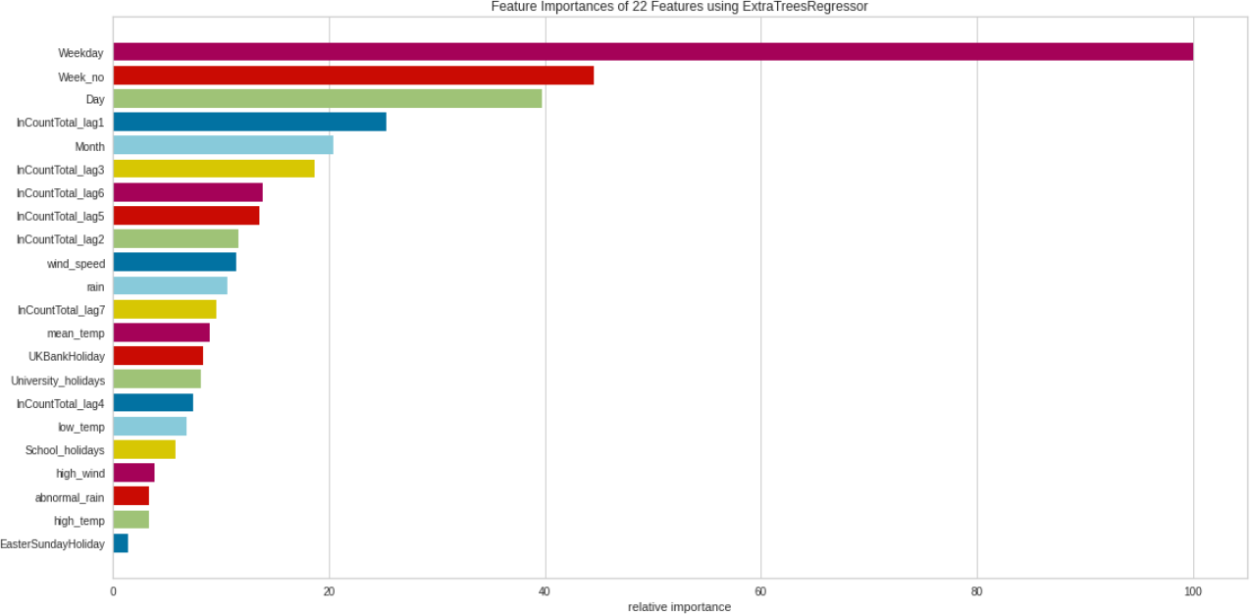

*Figure 45: Feature importance using normal dataset*

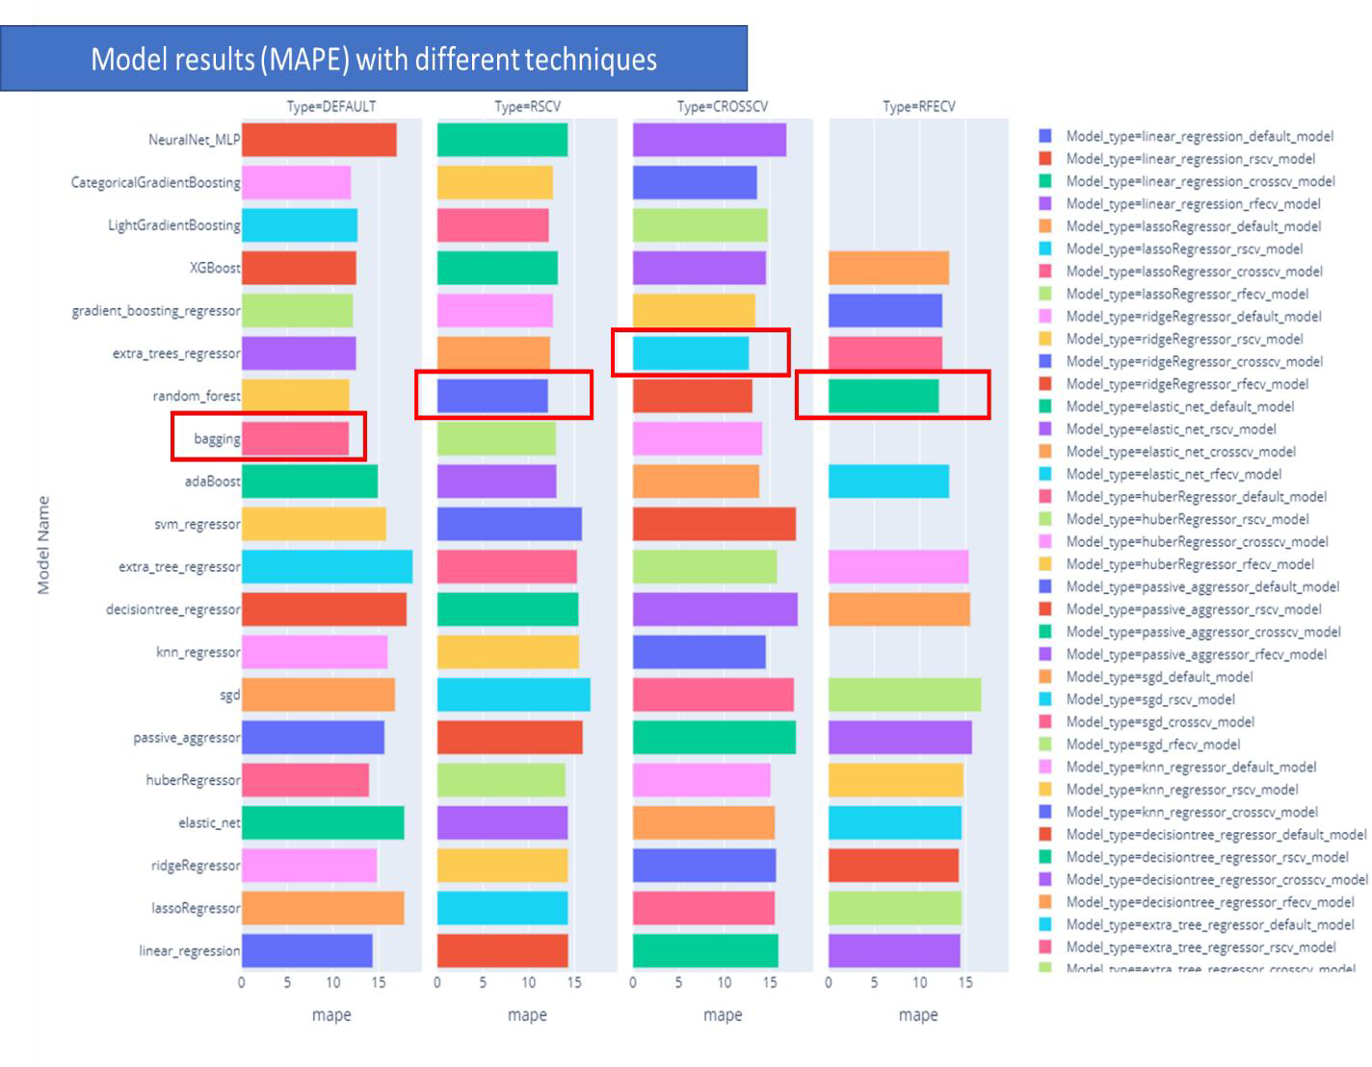

Best models

*Figure 46: Model results (MAPE) with different model tuning techniques*

From the above diagram, we can see that Random Forest performs best with Randomized Search CV and RFE CV. Extra Trees Regressor performs the best with Cross CV. Bagging performs best with default parameters

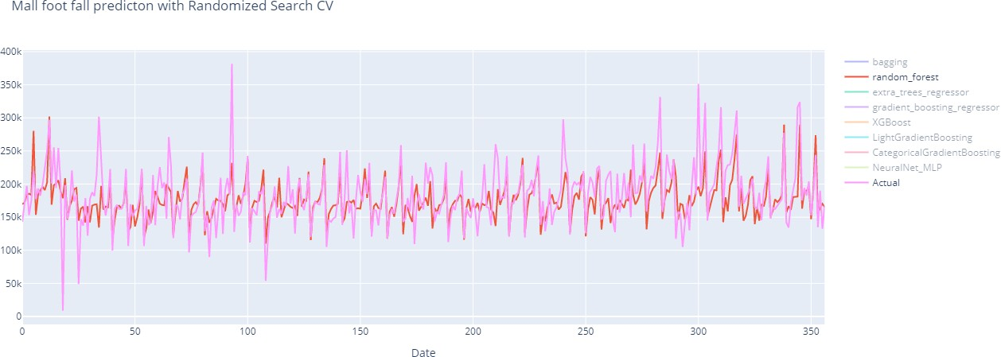

# Models with normal dataset

The above 20 regression models were trained using normal data (without removing outliers). 20 models were created using all the above 4 techniques (Default parameters, RandomizedSearchCV, CrossCV and RFECV)



*Figure 47: Model prediction using Normal dataset*

# Top models from this set of models:

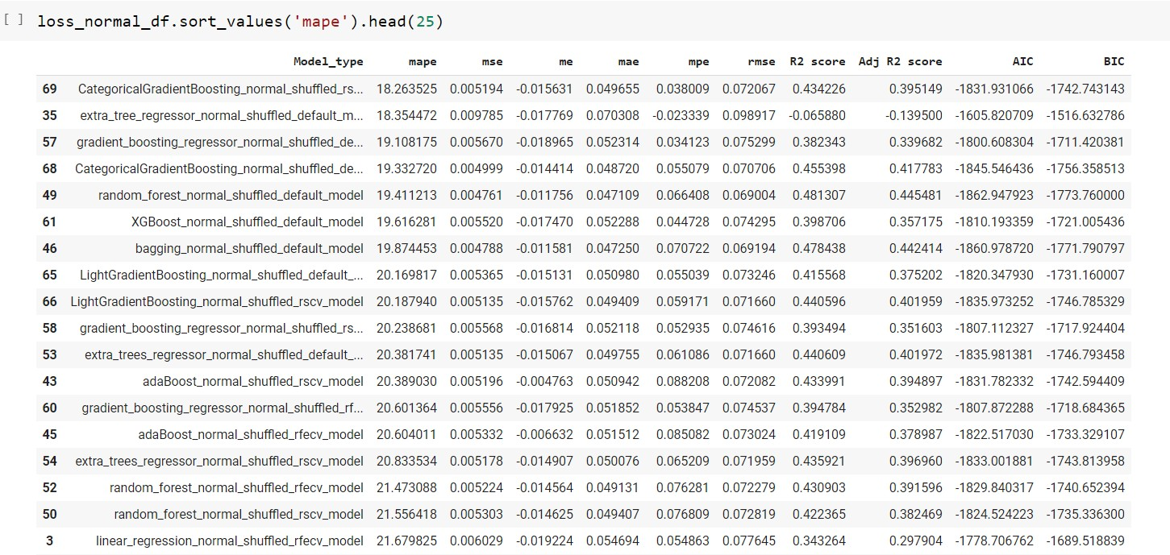

*Figure 48: Model metrics on Normal dataset*

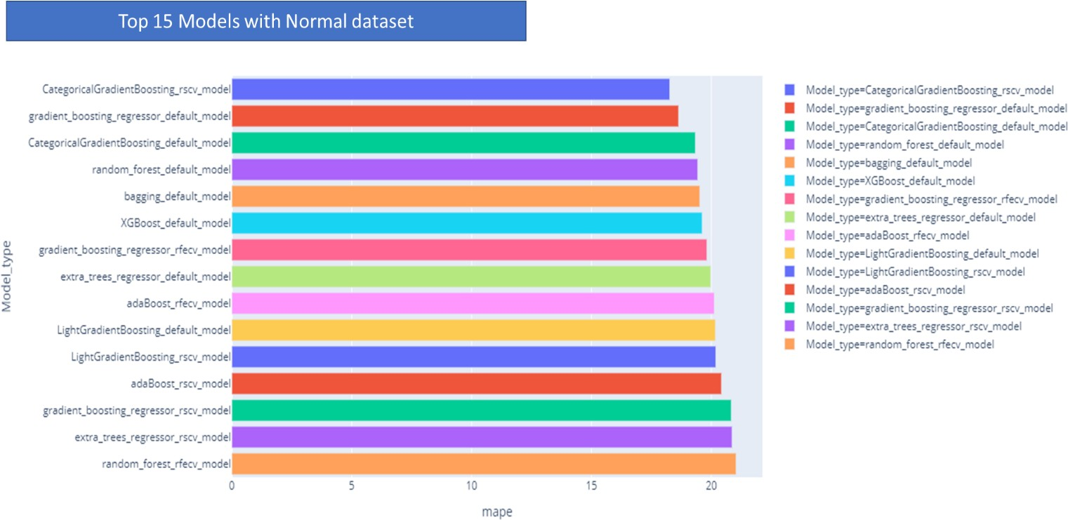

*Figure 49: Top 15 models (MAPE) with normal dataset*

# Models with detrended data

In this set, the models were trained with detrended data – trend and seasonality removed.

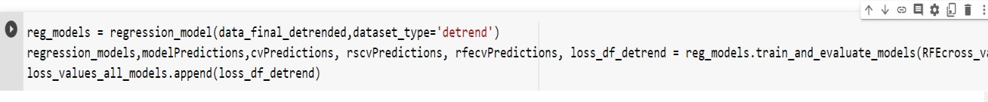

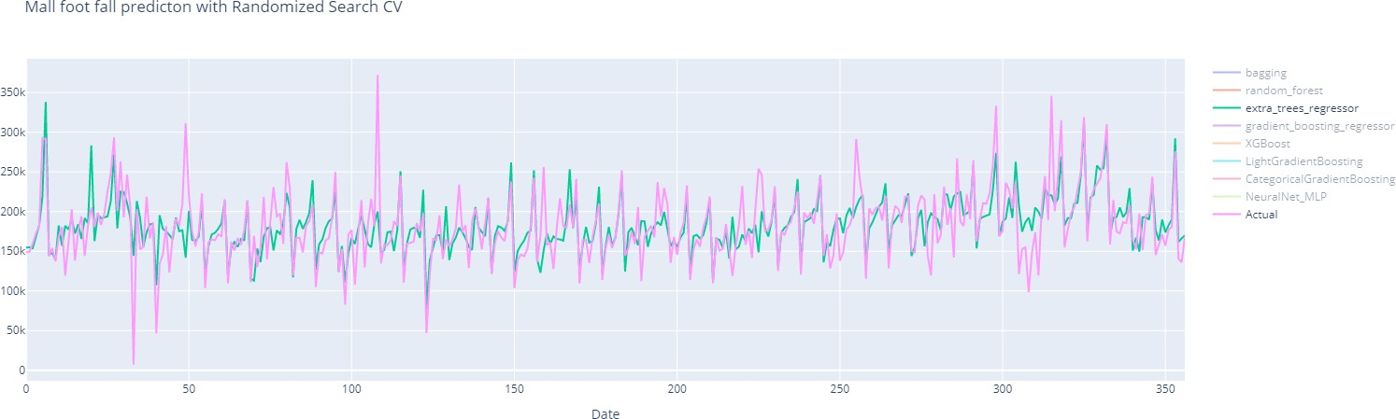

*Figure 50: Model prediction using detrended dataset*

# Top models from this set of models:

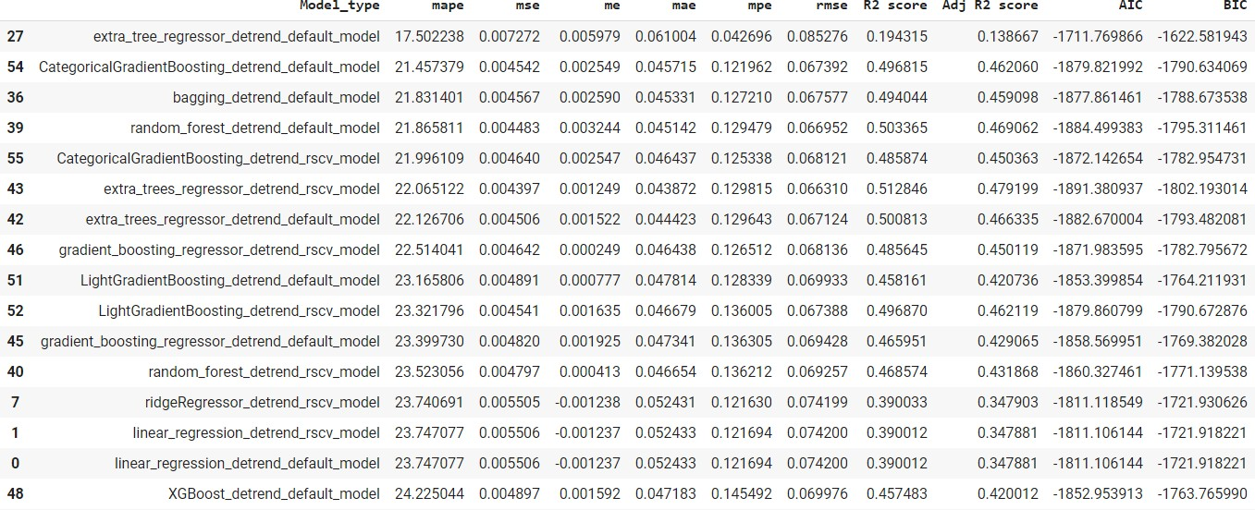

*Figure 51: Model metrics on detrended dataset*

# Models with outlier removed data

In this set of models, the models were created with dataset after removing the outliers



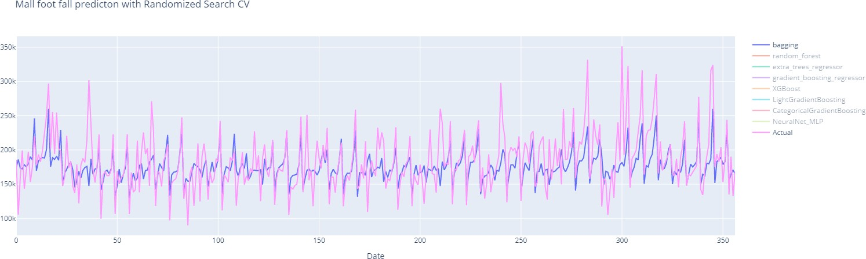

*Figure 52: Model prediction with outlier removed dataset*

Top models from this set of models:

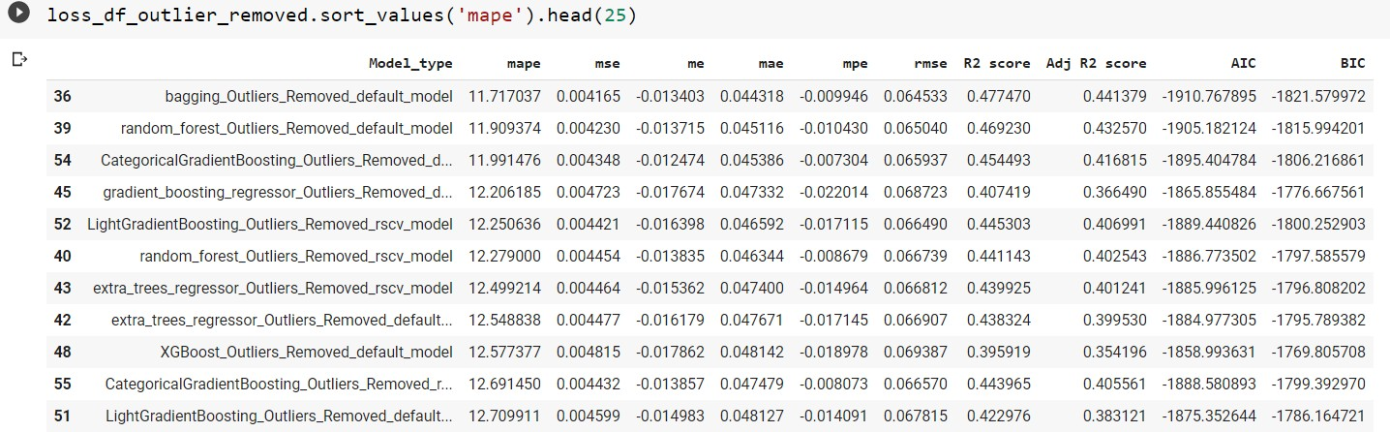

*Figure 53: Model Metrics using outlier removed data*

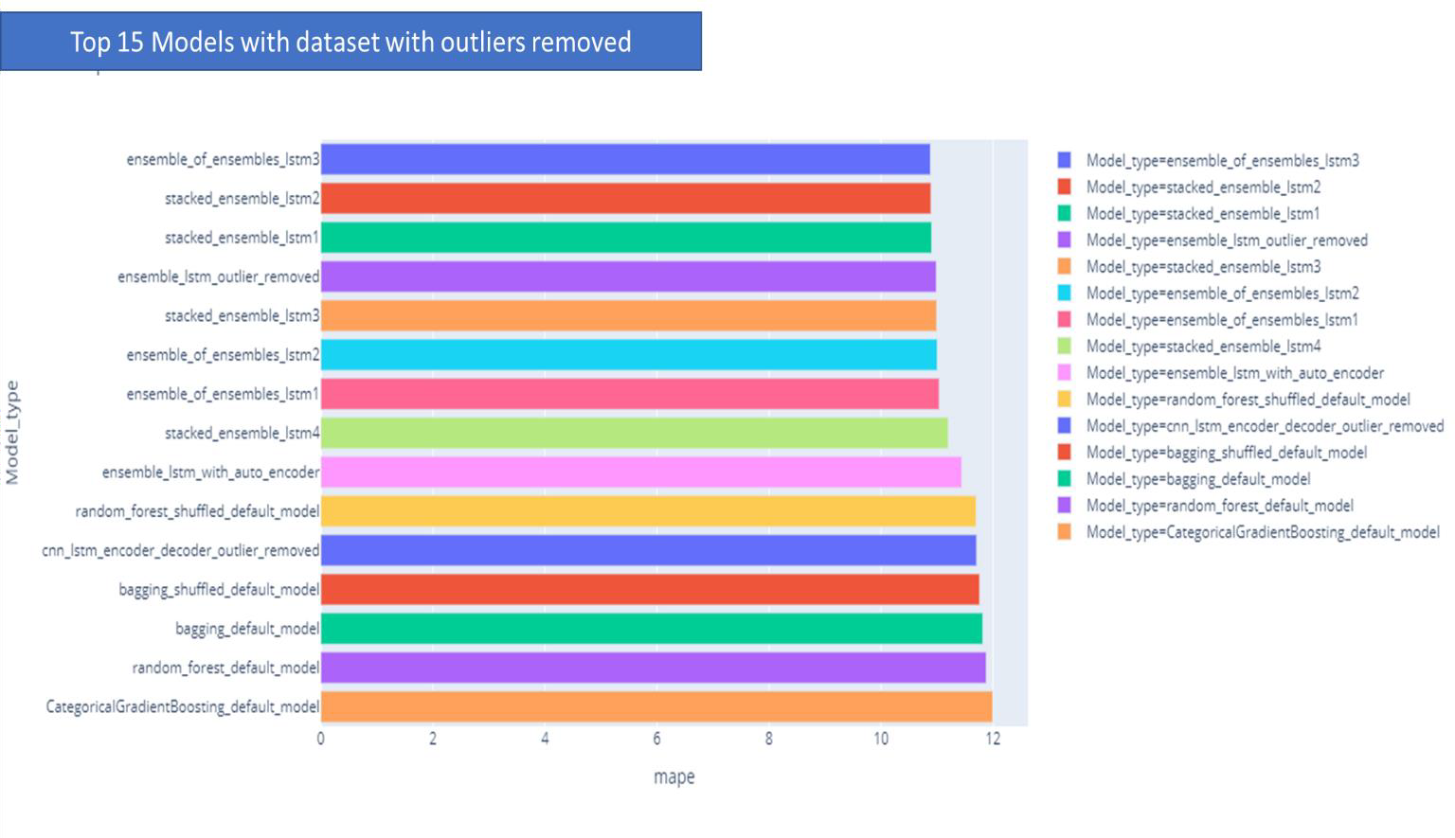

*Figure 54: Top 15 models (MAPE) with dataset with outliers removed*

# Models with extra features

In this set of models, the dataset had extra derived features like rolling_mean, trend and seasonality, date specific derived features.



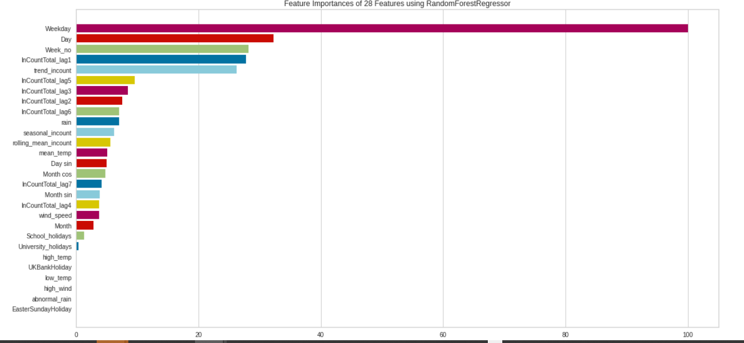

*Figure 55: Feature importance with extra features*

# Model prediction with Categorical Gradient Boosting:

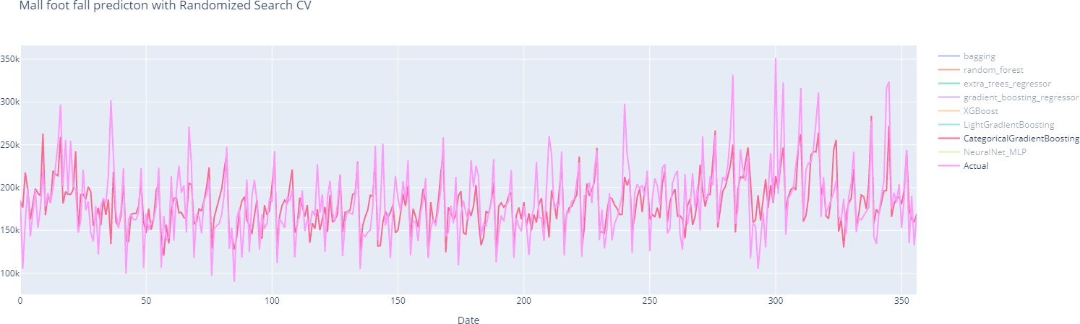

*Figure 56: Model prediction with extra features*

# Models with PCA reduced features

The features were reduced to 12 features with 99% variance preserved. This dataset was used to create a new set of models.



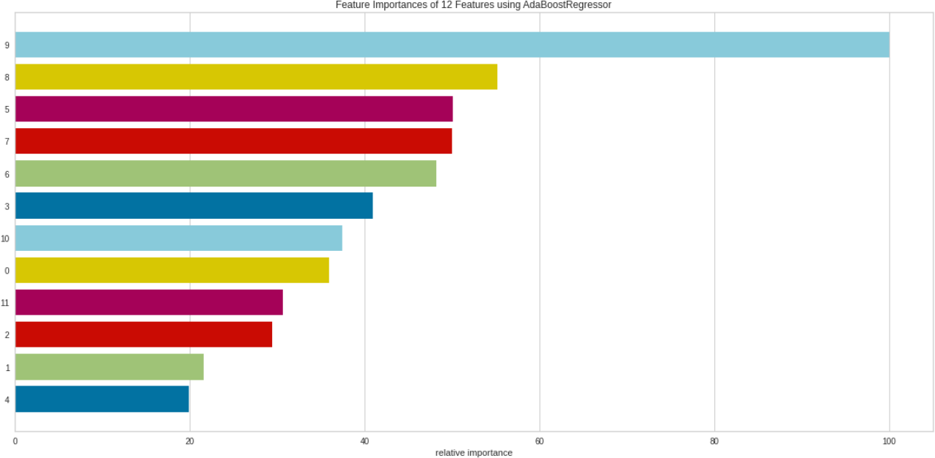

*Figure 57: Feature importance on the PCA reduced dataset*

From the above diagram, it is seen that principal component 9 is most important feature for prediction.

# Model prediction with ExtraTreesRegressor:

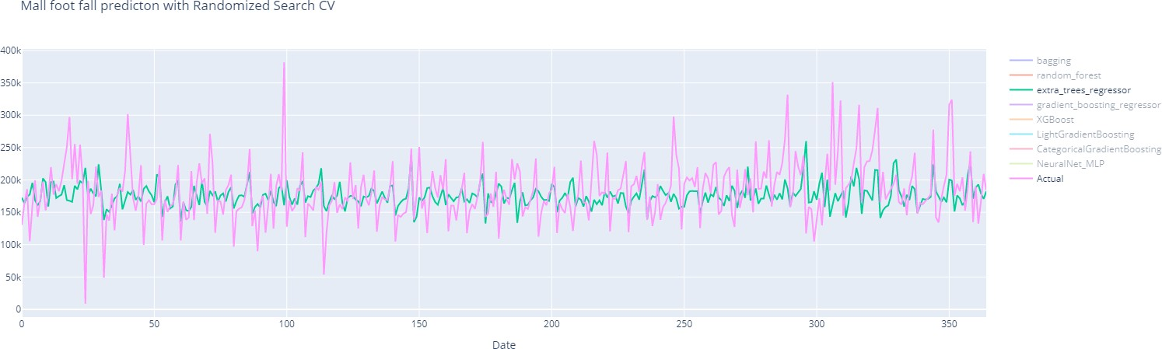

*Figure 58: Model prediction using PCA reduced dataset*

# Top models from this set:

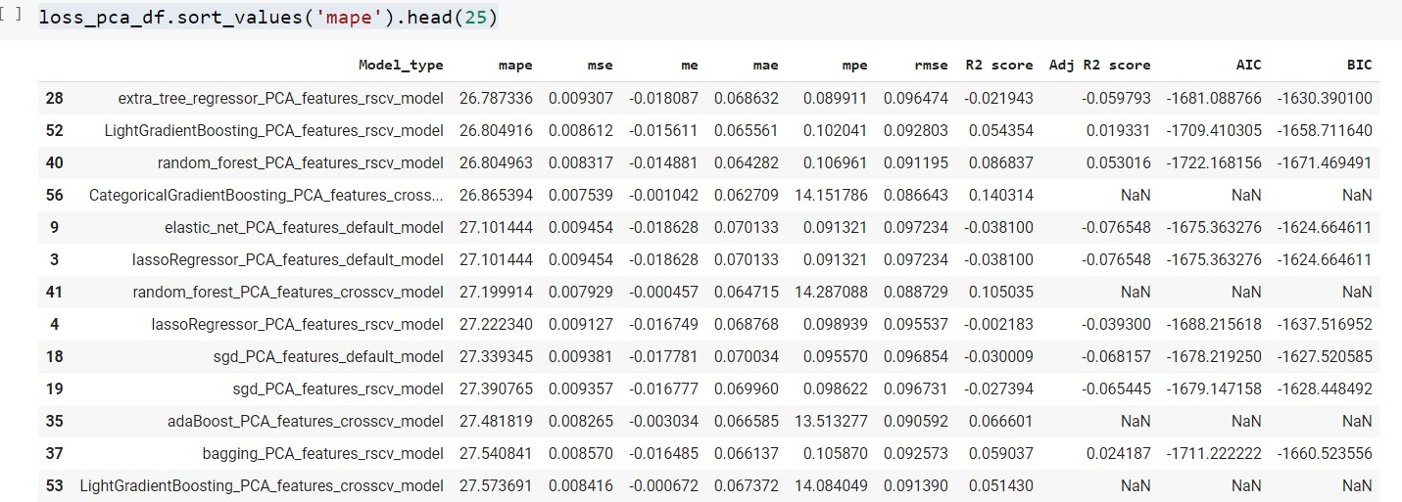

*Figure 59: Model metrics with feature removed using PCA*

With PCA reduced feature set, the model performance is not good. This can be due to the fact that dataset is not linear and dimensionality reduction using PCA will not work effectively.

# Models with weekly data

Models were also created with weekly data instead of daily data. These models can be used to predict the weekly mall inflow.



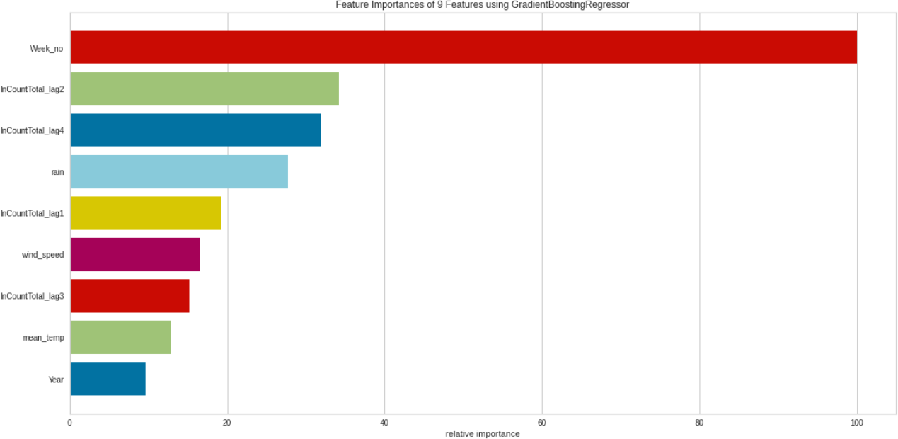

*Figure 60: Feature importance with Gradient Boosting Regressor*

# Model prediction:

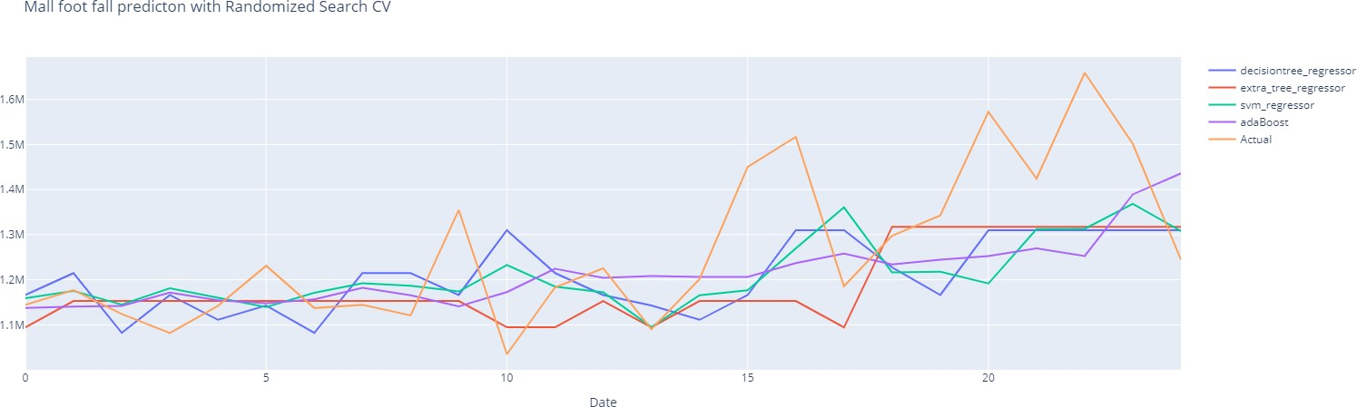

*Figure 61: Model prediction with weekly dataset*

# Top models from this set:

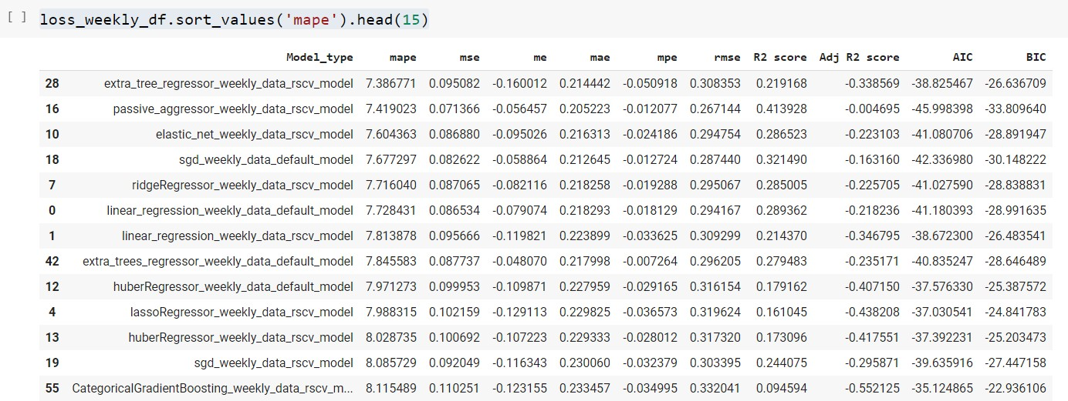

*Figure 62: Model metrics for weekly dataset*

# LSTM models

Different LSTM techniques were used to create various models to capture the variation in the training data and create generalized time series supervised model. For all the LSTM models, keras Functional models were used. Relu is used as the activation function. After careful fine tuning, it is found that initial learning rate: 0.0001 and batch-size: 16 are the best hyperparameters for model training

# LSTM encoder decoder

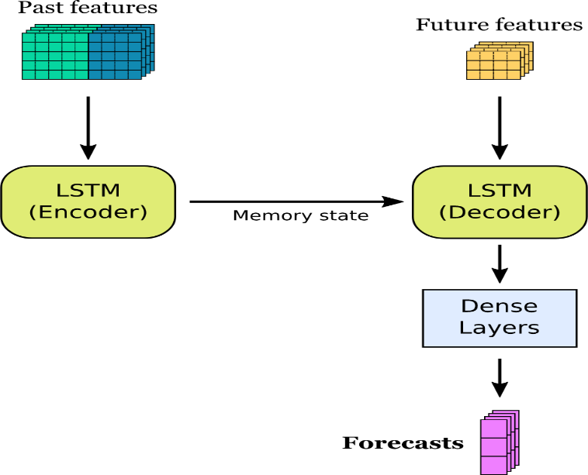

*Figure 63: LSTM encoder decoder architecture ( source : https://*[*www.angioi.com/time-series-encoder-decoder-tensorflow/)*](http://www.angioi.com/time-series-encoder-decoder-tensorflow/))

This model uses the past features for creating the encoder model. The memory state of LSTM and sequence information is used together future deterministic features like ‘Weekday’, ‘Day’, ‘Month’, ‘Holidays’ etc to create the decoder model. Finally, the decoder output is fed into Dense layers and output is created.

Encoder takes the input in the shape (n_timesteps, n_features). This goes through LSTM layers with 32 cells with return-states = True. This will enable the model to get the all the hidden states for the decoder. The decoder takes the future inputs in the shape (n_forecast (1), n_deterministic_features) and the LSTM layer uses the hidden states from the encoder and these future inputs. This is followed by 2 dense layers. The final dense layer is the output layer to predict the target variable.

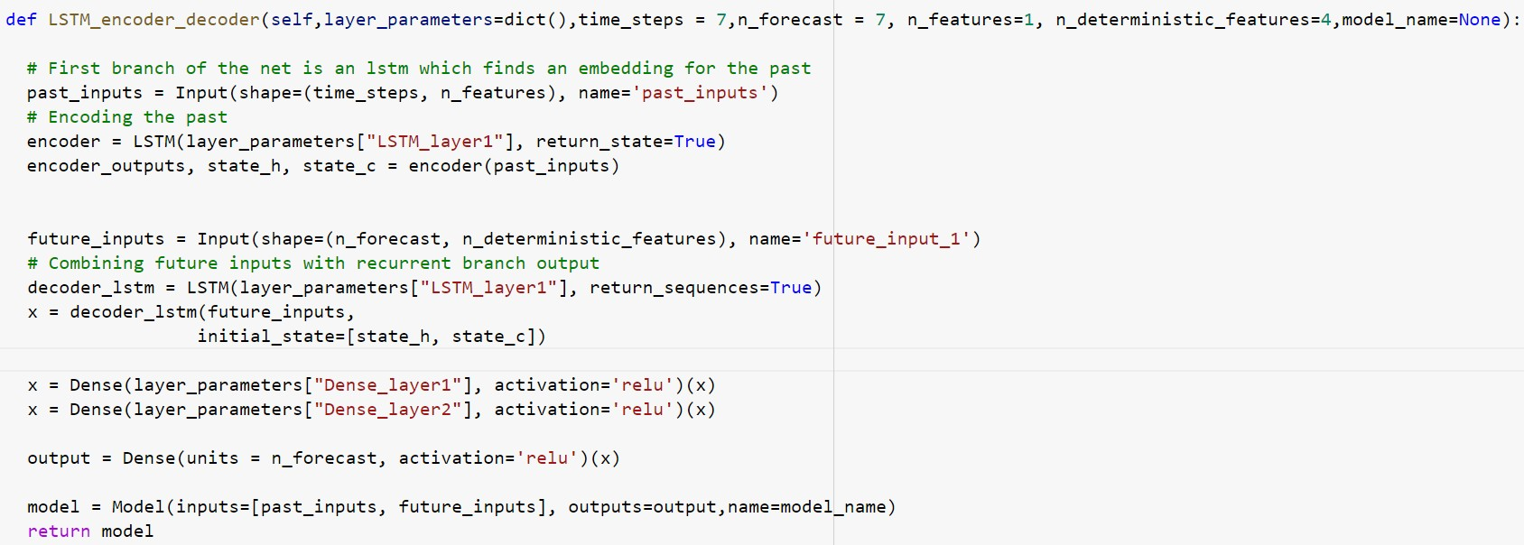

# Training of LSTM encoder decoder:

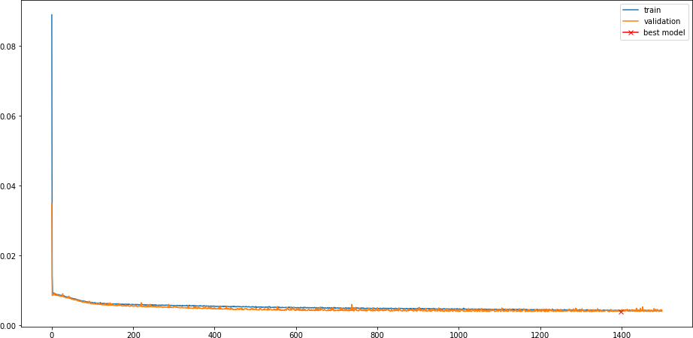

*Figure 64: LSTM encoder decoder training*

# Model prediction results:

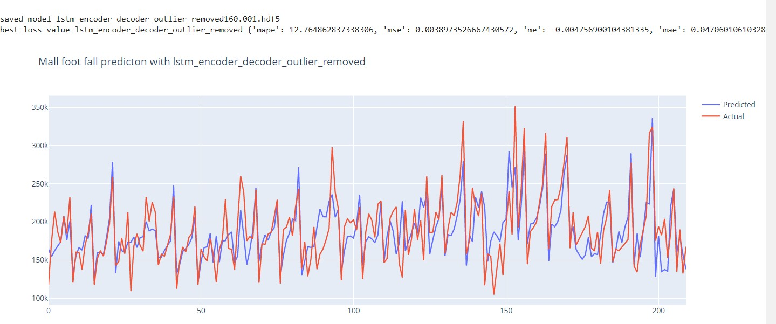

*Figure 65: Model prediction with LSTM encoder decoder*

# CNN LSTM encoder decoder

In order to capture the interesting patterns in the input data, a CNN layer (ConvLSTM2D) was added in the LSTM encoder-decoder model before the encoder.

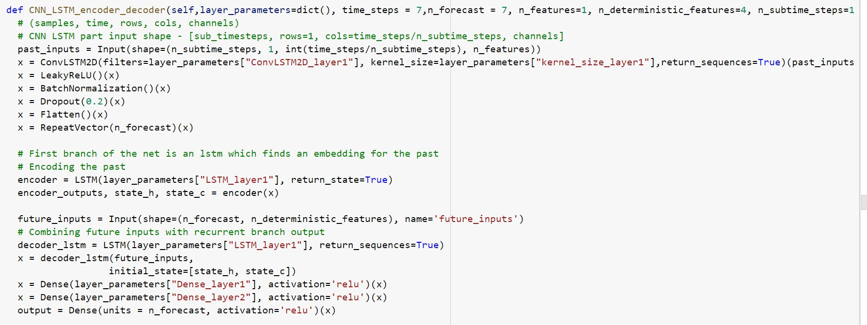

Model prediction:

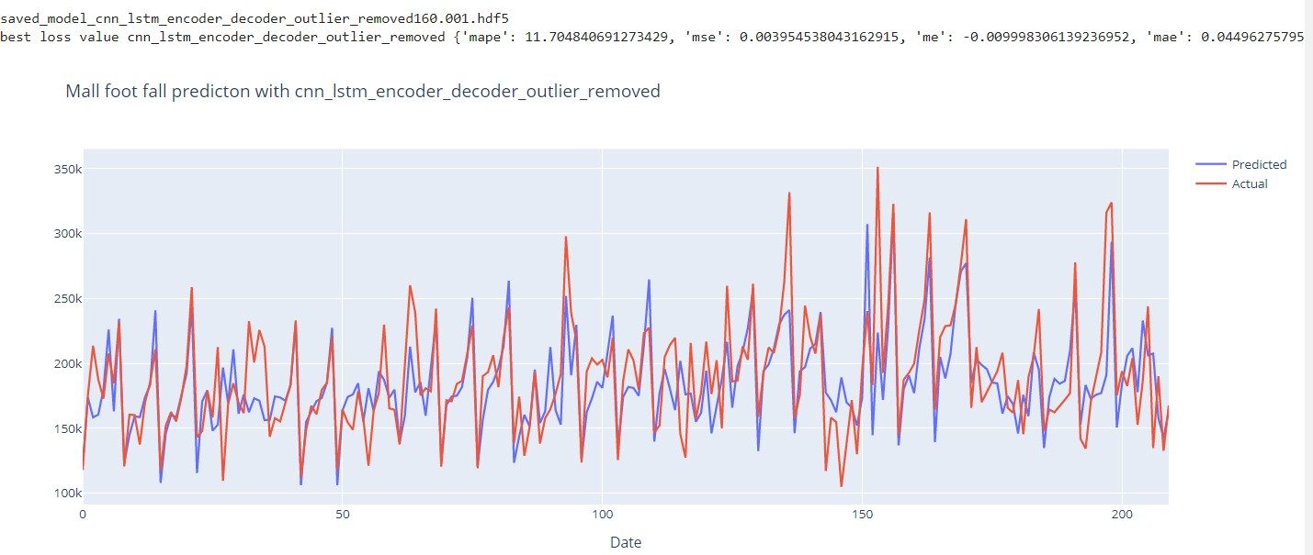

*Figure 66: Model prediction with CNN LSTM encoder decoder*

# LSTM auto encoder

LSTM Autoencoder was used to encode the input features to latent space and thereby reducing the dimensionality of the input features. The autoencoder model was trained first to get the autoencoder to reduce the reconstruction loss. The encoded features were extracted from the encoder part of the autoencoder and used in a separate MLP neural network to predict the output.

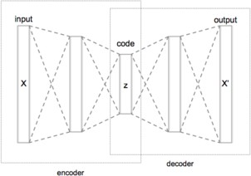

*Figure 67: Autoencoder architecture*

AutoEncoder model has two LSTM layers with Dropout of 0.2. Dropout acts as a regularization and it helps to reduce overfitting. Output from the encoder is the reduced set of features.

RepeatVector is used to repeat the output to n-timesteps. Decoder takes this input and goes

through 2 LSTM layers in the reverse order. Finally, the output is the re-constructed set of original features. Loss is calculated against the re-construction.

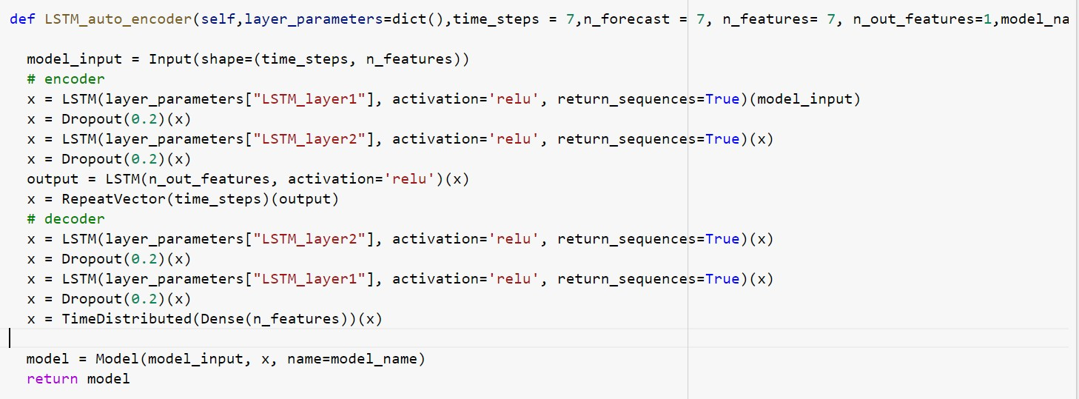

Once the autoencoder is trained with minimum loss, the output from the Encoder is used further to create an MLP model to predict the target.

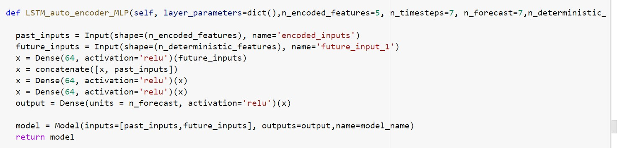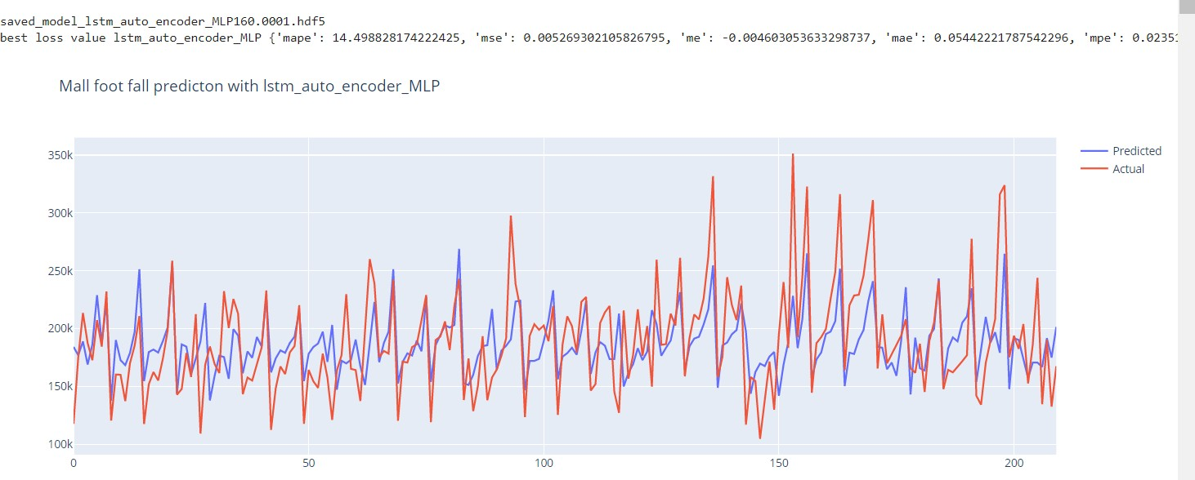

*Figure 68: Model prediction with LSTM autoencoder MLP*

# LSTM simple model

In this model, 2 LSTM layers are used with a dropout of 0.2, followed by 2 Dense layers. Final layer is the Dense layer with 1 output.

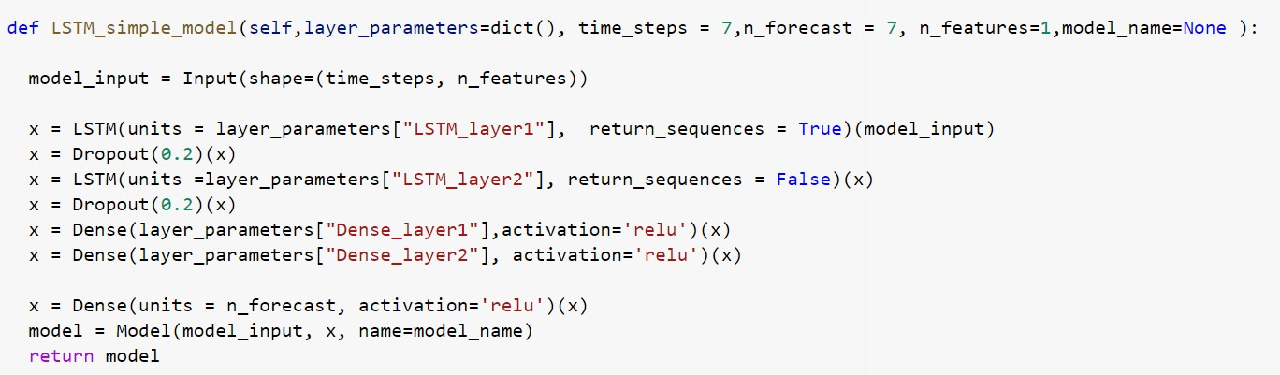

# Model prediction:

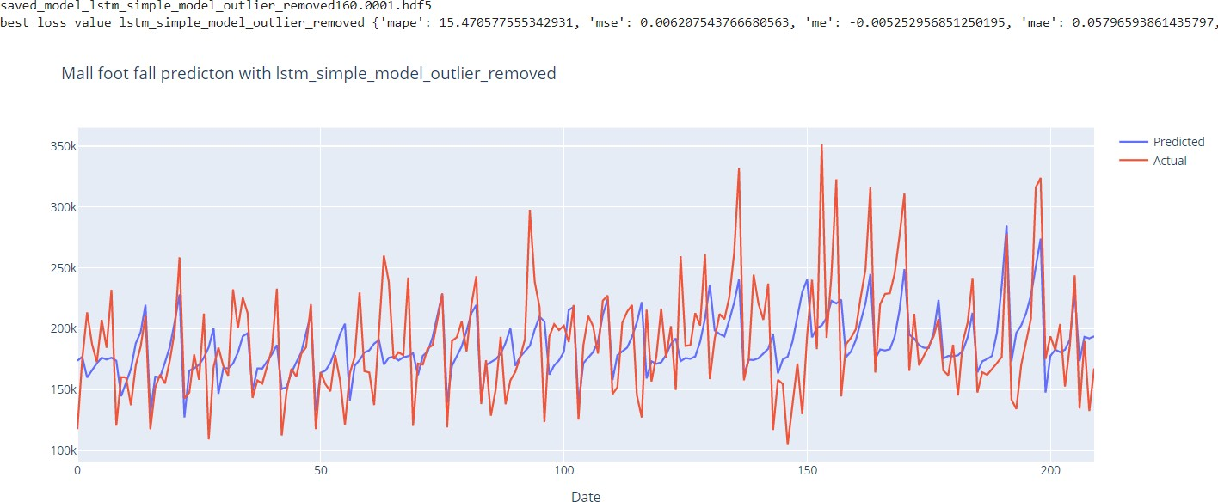

*Figure 69: Model prediction with LSTM simple model*

# Ensemble LSTM Average model

In this Ensemble model, the individual models are combined, and average of the output is taken as the predicted value. Ensemble of LSTM encoder-decoder and CNN-LSTM encoder-decoder is used in this model.

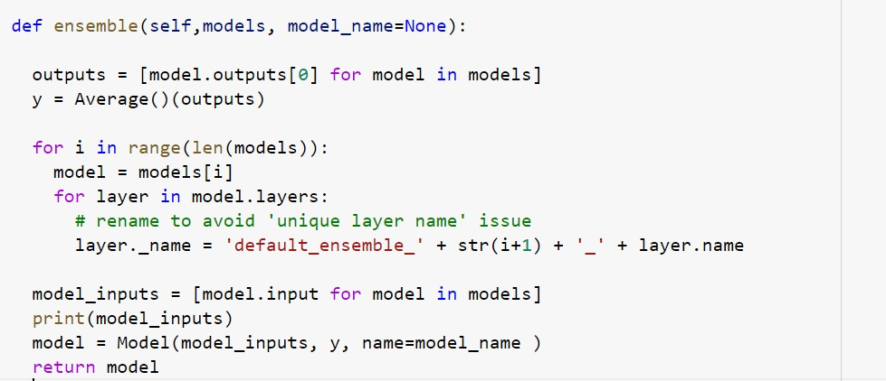

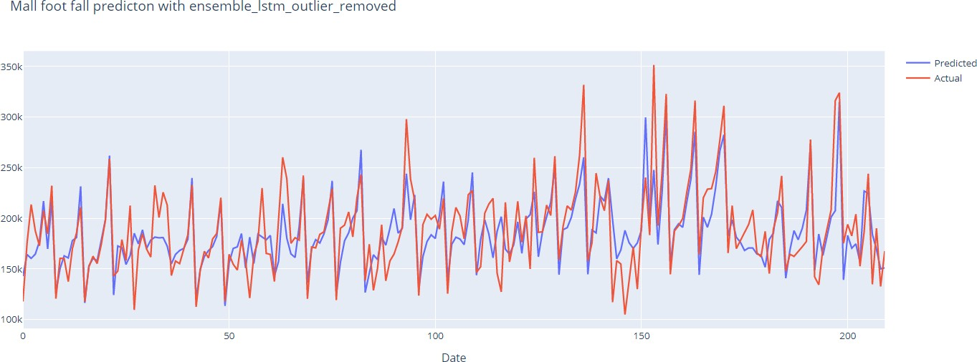

*Figure 70: Model prediction with Ensemble average*

# Stacked and Integrated Ensemble LSTM model

In the stacked and integrated ensemble models, the individual models are concatenated and further trained using 2 dense NN layers.

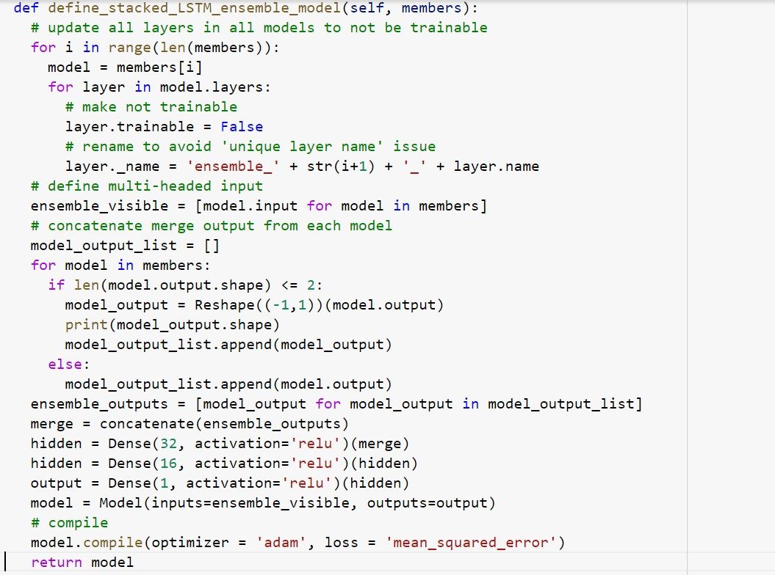

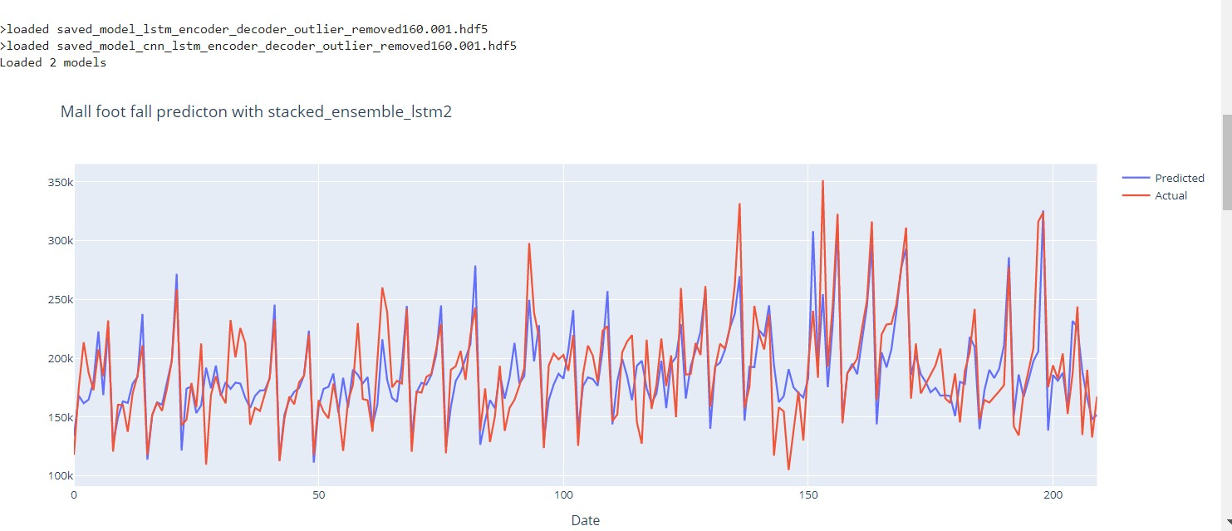

*Figure 71: Model prediction with stacked Ensemble LSTM*

# Ensemble of Ensembles LSTM

This model is an ensemble of ensemble models. This model takes two or more individual ensemble models and concatenates the output. This is further trained on dense neural network with 2 dense layers.

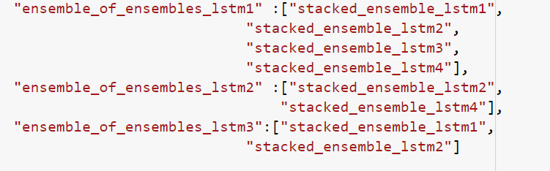

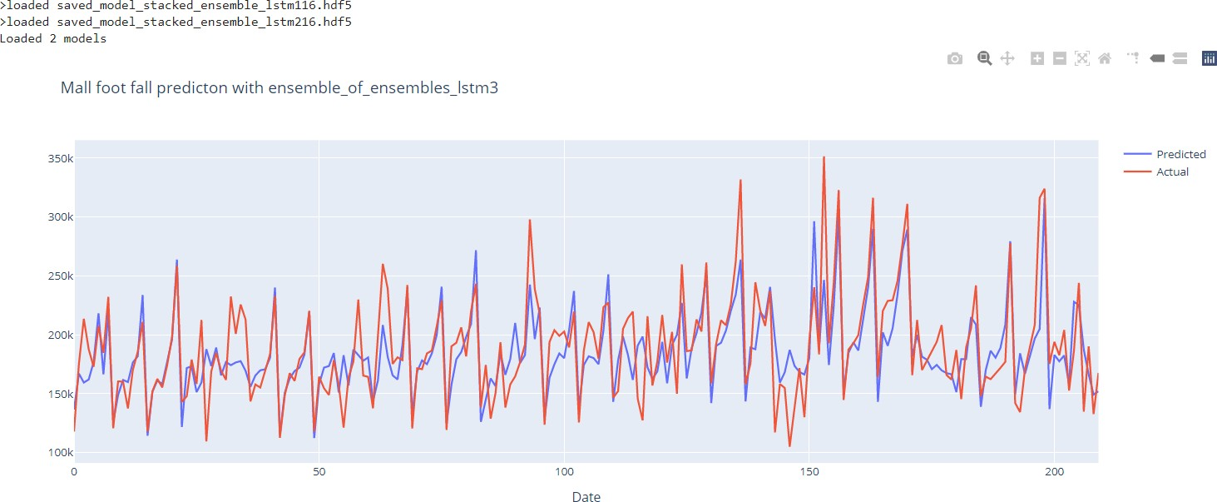

*Figure 72: Model prediction with Ensemble of Ensembles LSTM*

# Top models from LSTM models:

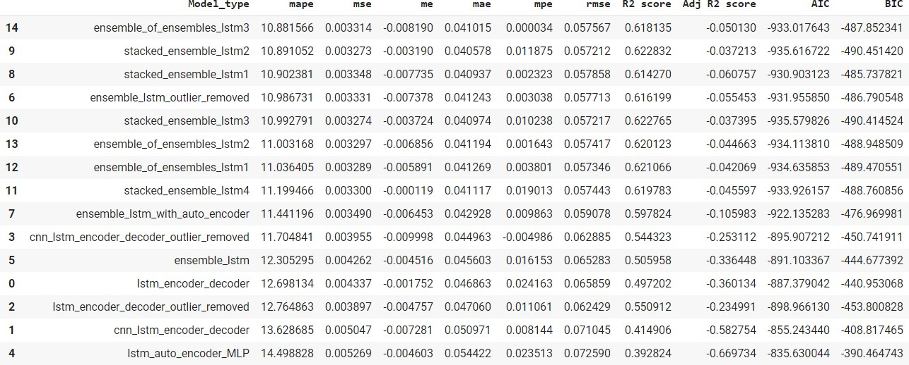

*Figure 73: LSTM model metrics*

# H2O models

H2O is a Java Virtual Machine that is optimized for doing in-memory processing of

distributed, parallel machine learning algorithms on clusters.H2o provides great flexibility in training and scaling machine learning algorithms in large datasets.

**(source :** [**https://medium.com/@ODSC/machine-learning-with-h2o-part-1-f6bf4f356c7a)**](https://medium.com/%40ODSC/machine-learning-with-h2o-part-1-f6bf4f356c7a))



*Figure 74: Different H2O machine learning tools (source: H2O.ai)*

H2O has a nice set of available algorithms : Supervised Learning. Deep Learning (Neural Networks), Distributed Random Forest (DRF), Generalized Linear Model (GLM), Gradient Boosting Machine (GBM), Naïve Bayes Classifier, Stacked Ensembles, XGBoost

# H2O models were finetuned using H2OGridSearch.

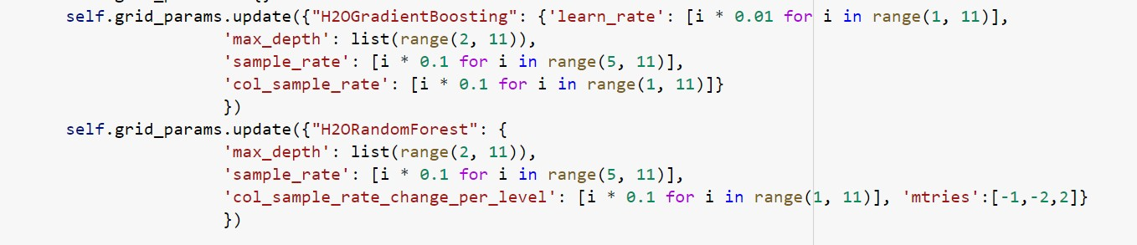

*Figure 75: H2O model hyper parameters*

Ensemble H2O models were created using stacked Ensemble of GradientBoosting and RandomForest. In addition, random grid ensembles were created for both Random Forest and Gradient Boosting.

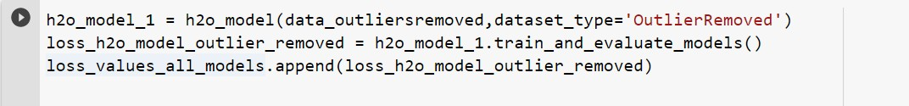

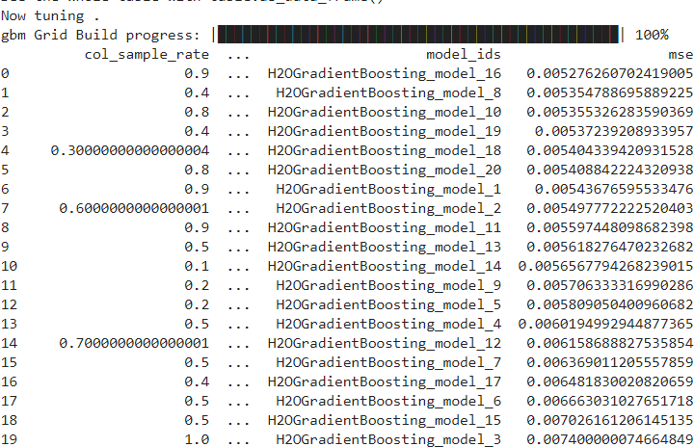

*Figure 76: H2O model tuning*

# Prediction with H2O models:

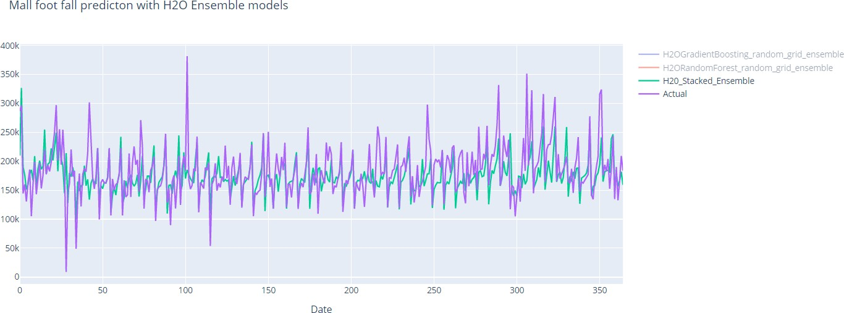

*Figure 77: H2O model prediction*

# AutoML models



(source : <http://docs.h2o.ai/h2o/latest-stable/h2o-docs/automl.html)>

H2O’s AutoML can be used for automating the machine learning workflow, which includes automatic training and tuning of many models within a user-specified time-limit. Stacked Ensembles – one based on all previously trained models, another one on the best model of each family – will be automatically trained on collections of individual models to produce highly predictive ensemble models which, in most cases, will be the top performing models in the AutoML Leaderboard.

H2O offers a number of model explainability methods that apply to AutoML objects (groups of models), as well as individual models (e.g. leader model). Explanations can be generated automatically with a single function call, providing a simple interface to exploring and explaining the AutoML models.

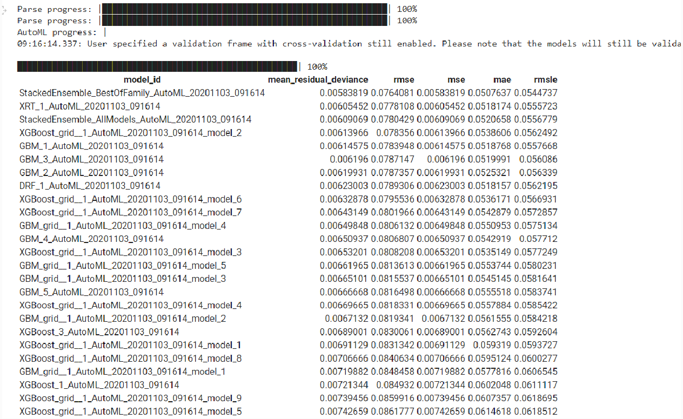

*Figure 78: Model training with AutoML*

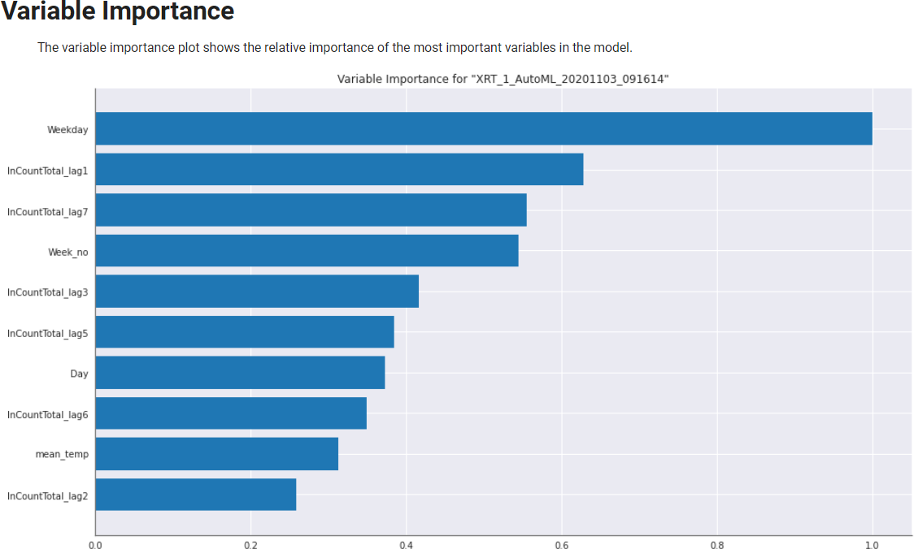

*Figure 79: Feature importance*

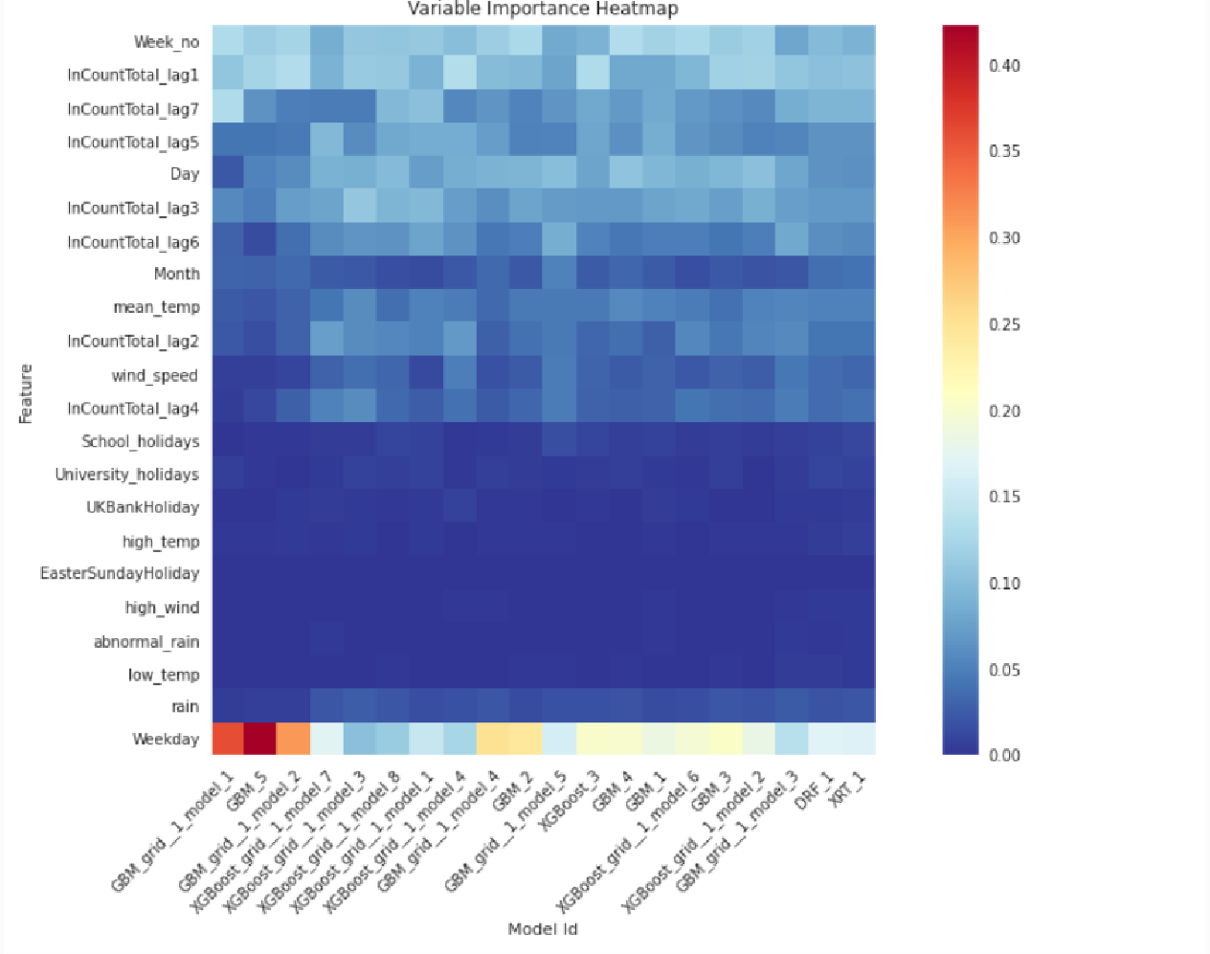

*Figure 80: Feature importance against different models*

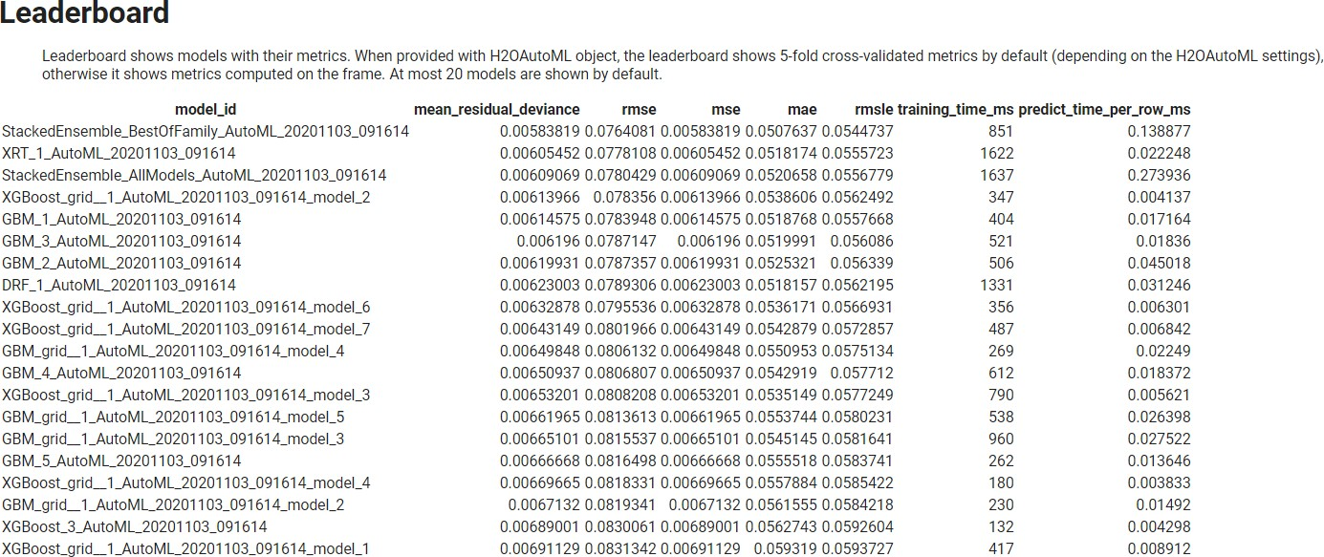

*Figure 81: AutoML leaderboard and model scores*

# FB Prophet models

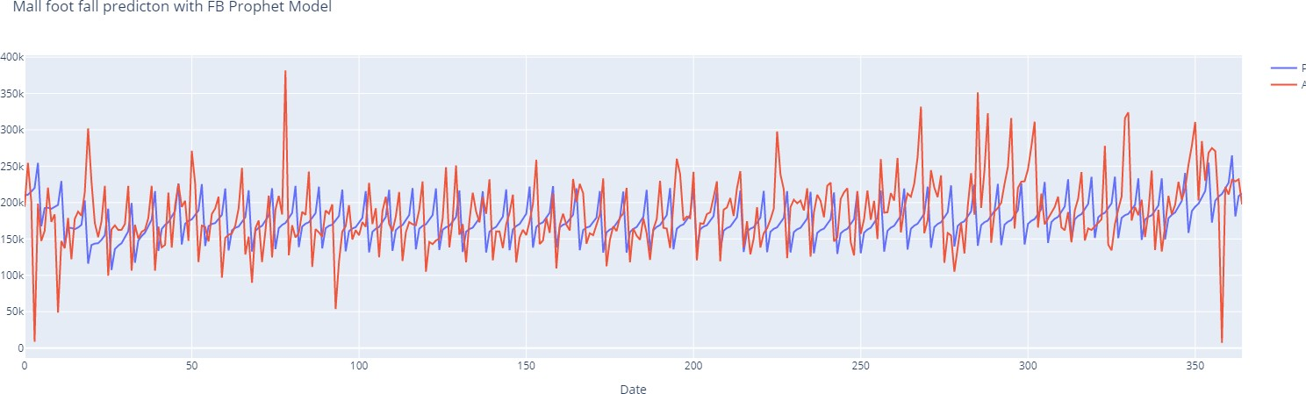

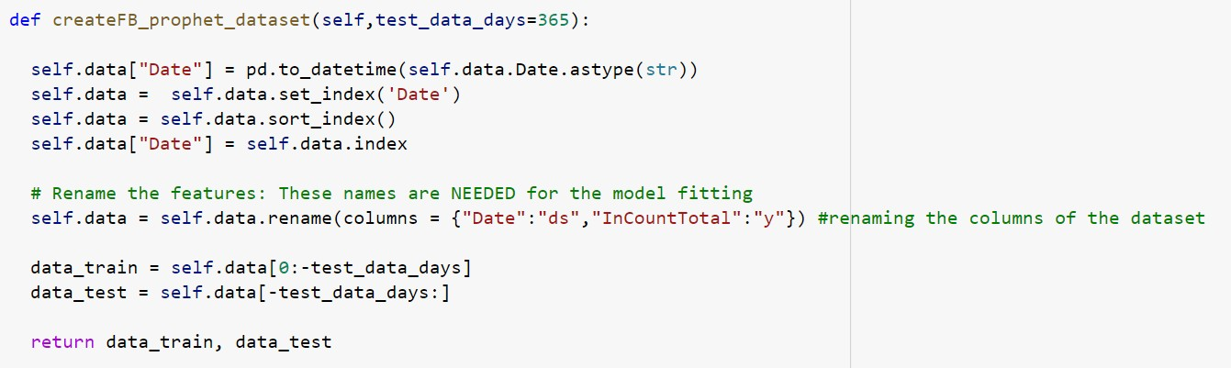

*Figure 82: FB prophet dataset creation*

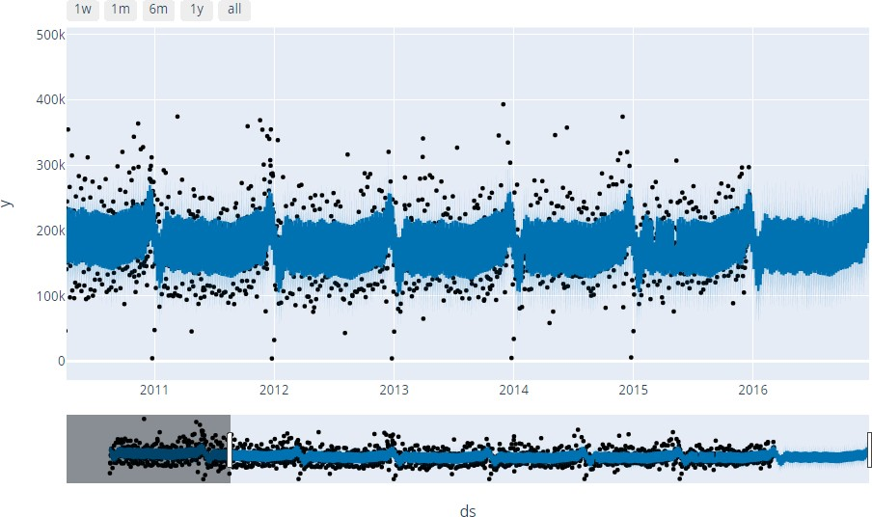

*Figure 83: FB Prophet model plot*

*Figure 84: FB prophet model prediction*

Model metrics:



*Figure 85: Model score with FB prophet*

# GAN (Generative Adversarial Network) model

Generally, GAN is used as a generative model for image generations. This is widely used in Computer Vision. We used this as an experiment to check if GAN can be used for regression and time-series predictions.

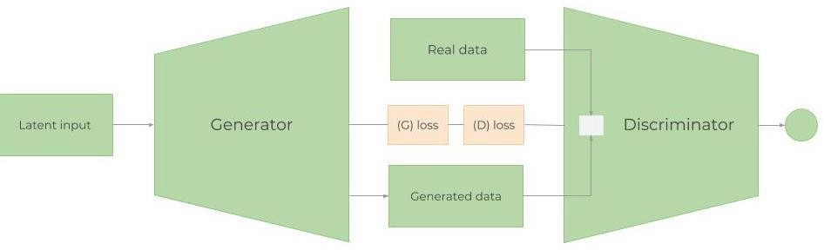

*Figure 86: GAN architecture*

Randomly, real or generated data is fitted into the Discriminator, which acts as a regressor and tries to understand whether the data is coming from the Generator or is the real data. D estimates the (distributions) probabilities of the incoming sample to the real dataset. D estimates two loss values 1) against fake samples 2) against real samples using mean_squared_error.

Then, the losses from G and D are combined and propagated back through the generator. The generator’s loss depends on both the generator and the discriminator. This is the step that helps the Generator learn about the real data distribution. If the generator doesn’t do a good job at generating a realistic data (having the same distribution), the Discriminator’s work will be very easy to distinguish generated from real data sets. Hence, the Discriminator’s loss will be very small. Small discriminator loss will result in bigger generator loss (see the equation below for L(D,G)). This makes creating the discriminator a bit tricky, because too good of a discriminator will always result in a huge generator loss, making the generator unable to learn. The process goes on until the Discriminator can no longer distinguish generated from real data.

When combined, D and G as sort of playing a minmax game (the Generator is trying to fool the Discriminator making it increase the probability for on fake examples, i.e. minimize

𝔼z∼pz(z)[log(1−D(G(z)))]. The Discriminator wants to separate the data coming from the Generator, D(G(z)), by maximizing 𝔼x∼pr(x)[logD(x)]. Overall, the combined loss function looks like:



# Generator model:

The task of the generator is to take the samples from latent space and generate feature set. Generator is an MLP neural network which takes input with latent-dimension. In this case, latent_dimension is set to 100. The input goes through 3 Dense layers with LeakyReLu activation function. Finally, the output is the artificial feature set generated for n_timesteps. The generator model is not compiled as this is compiled in the composite GAN model.

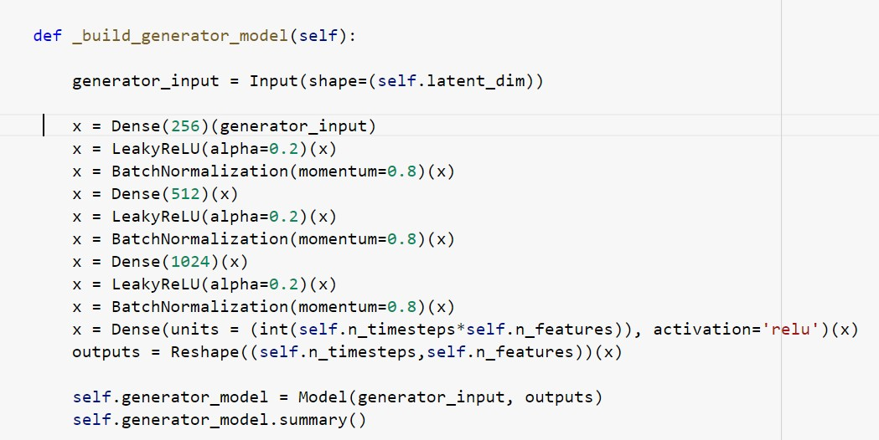

# Discriminator model:

The task of the discriminator is to take the real or fake dataset as the input and predicts the target value. The input is the dataset with shape (n-timesteps, n_features). This has one LSTM layer with 512 cells, followed a bi-directional LSTM with 512 cells. After that there are two dense layers with 512 and 256 neurons. Finally, the output is target value to be predicted. This model is compiled with loss: mse and Adam optimizer.

# The discriminator model:

**Composite GAN model:**

Composite GAN model is the one who trains the generator based on discriminator outputs. This takes the inputs as random sample and this is processed via generator model. Output from generator is given to discriminator as the input. Finally, discriminator output is the output of

composite GAN. Inside composite GAN, the discriminator model is set as NOT trainable as only generator model is trained here. Model is compiled with loss: ‘mse’ and Adam optimizer.

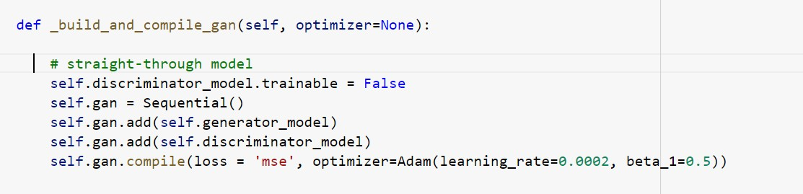

# Training of GAN model:

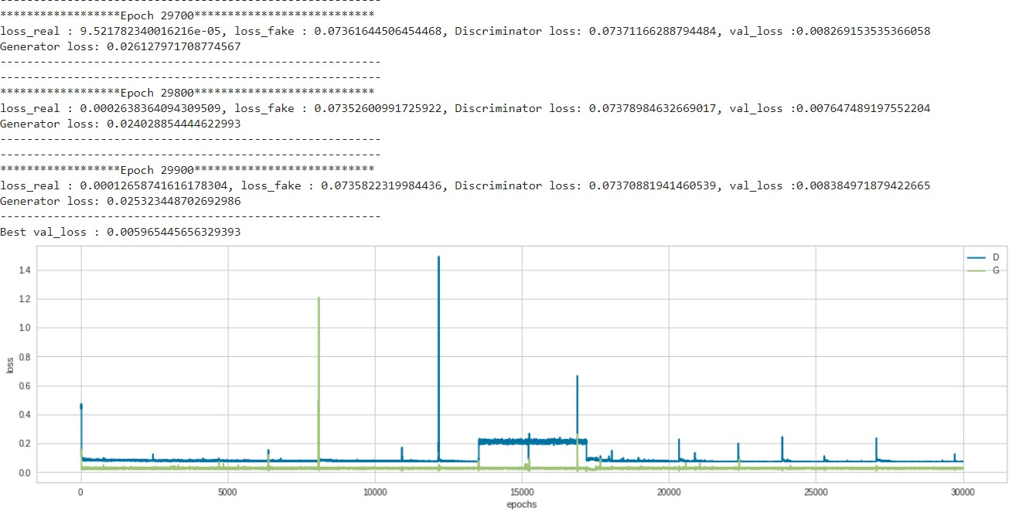

*Figure 87: Training of GAN models*

Both discriminator and generator try to compete with each other, and losses are fluctuating.

# Prediction and accuracy with GAN model:

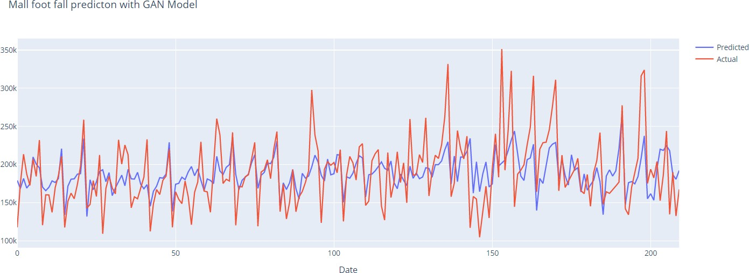

*Figure 88: Model prediction with GAN model*

# Observation:

In this experiment, the discriminator and generator models are competing, and the losses are fluctuating. The mape result of GAN model is 15.38. We strongly believe that this can be finetuned further to get the very good mape results.

# Code & Screenshots (Full screenshot without cropping the system date-time)

Please refer to the complete Code Snippets in below link with system date-time as requested. Code Snippets Links:

Part-1

Part-2 Part-3

# Interpretation

# Justification of Measures / Metrics used

We used MAPE (Mean Absolute Percentage Error) as the main metric to evaluate the final models, although a wide range of other metrics were also calculated for each model. (mse, me, mae, mpe, r2 score, adjusted r2 score, AIC, BIC). In case of LSTM/GAN models, MSE (mean_squared_error) was used for training/validation and the models were fit to minimize the mse error.

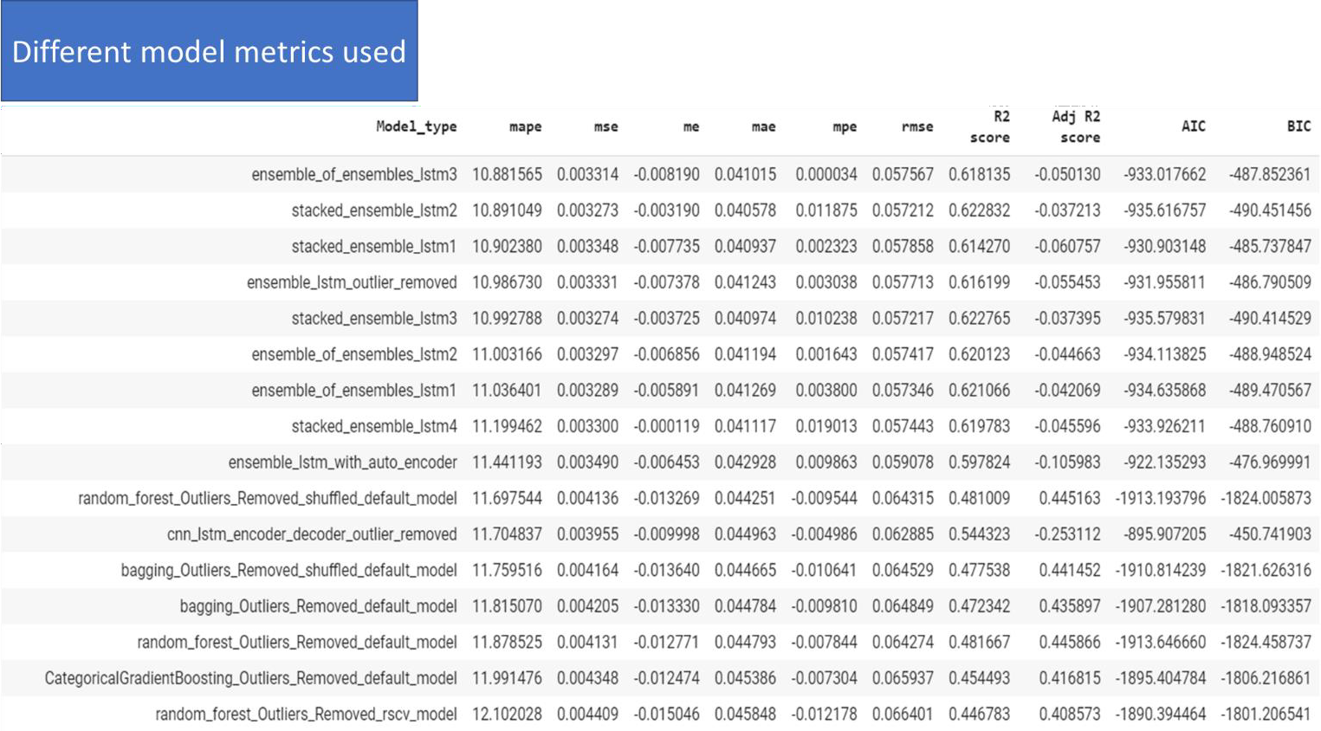

*Figure 89: Metrics used for different models*

# Project output in terms of above measures/metrics

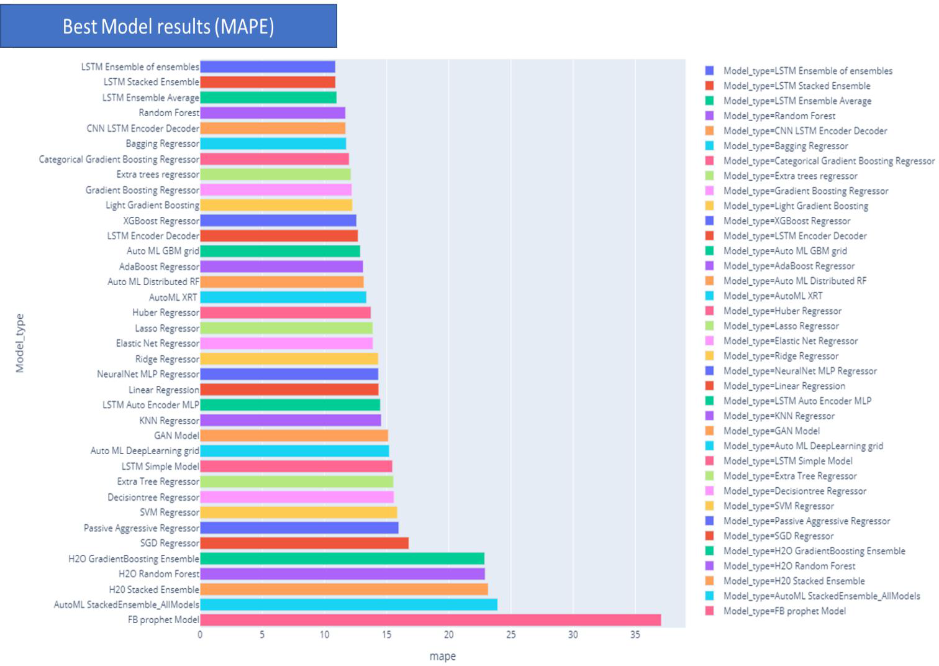

*Figure 90: Best models (based on MAPE)*

From the above diagram, it is clear that LSTM ensemble of ensembles performs the best based on mape metric. Generally, LSTM/GAN models are computationally expensive for the training, however, the once the models are trained, the saved models can be reloaded later for inference. The inference is done very fast. The saved models can also be retrained later with new samples and observations. On the other hand, standard Ensemble models like Random Forest or Bagging also work very well. The advantage of Random Forest or Bagging compared to LSTM/GAN models is that they can be trained much faster. So, depending on the availability of training resources, either of these approaches can be taken.

# Visualization Plots

Various graphs have been plotted on the given dataset to gain more insights from the data.

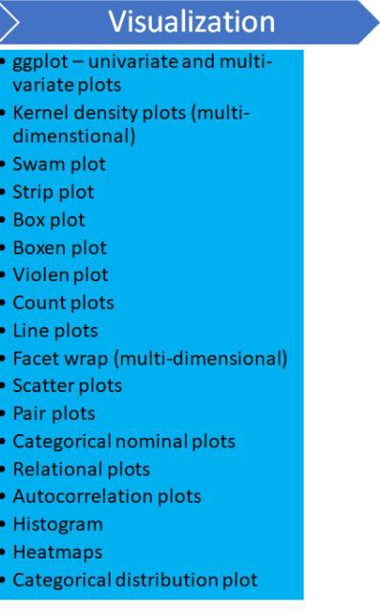

|  |  |
| --- | --- |
| *Figure 91:Code snippet for ggplot*    *Figure 92: Histogram of InCount Total* | **Technique:** ggplot **Stage Used**: After pre processing data **Purpose**: To  Understand the  histogram of Univariate variables IncountTotal, Rain, mean_temp and wind speed  **Data**: Visualization data  **Inference**:   * mean of InCount : 180000 * mean of rain < 1 * mean of temp : 10.5 * mean of wind_speed :   ~1.75 |

*Figure 93: Distribution of rain*

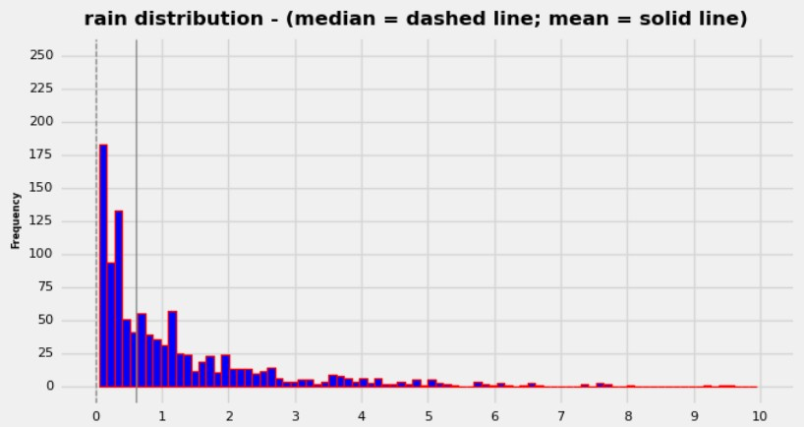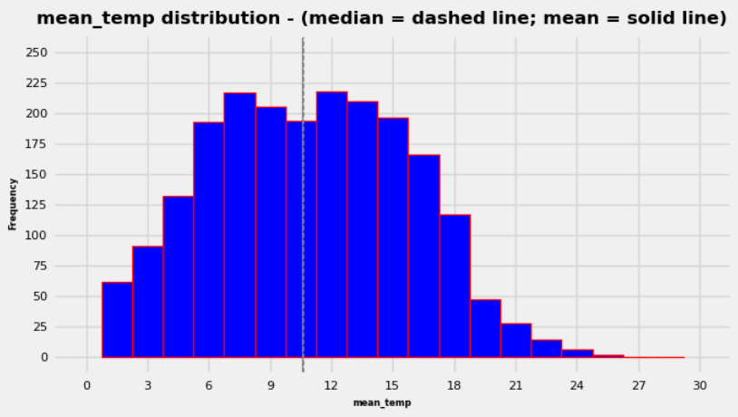

*Figure 94: Mean temperature distribution*

|  |  |
| --- | --- |
| *Figure 95: Distribution of wind-speed* |  |
| *Figure 96: Code snippet for ggplot* | **Technique:** facet ggplot  **Stage Used**: After Pre processing data **Purpose**: To understand the incount distribution based on Weekday, high  temperature and abnormal rain  **Data**: Visualization data  **Inference**:   * The Incount is significantly low during the days with Abnormal rain and High temperature * Abnormal rain seems to have more impact on the Incount than the High temperature. Days with only Abnormal rain has slightly low footfall than the   days with only |

|  |  |
| --- | --- |
|  | High Temperature |

*Figure 97: Distribution of InCount total based on other categorical attributes*

|  |  |
| --- | --- |
| *Figure 98: Code snippet for Seaborn Swarm plots*    *Figure 99: Daily distribution of InCount total* | **Technique:** seaborn swarm and strip plots **Stage Used**: After Pre processing data **Purpose**: To understand the scatter plot for incount based on the weekday and month  **Data**: Visualization data  **Inference**:   * Weekdays: There is a gradual increase in   incount from  Sunday to Saturday.  Saturday being highest incount   * + Months   : we can see a seasonal trend in months - peaks in the months of Dec, Nov and March. Lower in the summer months(Jul and August) and in Jan |

*Figure 100: Incount daily distribution with hist=Month*

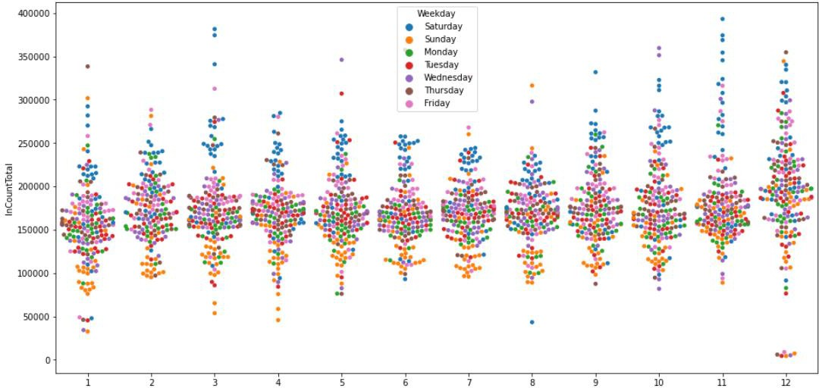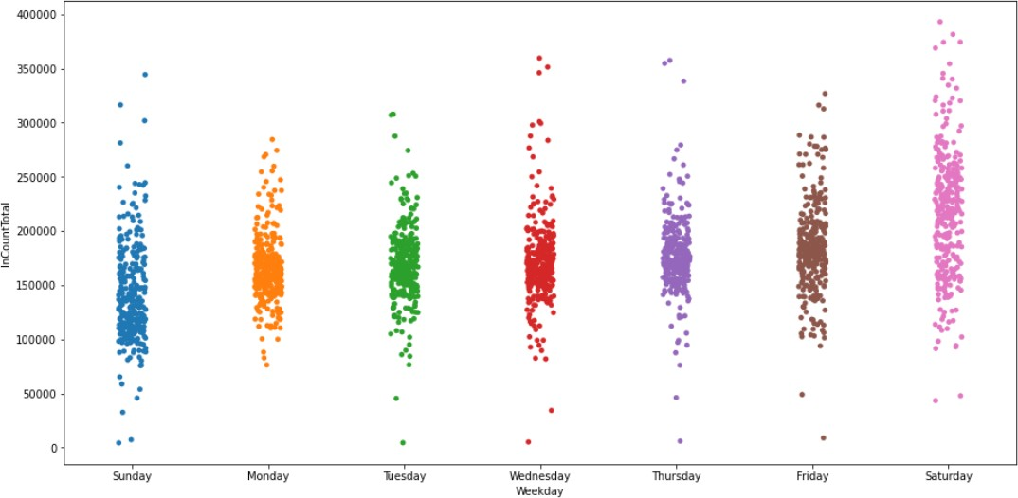

*Figure 101: Incount total Monthly distribution(Swarm plot)*

*Figure 102: Strip plot of Incount Total*

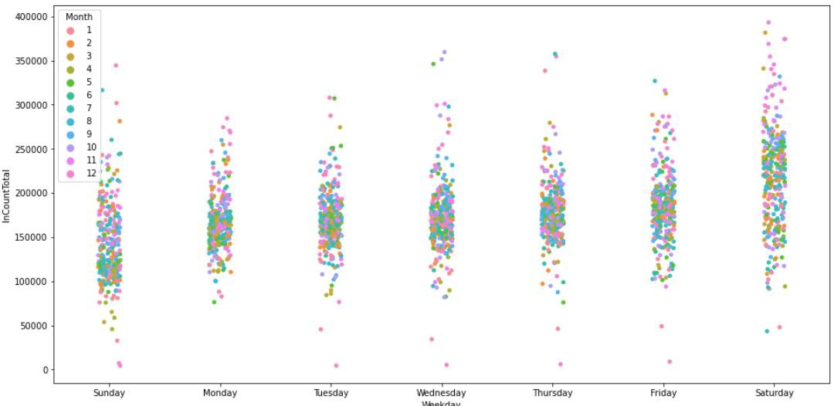

*Figure 103: Strip plot Monthly distribution of Incount*

|  |  |
| --- | --- |
| *Figure 104: Bar graph of Incount total*    *Figure 105: Violin plot(Incount total)* | **Technique:** seaborn box, violin and boxen plot for data distribution  **Stage Used**: After Pre processing data **Purpose**: To understand the Incount Total Distribution based on weekday.  **Data**: Visualization data  **Inference**:   * Distribution of data in more on Saturday which is between 100000 and 300000 * Monday to   Friday the distribution is similar   * On some of the weekdays the distribution is also minimum except Monday and Saturdays. * Saturday we can see that there are some data which has count of   ,400000 count compared to other days where data is normally at 350000 |

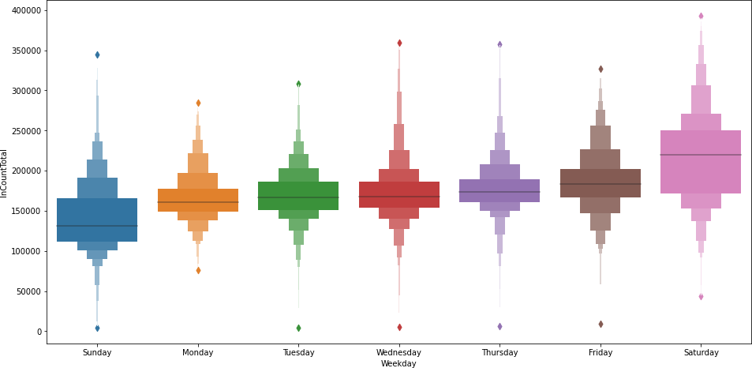

*Figure 106: Boxen plot (Incount total)*

|  |
| --- |
| *Figure 107: Line graph of Incount Over years* |
| **Technique:** Trend analysis of In-count total for each gate  **Stage Used**: Before normalization  **Purpose**: To understand trend and seasonality  **Data**: InCount data  **Inference**:   1. Incount is higher during the last weeks of December 2. 'Briggate' : There seems to be downward trend in 2015. overall, this seems to be the main gate. 3. Briggate has more incount compared to other gates 4. 'AlbionStNorth' : There is a downward trend throughout   **Action Taken**: created a separate dataset for detrended data. |

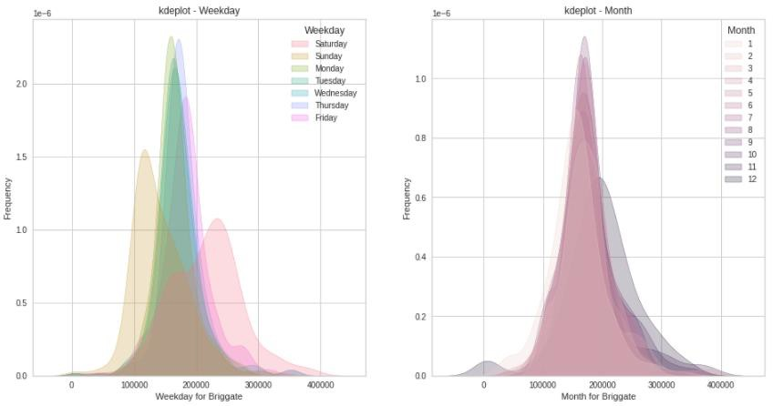

*Figure 108: Kde plot (Incount of gate Briggate : Daily & Monthly)*

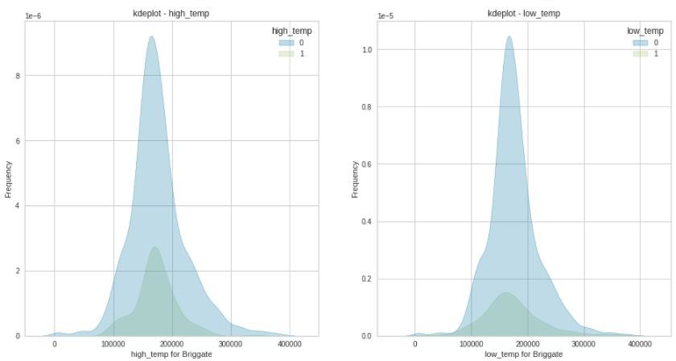

*Figure 109 Kde Plot (distribution over HIgh temp & Low temp)*

|  |
| --- |
| *Figure 110: Kde plot (distribution over Rain & Holidays)* |
| **Technique:** KDE plot  **Stage Used**: Before pre-processing  **Purpose**: To understand distribution of in-count total over categorical attributes  **Data**: InCount data  **Inference**:   1. weekday : Saturday seems to be having more incount as expected 2. Month : December is seen as the busy month with more footfall 3. high_temp, low_temp, abnormal_rain : Incount is high in the absence of these 4. EasterSundayHoliday : InCount is very low 5. Other holidays : We do not see any significant impact on the InCount.   **Action Taken:** Created target encoding for categorical attributes |

|  |
| --- |
| *Figure 111: Categorical variables distribution* |
| **Technique:** Histogram plot  **Stage Used**: Before pre-processing  **Purpose**: To understand distribution of in-count total at each gate  **Data**: InCount data  **Inference**:   1. Incount is lower as windSpeed is higher 2. Incount is lower, as the rain is higher 3. Incount is significantly low during Abnormal rain |

4) Incount is almost normally distributed over mean temperature. The Incount is lower when the mean temperature is low or high.

|  |
| --- |
| *Figure 112: Pair plots* |
| **Technique:** Pair plot  **Stage Used**: Before pre-processing  **Purpose**: To understand co-relation among input variables  **Data**: All input variables  **Inference**:   1. rain : when there is no rain or less rain, incount is higher 2. wind-speed : When the wind-speed is lower, the incount is higher 3. abnormal_rain : when there is no abnormal_rain, incount is higher. linked with rain attribute 4. high_temp : when there is no high_temp, Incount is higher 5. low_temp : There is no impact on Incount if low_temp or not 6. high_wind : if there is no high_wind, Incount is higher 7. EasterSundayHoliday : if it's EasterSunday, the InCount is very low 8. School Holiday/University Holiday - we do not see any major changes in the in-flow 9. UK Bank holiday - Incount is slightly lower on bank holidays |

|  |  |
| --- | --- |
| *Figure 113: Correlation among discrete variables* | **Technique:** Correlation plot  **Stage Used**: Before pre- processing  **Purpose**: To understand co-relation among categorical variables **Data**: Categorical variables  **Inference**:   1. School and University Holidays has correlation with Month, Week No and Day 2. School and University Holidays are correlated |

|  |
| --- |
| *Figure 114: Intra-day distribution* |
| **Technique:** Swarm plot  **Stage Used**: Before pre-processing  **Purpose**: To understand hourly distribution of incount |

**Data**: inCount total, hours

**Inference**:

1. On Friday and Saturday mall has more people between 11:00 to 16:00 hours
2. On Monday, Tuesday, Wednesday and Thursday mall has more people between 12:00 to 14: hours.
3. Sunday has more people between 12:00 to 16:00 hours.

We can also see that hours **13:00-17:00 are busy hours**.

|  |
| --- |
| *Figure 115: % Distribution of categorical variables (1)* |
| **Technique:** Categorical distribution plot  **Stage Used**: Before pre-processing  **Purpose**: To understand distribution of rain and temperature over complete data  **Data**: inCount , rain, high & low temperature and wind speed  **Inference**:   1. 9.78 % of days are with Abnormal Rain 2. 19.1% of the Total days are with High Temperature |

1. 16.1% of the Total days are with Low Temperature
2. 14.76% of the Total days are with High Wind

|  |
| --- |
| *Figure 116: % Distribution of categorical variables (2)* |
| **Technique:** Categorical distribution plot  **Stage Used**: Before pre-processing  **Purpose**: To understand distribution of School and University Holidays  **Data**: inCount , Holidays (Bank/School/University  **Inference**:   1. 43.96% of the Total days are University Holidays 2. 26.11% of the Total days are School Holidays 3. 2.26% of the Total days are Bank Holidays |

|  |
| --- |
| *Figure 117: % Distribution of categorical variables (3)* |
| **Technique:** Categorical distribution plot  **Stage Used**: Before pre-processing  **Purpose**: To understand distribution of School and University Holidays  **Data**: inCount , (Bank/School/University) Holidays  **Inference**:   1. 43.96% of the Total days are University Holidays 2. 26.11% of the Total days are School Holidays 3. 2.26% of the Total days are Bank Holidays |

|  |
| --- |
| *Figure 118: % Distribution of categorical variables (1)* |
| **Technique:** Categorical distribution plot  **Stage Used**: Before pre-processing  **Purpose**: To understand distribution of incount daily , weekly and monthly  **Data**: inCount , Day, Week and Month  **Inference**:   1. Biggate has more incount compared to other gates 2. Saturday has more Incount compared to other days 3. Incount on dates 9th and 11th are slightly lower compared to other dates. |

# Summary of top observations from the visualization plots:

1. Missing data is seen with for 2 days only with one specific gate. This is imputed with KNN Impute
2. Stationarity check on the data: Augmented Dickey-Fuller (ADF) test shows p-value << 0.05, so the series is already stationary
3. Decomposing Data to Trend, Seasonality, noise, residuals a.) There is no visible trend seen in the Incount data

b). there is seasonality visible

c.) The residual density data for all the gates and IncountTotal almost follows a normal distribution

1. PCA - 85% variance achievable with 6 principal components and 90% variance preserved with 11 components
2. Outlier detection –
   1. 19 Outliers are seen when DBSCAN is applied on the InCountTotal, out of these outliers, 13 are either Christmas Day, New Year or Easter Sunday, with very low total InCountTotal.
   2. Out of remaining 6, 5 are Saturdays and 3 of them are immediate weekend after the Thanksgiving Day
   3. For the years where the immediate weekend after the Thanksgiving is not identified as Outlier, the InCountTotal is still significantly high and are close to be marked as Outliers
3. Autocorrelation plot - every 7th day or multiples of 7th seem to have correlation
4. rain: when there is no rain or less rain, InCountTotal is higher
5. wind-speed: When the wind-speed is lower, the InCountTotal is higher
6. InCountTotal is low during Abnornal Rains, High Wind, High Temperature, Low Temperature.
7. Abnormal rain seems to have more impact on the InCountTotal than the High temperature. Days with only Abnormal rain has slightly low footfall than the days with only High Temperature
8. EasterSundayHoliday : if it's EasterSunday, InCountTotal is very **low**
9. School Holiday/University Holiday - we do not see any major changes in the in-flow
10. UK Bank holiday - InCountTotal is slightly lower on bank holidays
11. Weekdays: There is a gradual increase in incount from Sunday to Saturday. Saturday having highest InCountTotal
12. Month: we can see a seasonal trend in months - peaks in the months of Dec, Nov and March. Lower in the summer months (Jul and August) and in Jan
13. Hourly analysis: busy hours are 13.00-17.00
    1. On Friday and Saturday mall has more people between 11:00 to 16:00 hours
    2. On Monday, Tuesday, Wednesday and Thursday mall has more people between 12:00 to 14: hours.
    3. Sunday has more people between 12:00 to 16:00 hours.
14. School holidays and University Holidays are highly correlated to each other.

# Future Work & Extension or Scope of improvements

The below items can be explored further as future work.

* + This model can be extended further to analyse if any nearby malls would influence the Incount of the current mall. The relative inflow details in the nearby malls can be considered as extra features to our model.
  + Fine-tuning of GAN models to improve val_loss and to generate more realistic samples from noise
  + Exploring Transformer based time series models (e.g., Temporal Fusion Transformer)

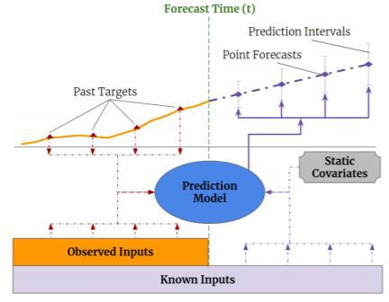

*Figure 119: Multi-horizon forecasting with static covariates, past-observed and future known inputs*

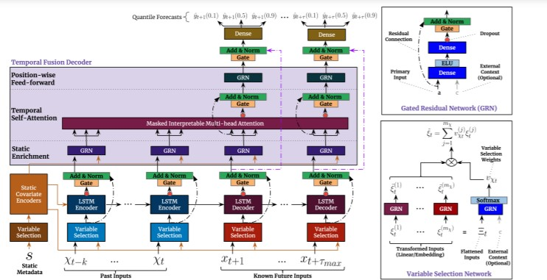

*Figure 120: TFT architecture (source : https://arxiv.org/pdf/1912.09363.pdf)*

# Conclusions / Recommendations

From the visualization of the data, it is seen that Saturday is the peak day of the footfall. With the best models that we have created, we are able to predict the daily and weekly footfall variations correctly with an accuracy of mape 10.88 and 7.38 respectively. Peak time of the day is predicted to be 13.00 to 17.00 hours.

The below prediction is based on LSTM ensemble of ensembles.

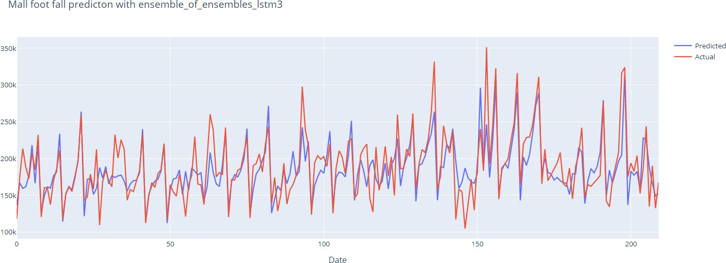

* + During the process of model development, 656 models were created, trained and evaluated
* Model tuning with was done with default params/Random Search CV, Cross CV and RFE CV
* Different types of Regression/Ensemble/LSTM/GAN/FB Prophet/H2O/AutoML models were created
* Best models identified are LSTM Ensemble models and Random Forest
* Standard regression/ensemble models can be trained quite easily.
* LSTM / GAN models are expensive to train, but once the model is trained, we can reuse the saved model for inference later.
* Daily and weekly traffic predictions can be done with these models to help the mall/shop owners to increase their business
* The same model architecture can be used for similar use cases like network traffic prediction, road traffic prediction, anomaly detection etc.

# Directions for future work

* + If we can get the data from the nearby malls, we can enhance the current models with those extra features.
  + For GAN, we can reuse the same model architecture and classes and enhance it from there. It requires a lot of hyper parameter tuning to arrive at the best model.
  + For Transformer based models, we can use the below reference to understand the attention models and TFT and take the next steps from there.

Temporal Fusion Transformer (TFT): https://arxiv.org/pdf/1912.09363.pdf

# Bibliography / References

1. Sklearn : https://scikit-learn.org/stable/supervised_learning.html
2. https://machinelearningmastery.com/time-series-forecasting-performance-measures-with- python/
3. https://machinelearningmastery.com/bagging-ensemble-with-python/
4. https://mlwave.com/kaggle-ensembling-guide/
5. https:/[/www.sciki](http://www.scikit-yb.org/en/latest/api/model_selection/importances.html)t[-yb.org/en/latest/api/model_selection/importances.html](http://www.scikit-yb.org/en/latest/api/model_selection/importances.html)
6. https://machinelearningmastery.com/calculate-feature-importance-with-python/
7. https://machinelearningmastery.com/gradient-boosting-with-scikit-learn-xgboost- lightgbm-and-catboost/
8. https://blog.cambridgespark.com/hyperparameter-tuning-in-xgboost-4ff9100a3b2f
9. https://info.cambridgespark.com/latest/getting-started-with-xgboost
10. Statsmodels : https:/[/www.statsmodels.org/stable/index.htm](http://www.statsmodels.org/stable/index.html)l
11. Light Gradient Boosting : https://lightgbm.readthedocs.io/en/latest/pythonapi/lightgbm.LGBMRegressor.html
12. Categorical gradient boosting : https://arxiv.org/pdf/1810.11363.pdf
13. Tensor Flow : https:/[/www.tensorflow.org/tutoria](http://www.tensorflow.org/tutorials/structured_data/time_series)l[s/structured_data/time_series](http://www.tensorflow.org/tutorials/structured_data/time_series)
14. Plotly Graphs : https://plotly.com/python/horizontal-bar-charts/#horizontal-bar-chart-with- gobar
15. Machine Learning Visualization : https:/[/www.sciki](http://www.scikit-yb.org/en/latest/)t[-yb.org/en/latest/](http://www.scikit-yb.org/en/latest/)
16. Tabulate : https://pypi.org/project/tabulate/
17. FB Prophet : https://facebook.github.io/prophet/docs/quick_start.html
18. Keras : https://keras.io/guides/
19. Keras: Starting, stopping, and resuming training: https:/[/www.pyim](http://www.pyimagesearch.com/2019/09/23/keras-starting-stopping-and-resuming-)a[gesearch.com/2019/09/23/keras-starting-stopping-and-resuming-](http://www.pyimagesearch.com/2019/09/23/keras-starting-stopping-and-resuming-) training/
20. LSTM : https://colah.github.io/posts/2015-08-Understanding-LSTMs/
21. LSTM encoder decoder : https:/[/www.angioi.com/](http://www.angioi.com/time-series-encoder-decoder-tensorflow/)t[ime-series-encoder-decoder-tensorflow/](http://www.angioi.com/time-series-encoder-decoder-tensorflow/)
22. Multi step LSTM :

https://machinelearningmastery.com/how-to-develop-lstm-models-for-multi-step-time- series-forecasting-of-household-power-consumption/

1. LSTM Auto encoders : https://machinelearningmastery.com/lstm-autoencoders/
2. LSTM keras : https://awaywithideas.com/keras-implementation-of-a-sequence-to- sequence-model-for-time-series-prediction-using-an-encoder-decoder-architecture/
3. Deconstructing Time Series using Fourier Transform: [https://medium.com/@khairulomar/deconstructing-time-series-using-fourier-transform-](https://medium.com/%40khairulomar/deconstructing-time-series-using-fourier-transform-) e52dd535a44e
4. H2O: [https://medium.com/@ODSC/machine-learning-with-h2o-part-1-f6bf4f356c7a](https://medium.com/%40ODSC/machine-learning-with-h2o-part-1-f6bf4f356c7a)
5. H2O: [https://medium.com/@jamal.robinson/introduction-to-h2o-ai-1ba51a884f02](https://medium.com/%40jamal.robinson/introduction-to-h2o-ai-1ba51a884f02)
6. AutoML : <http://docs.h2o.ai/h2o/latest-stable/h2o-docs/automl.html>
7. GAN: https://towardsdatascience.com/generating-pokemon-inspired-music-from-neural- networks-bc240014132
8. GAN : https://machinelearningmastery.com/what-are-generative-adversarial-networks- gans

# Appendices

Appendix I:

Model metrics of all the models (656 models): Click here for model metric link.

# List of Publications/Conference Presentations, if any.

1. C-GAN : https://arxiv.org/pdf/1905.12868.pdf
2. C-RNN-GAN:Continuous recurrent neural networks with adversarial training https://arxiv.org/pdf/1611.09904.pdf
3. Time-seriesGAN: https://papers.nips.cc/paper/2019/file/c9efe5f26cd17ba6216bbe2a7d26d490-Paper.pdf
4. Data-augmented regression with GAN : https://uploads-

ssl.webflow.com/5cd23e823ab9b1f01f815a54/5cfa0da102585b5dcc8b03bf_Data- Augmented%20Regression%20with%20Generative%20Convolutional%20Network.pdf

1. Transformer based time series prediction: https://arxiv.org/pdf/2001.08317.pdf

# 18. Duly Completed Checklist

|  |  |  |
| --- | --- | --- |
|  | **Check list of items for the Final report** | **Y/N** |
| a) | Is the Cover page in proper format? | Y |
| b) | Is the Title page in proper format? | Y |
| c) | Is the Certificate from the Mentor in proper format? Has it been signed? | Y |
| d) | Is Abstract included in the Report? Is it properly written? | Y |
| e) | Does the Table of Contents page include chapter page numbers? | Y |
| f) | Does the Report contain a summary of the literature survey? |  |
|  | i. Are the Pages numbered properly? | Y |
|  | ii. Are the Figures numbered properly? | Y |
|  | iii. Are the Tables numbered properly? | Y |
|  | iv. Are the Captions for the Figures and Tables proper? | Y |
|  | v. Are the Appendices numbered? | Y |
| g) | Does the Report have Conclusion / Recommendations of the work? | Y |
| h) | Are References/Bibliography given in the Report? | Y |
| i) | Have the References been cited in the Report? | Y |
| j) | Is the citation of References / Bibliography in proper format? | Y |

*Table 3: Completion Checklist*